ECHO MEANS BUSINESS (EMB)

Functional Specification

# Contents

[ECHO MEANS BUSINESS (EMB) 1](#_Toc67436229)

[Contents 2](#_Toc67436230)

[1 Overview 4](#_Toc67436231)

[1.1 Next version 4](#_Toc67436232)

[1.2 Gamification 6](#_Toc67436233)

[1.3 Scope of Work 6](#_Toc67436234)

[1.4 Timelines 7](#_Toc67436235)

[1.4.1 Phase 3 (Apr 5, Monday) 7](#_Toc67436236)

[1.4.2 Phase 4 (Apr 20, Tue) 7](#_Toc67436237)

[1.4.3 Phase 5 (May 4, Tue) 8](#_Toc67436238)

[1.4.4 Phase TBD 9](#_Toc67436239)

[1.5 Testing Requirements 12](#_Toc67436240)

[2 Screen by screen specification 14](#_Toc67436241)

[2.1 Template ‘Main’ 14](#_Toc67436242)

[2.1.1 [NEXT VERSION: Control Mission] 18](#_Toc67436243)

[2.2 Page ‘Home’ 19](#_Toc67436244)

[2.3 Register / Log In /Profile 30](#_Toc67436245)

[2.3.1 Page ‘Log In’ 30](#_Toc67436246)

[2.3.1.1 Page ‘Forgot Password’ 31](#_Toc67436247)

[2.3.1.2 ‘Log In’ via Google 34](#_Toc67436248)

[2.3.1.3 ‘Log In’ via Facebook 34](#_Toc67436249)

[2.3.2 Page ‘Join’ 35](#_Toc67436250)

[2.3.2.1 Page ‘Registration Promo’ 41](#_Toc67436251)

[2.3.2.2 Register via Facebook 44](#_Toc67436252)

[2.3.2.3 Register via Google 44](#_Toc67436253)

[2.3.2.4 Adding New User via Admin Dashboard 46](#_Toc67436254)

[2.3.3 Page ‘User Profile’ 47](#_Toc67436255)

[2.3.3.1 Profile Completeness 51](#_Toc67436256)

[2.3.3.2 Email ‘Email Changed’ 51](#_Toc67436257)

[2.3.3.3 Page ‘User Subscriptions’ 52](#_Toc67436258)

[2.3.3.3.1 Page ‘Membership Payment’ 53](#_Toc67436259)

[2.3.3.3.2 Page ‘Subscription Completed’ 54](#_Toc67436260)

[2.3.3.3.3 Page ‘View Receipt’ 55](#_Toc67436261)

[2.4 Page ‘Pro Tips’ 55](#_Toc67436262)

[2.4.1 Page ‘Pro Tips – Details‘ 60](#_Toc67436263)

[2.4.2 Page ‘Pro Tips by Category’ 65](#_Toc67436264)

[2.5 Page ‘Pro Forums & Fun’ 67](#_Toc67436265)

[2.5.1 Page ‘Pro Forums & Fun – Details’ 70](#_Toc67436266)

[2.5.2 Forum Admin Emails 70](#_Toc67436267)

[2.6 Page ‘Pro Rewards’ 72](#_Toc67436268)

[2.6.1 Page ‘Pro Reward - Details’ 75](#_Toc67436269)

[2.6.1.1 Popup ‘How to Redeem’ 79](#_Toc67436270)

[2.7 Page ‘Pro Workshops’ 80](#_Toc67436271)

[2.8 Page ‘Pro Networking’ 89](#_Toc67436272)

[2.8.1 Page ‘Pro Networking - Details’ 93](#_Toc67436273)

[2.8.1.1 Popup ‘Add to Your Calendar’ 103](#_Toc67436274)

[2.8.1.2 Email ‘Event Details’ 105](#_Toc67436275)

[2.9 Page ‘Pro Missions’ 105](#_Toc67436276)

[2.9.1 Details page 107](#_Toc67436277)

[2.10 Page ‘Leaderboard’ 110](#_Toc67436278)

[2.10.1 Page ‘Points and Badges’ 114](#_Toc67436279)

[2.11 Page ‘Become a Member’ 116](#_Toc67436280)

[2.12 Page ‘Contributors’ 120](#_Toc67436281)

[2.13 Page ‘UAG Members’ 122](#_Toc67436282)

[2.14 Page ‘Meet the Pros’ 126](#_Toc67436283)

[2.14.1 Public User – Gateway (please login pop-up) 129](#_Toc67436284)

[2.14.2 Public, Basic & Pro User 130](#_Toc67436285)

[2.15 Pages ‘About Us’, ‘Privacy Policy’, ‘Terms’, ‘Community Rules’, ‘FAQ’ 131](#_Toc67436286)

[2.16 Page ‘Get Mobile App’ 133](#_Toc67436287)

[2.17 Page ‘Membership Pricing’ 136](#_Toc67436288)

[2.18 Page ‘Unsubscribe’ 137](#_Toc67436289)

[3 Administrative Interface 139](#_Toc67436290)

[3.1 Page ‘EMB Settings’ 139](#_Toc67436291)

[3.2 Users 139](#_Toc67436292)

[3.3 Pro Tips 141](#_Toc67436293)

[3.4 Content Blocks 142](#_Toc67436294)

[3.5 Events 142](#_Toc67436295)

[3.6 Offers 144](#_Toc67436296)

[3.7 Plugin ‘Restrict’ 146](#_Toc67436297)

[3.7.1 Settings ‘Settings->Emails’ 146](#_Toc67436298)

[3.7.2 Settings ‘Settings->Invoices’ 148](#_Toc67436299)

[3.7.3 Settings ‘Settings->Misc’ 150](#_Toc67436300)

[4 Appendix 152](#_Toc67436301)

[4.1 General Website Sections 152](#_Toc67436302)

[4.1.1 Section ‘Leaderboard’ 152](#_Toc67436303)

[4.1.2 Section ‘Get to Know Pro Members’ 153](#_Toc67436304)

[4.1.3 Section ‘Pro Members You May Know’ 154](#_Toc67436305)

[4.1.4 Section ‘Listen to the EMB Podcast’ 155](#_Toc67436306)

[4.1.5 Section ‘Pro Tips’ 155](#_Toc67436307)

[4.1.6 Section ‘Pro Forum’ 157](#_Toc67436308)

[4.1.7 Section ‘Pro Rewards’ 158](#_Toc67436309)

[4.1.8 Section ‘Pro Workshops’ 158](#_Toc67436310)

[4.1.9 Section ‘Pro Networking‘ 159](#_Toc67436311)

[4.1.10 Section ‘UAG‘ 159](#_Toc67436312)

[4.1.11 Section ‘Check These Out’ 160](#_Toc67436313)

[4.2 Membership / User Roles 161](#_Toc67436314)

[4.3 Secure dialog for Admin 162](#_Toc67436315)

[4.1 Search Results 163](#_Toc67436316)

[4.2 Video Hosting Service 164](#_Toc67436317)

[4.3 Set/Reset Like Status 165](#_Toc67436318)

[4.4 Date/Time format for Comments 165](#_Toc67436319)

[4.5 List of Comments 165](#_Toc67436320)

[4.6 Points 167](#_Toc67436321)

[4.7 Badges 175](#_Toc67436322)

[4.8 UltimateMember Settings 179](#_Toc67436323)

[4.8.1 Email 180](#_Toc67436324)

[4.8.2 Registration Form 180](#_Toc67436325)

[4.8.3 User Roles 181](#_Toc67436326)

[4.8.4 Account Tab 182](#_Toc67436327)

[4.8.5 User Roles (Master) 182](#_Toc67436328)

[4.9 Mobile Testing Procedures 183](#_Toc67436329)

[4.10 Custom Plugins Naming Rules 187](#_Toc67436330)

# Overview

Creative mockups for presentation:

<https://drive.google.com/open?id=1aw6fNtgSxL5gi0z0nMfM3SZ5zGB9joeS&authuser=angelina%40senseimarketing.com&usp=drive_fs>

[Oct 5, 2020] Robert’s notes:

<https://docs.google.com/spreadsheets/d/1nBFBaD2FtEHmWyJ3Zm5aMI1fgdKMMPkUK4o4SHdR69E/edit#gid=1600543433>

[Nov 30, 2020] Google doc with Points, Badges and so on

<https://docs.google.com/spreadsheets/d/1nBFBaD2FtEHmWyJ3Zm5aMI1fgdKMMPkUK4o4SHdR69E/edit#gid=0>

[Jun 3, 2020]

|  |
| --- |
| Responsibilities:   * Sam/Laura: creative * Me: spec / development   Other considerations:   * Use new Bondai WP platform * Only Sensei will have access to Admin interface * Mobile creative – no changes, only add new features   [Open Issue to Sam: what payment gateway will be used for ECHO?]  [PM: need to code purchases from mobile – Membership subscription] |

## Next version

|  |  |
| --- | --- |
| **Feature** | **Details** |
| Forum | [Jun 10, 2020 from Sam]  Robert and I have reviewed the functionality you shared for the new forum you have included in BONDAI. I think it can work; however, we'll likely ask you about:   * Updating the creative/style guide [SP: should be part of the current version] * Can we send alerts through the mobile app when someone subscribes to the forum discussion and leaves a response? [SP: this requires extra time and writing spec] |
| monthly newsletter for EMB that’s just to highlight community conversations | [Sept 14, 2020 from Sam]  Take a look at the Asana email below. It’s a recap of the popular conversations.  Wondering if we should consider a monthly or bi-monthly newsletter for EMB that’s just to highlight community conversations?  So we may wish to consider two emails in EMB 2.0. One monthly newsletter that we create each month and an automated recap email like the one below? Just putting the idea out to there |
| Recommended plugins from Robert | [PM: review this below from Robert]  Check out:  - www.convertkit.com (http://www.convertkit.com)  - https://flyplugins.com/wp-courseware/ (for Pro School). |

## Gamification

[Jun 29, 2020 from a call]

[PM: review these notes below]

Notes from today's chat, re: Gamification. Please create a thread to update anything else that I may have missed.

* Points: Points should be equal for all members, Basic (free, subscribed) and Pro (paid, subscribed); public users cannot earn points. Paid members can be incentivized in other manners, such as the award of badges, etc. that allows for a 2nd level of rewards.   Remember, while we may have 1K -3K in paid members, there's an opportunity to engage tens of thousands of non-paid members and so we cannot dis-incentivize them.
* Badges: Badges can be earned by the achieving certain point levels (E.g. 1000, 5,000, etc.) during a time period (monthly or yearly) - and - badges can be earned by completing specific tasks such as: Top X of the month, or completing specific tasks (or combination of tasks) such as "Networker" badge for participating in 3 networking events, a "Mentor" badge for replying to 50 questions in the forum, or a "Contributor" badge for submitting 3 videos/articles in a quarter for the Pro-Tips section. We also have UAG and UAG Council badges given to members in the year they're nominated to the board.
* Mission of the Week (MOW): MOWs will be synced with current "Weekly Challenges" available on the mobile app so we only have one program. MOWs will earn extra points for completion and possibly earn "Most Engaged" Badge for completion of X challenges.
* Marketing Emails: We'll continue with monthly newsletters for the launch of the program, possibly with personalized content based on the user's points, next level opportunities, etc. Plan for future launch of additional marketing emails.

Action Items:

* Robert to complete a list of the all
* Badge names/actions to be developed and designed, all to contribute
* Plan/document email campaign

## Scope of Work

1. **BASE: DEVELOP A TIERED MEMBERSHIP PROGRAM**

Work/Service to Be Performed

1. **Upgrade the website and mobile app’s design** and application to allow for a tiered membership program where content and featured benefits will be made available to different groups based on their membership level.
2. **Develop a gamification strategy and user experience** that would encourage movement from the lowest tier to the highest tier and downloading of the mobile app or subscribing to emails and other features, during every engagement;
3. **Integrate an e-commerce component** that would allow members to purchase top tier membership or pay for digital or live events hosted by ECHO Means Business.
4. **Referral Program** - With the upgrading of ECHO Means Business to a tiered paid membership, Sensei recommends the introduction of a referral program for UAG or other members who recommend their fellow pros to enroll in the Pro Tier.
5. **E-commerce Management** 
   1. Pro tier members will be charged a suggested $95/year for access to this program, with a special introductory price of $39.99/year (example) for the first year through an integrated e-commerce platform.
   2. Note e-commerce transacts on the EMB website and no inventory needs to be purchased, warehoused, or shipped to fulfil this feature (unless ECHO products are included). All transactions occur on the website of participating vendors
6. **BASE: GENERAL SITE & ENGAGEMENT IMPROVEMENTS**

Work/Service to Be Performed

1. **Update the website forum design/tech** to improve user experience/ease of use
2. **Update creative design, navigation and layout** to:
   1. Accommodate new functions
   2. Improve gamification of website (motivating users to upgrade tiers and usage across all pages/functions)
   3. Increase subscriptions and gather more user feedback/preferences
3. **Search Engine Optimization Updates**
4. **Targeted Email Marketing Campaign** 
   1. Drip marketing for those who: Have subscribed but not registered; have subscribed to base membership to encourage paid memberships; have registered for paid tier requesting referrals and testimonial

## Timelines

Source <https://app.asana.com/0/607038627868623/1199155964593983>

### Phase 3 (Apr 5, Monday)

**Pro Tips / Networking / Rewards**

* Likes for objects
* Likes for comments

**Points**

* All other points [in coding]

**Badges** - whatever is available

* Display all available badges

**Meet The Pros (aka Member Directory)**

* Full function - all EMB community profiles so users can chat/connect
  + [Mar 23, SP>] utilize Member directory. Check what features allow people to use to avoid scam and spam
* Unhide homepage silder + updated pop-up

### Phase 4 (Apr 20, Tue)

**Subscriptions**

* 30 Day Free Trial
  + Membership functionality: landing page, add into profile, logic for upgrade
  + Add Paypal
  + Transactions
    - For users to upgrade to a pro membership
    - ***Note that by the end of the first user's 30 days, transactions MUST be completed so users can upgrade to a pro membership***
* **Drip marketing campaign** [Open Issue: does it mean expiration and renewal email?] AK: Yes and also the other emails for those who start a trial as per below. The trial emails are less important than the expiration/renewal emails.

|  |
| --- |
| Marketing campaign for conversion (Robert working on business rules)  <https://app.asana.com/0/607038627868623/1199209490925924>  [PM: describe this. Creative in Zeplin for emails for those who join TRIAL membership  ] |

**Pro Missions** [Open Issue: 1) is it what we have in CPA or different? 2) is ‘Mission if the week’ the same thing?] AK: Same thing, yes

* Full functionality? or maybe only image/text missions? Let me know AK: full functionality if possible, but understand if we can only do text/images for now. We can move videos to phase 5? Let me know your thoughts.
* Angel needs to provide missions
* This is similar to CPA’s challenges so you may be able to duplicate.

### Phase 5 (May 4, Tue)

**Pro Workshops – from Sam**

* Full function
* Questionnaire/post-event survey after each video
* Including the ability to track if a unique user has watched 80% of the video without skipping. AK: how is this possible?
* Details

|  |  |
| --- | --- |
| [Feb 23, 2021 from Angelina]   |  | | --- | | As discussed today, we will need to find a way to track whether users watch 80% of each video without skipping it. Is it possible?  We will also need to figure out how to add a survey/questionnaire at the end of each video (for a later phase) |   NOTE that "workshops" are "videos" that will be somewhere between 30 and 60 minutes. We need to host/stream them so that only PRO members can access them. I am open to hosting them on our own servers (media servers if needed) or 3rd party service (Vimeo?) as long as it meets our requirements for only PRO members to be able to see them on our site. [SP>we will use our hosting (as a quick and temp solution), Vimeo or CloudFare (as it was on CPA). I am checking what is the best one][PM>we will use our hosting (as a quick and temp solution), Vimeo or CloudFare (as it was on CPA). I am checking what is the best one] |

**Pro Resources – from Angel**

* [Open Issue: please provide details] AK: I will provide.

**Registration**

* Update with testimonials. AK to provide info

**Leaderboard**

* Mentor [Open Issue: please provide details]. AK: I will provide, low priority

### Phase TBD

**OTHER: STAGGERED/WHENEVER IT CAN HAPPEN** AK: Sergey, please advise when you know

|  |  |
| --- | --- |
| **Feature** | **Details** |
| Mobile API | **[SP>let plan – end of June]**   * Plan switching API on WP   + Pro-tips     - Existing comments + likes     - Add main image with overlay – maybe add it automatically?   + Posts   + Consult with Igor |
| Mission Control | **[SP>let plan – end of May]**  <https://app.asana.com/0/1178924434621079/1198951217657822/f> |
| Metrics | Metrics (from Sam, Angelina doc: <https://docs.google.com/document/d/1sHX4sjr06ovD-kS5Kh84fYozjQa6g1gEe_H__h15iL4/edit> )   |  | | --- | | **Total Engagements** (User posts + User comments on posts + responses to challenges + comments on user challenge responses + all likes + shares (if possible) per period (day/week/month)  [Would be interesting to see these #’s individually for internal purposes, we show the client total actions]    And   * (Total actions / users \*100)   [SP: it was in Data Studio, but for UAG only. Now reports in Data Studio do not work and require updates, because we moved on a new server. I included this into my plan to fix - may take ~1mo] | | * % Total Website engagement * 2 stats:   **Total page views** (site pages + forum posts) + **Total comments** (forum) + **Total actions** (Likes + Shares) + **Total comments on articles** (when available) per period (day/week/month)  - both Unique and Total  [SP: page views can be taken from Google Analytics, Comments can be taken from WP Comments, Actions (likes, shares) - not available now - I included them into my plan]  And     * (Total actions / users \*100) | | * Conversion   (Total visitors >> Free Trial; Free Trial member >> Paid Member)  [SP: once Paid members will be implemented, then we can check how many of them have Paid status and compare with all others] | | * Churn/Loss (EoY ONLY)   (Total Paid Members >> Not Renewing)  [SP: need to add some additional stats to check this. I included this into plan for NEXT version] | |
| Challenges | * Develop Challenges (which are used on mobile now, but allow to use them on web as well) * Move existing challenges, replies from existing on new one |
| Mobile Posts | * Develop Posts (which are used on mobile now, but allow to user on web as well) * Move posts from existing one on new one |
| Plugin ‘Friends’ | AK: can we change the text “friends” to “connections”?  [SP>Nov 30, we can try, but it takes time. So I moved this into Phase2 or 3] |
| Feed | [Dec 1, 2020: from Sam + Angelina + Robert call]  [PM: <https://app.asana.com/0/1178924434621079/1199408046516223>  review how feed is looks like in UM, check how to combine all user activity feeds into one with UM, provide mockups]  Options:   * Display website feed, without user activity feeds * Display all users activity feed * Display website and user activity feed   ] |
| Forum | Apply for mobile |
| Membership Subscription | Apply for mobile |
| Pro Tips | Apply for mobile |
| Pro Rewards | Apply for mobile |
| Pro Workshop | Apply for mobile |
| Pro Networking | Apply for mobile |
| Reply on emails from Forum | [Jan 17, 2021. from Angelina]  Question re user flow for responding to forum replies from email notifications.  I clicked the link in the email to respond, it asked me to log in but when I logged in it took me to my profile and not the forum post. Is there any way we can direct users back to the post so that they can respond? |
| Gallery | [Dec 28, from Angelina. Source: <https://app.asana.com/0/607038627868623/1198971378001209> ]  Hi Sergey,  Okay, so there are 2 things we need here. This doesn't have to be done for phase 1 (BETA) but it will need to be completed for when we launch to the public.  A dedicated gallery page  Within the page, there could be multiple galleries (see screenshot)  can be a carousel?  Articles that have a gallery within  the same as every article except we now have multiple images and a link that directs them to the specific gallery on the gallery page (see screenshot)  Maybe we need to add a "campaign" menu item in the navigation bar. This way we can put specific campaigns and content series that we have planned for 2021 under it. It will make it easier for users to find them. E.g. the current Social Lounge page (https://www.echomeansbusiness.com/client/digital-events.jsf?subCategoryId=30) can live under there. So URL could be: echomeansbusiness.com/campaigns/social-lounge. We can add the gallery in here too?  What are your thoughts on this? If you are okay with this, I will get Laura to create these. Happy to discuss further on a call if required!    [Dec 1, 2020: after team call with Sam+Angelina+Robert]   |  | | --- | | [PM:  Allow people to create posts on PUBLIC website and add content and images/videos.  Mockup this and send to Angelina/Sam for review  ] |   Reference: <https://app.asana.com/0/607038627868623/1198971378001209>  We can implement something similar to CPA:   * Upload BEFORE image * Upload AFTER image * Add content * Submit   Once submitted we can display these works in a gallery - the same way as it was on CPA with a possibility to share or even comment.  Maybe we can incorporate these works into user profile like 'Jobs'. In this case if someone opens user profile he/she can see all these submits related to this user this type of changes/integration into the existing user profile can be complicated  Please let me know if need to discuss the workflow.  **Estimate:** ~80hr for the whole team |
| Data Studio | Reconnect Data Studio to New WordPress instance   * Fully rebuild reports to display all data, not only UAG |
| Add ‘Share by Email’ item into the Share section | Add ‘Share by Email’ item into the Share section – the same as it is in the existing website |
| UAG application form access | [Jan 1, 2021 from Angelina]  UAG application form must only be accessible when someone is logged in - is this doable? |
| User Advisory Group | [Jan 19, 2021 from Angelina]  What is a difference between 'User Advisory Group' and 'A Few Pro Members...'   * A few pros you may know section is meant to be varying EMB members who have created profiles. They do not need to be UAG. As this profile feature will not be ready for Feb 1 launch, I thought we could put UAG members in this section for now. * UAG section in this task is meant to be focused on UAG only. This can be for phase 2 if need be. |
| ‘A Few Pro Members You May Know’ | [Jan 19, 2021 from Angelina]  Display randomly Any members in the section ‘A Few Pro Members You May Know’, not only UAG members |

## Testing Requirements

Do testing using recent version only:

|  |  |
| --- | --- |
| **Platform** | **Browsers** |
| Windows | * Chrome, * FireFox, * Edge |
| Mac | * Safari |
| iOS | * Safari, * Chrome |
| Android | * Chrome |

# Screen by screen specification

Where required, use the following page title ‘*ECHO Means Business: <page name>*’.

## Template ‘Main’

This is template which will be applied for all pages.

This template may look like this (for illustration only)

|  |
| --- |
| **[User dependent page content]** |

Controls description:

|  |  |  |  |  |  |  |  |  |  |  |
| --- | --- | --- | --- | --- | --- | --- | --- | --- | --- | --- |
| **Header**   |  |  | | --- | --- | | **Membership** | **Description** | | Public | * - Logo. Link to [Home page](#_Page_‘Home’_1). It opens in the same tab; * - the same link as a logo; * - Textbox. Empty by default. Max with 300chars. It allows user to search specific information on the website. When the user clicks in the search box, the word that is put there to trigger users to input text (the word 'search' is used) should instantly disappear, so they do not have to delete the word manually before they can enter their search term. After user enters search word or phrase + Enter, he’s redirected to the page [Search Results](#_Search_Results).   [NEXT VERSION: to investigate plugins which allow user to see the tips while entering the search word or phrase. Probably, for the next version.]   * - Link to [Register page](#_Page_‘Join’). It opens in the same tab. * - Link to [Login page](#_Page_‘Log_In’_1). It opens in the same tab. | | Basic | * Such items like EMB logo, text ‘Green Industry Community – For Pros, By Pros, textbox ‘Search’ described above for Public user are the same for Basic user. * - User avatar. * **Sam** **Fiorella** – User First and Last name. Must be taken from **Users -> First Name and Last Name.** When user clicks his name, it shows:   + My Profile, it opens [‘User profile’ page](#_Page_‘User_profile’) in the same window;   + Membership, it opens [page ‘User Subscriptions’](#_Page_‘User_Subscriptions’) in the same window   + Logout, it closes user session and opens the [Home page](#_Page_‘Home’) in the same window.      * [Dec 26, 2020: I removed to avoid SPAM messages]  ~~- friends request icon~~ * [Dec 26, 2020: I removed to avoid SPAM messages]  ~~- Icon. When user clicks, it shows the newest conversations and a text-link ‘~~**~~See all messages’,~~** ~~which redirects user to~~ **~~Profile -> Private messages.~~**  * - Icon. When user clicks, it shows the newest notifications and a text-link ‘**See all notifications’**,which redirects user to Notification page. * Membership:   + - Static text for [‘Basic’ membership](#_Membership_/_User); * Points:   + - Static icon and text.   + **54** – Total number of points for user. Must be taken from **Users -> Balances (Points).** | | Pro | * Such items like EMB logo, text ‘Green Industry Community – For Pros, By Pros, textbox ‘Search’, user avatar, user first name, ‘friends request’, ‘message’ icon, ‘notification’ icon, text ‘Membership’ and ‘Points’ described above are the same for Pro user. * - Static text for [Pro membership](#_Membership_/_User). | | Any other  (Admin for example) | Do not display ‘Membership’ section | |
| **Top menu**   |  | | --- | | * Pro Tips. Opens [Pro Tips page](#_Page_‘Home’) in the same window; * Pro Forums & Fun. Opens [Pro Forums and Fun page](#_Forum_1) in the same window; * Pro Workshops. Opens [Pro Workshops page](#_Page_‘Pro_Workshops’) in the same window; * Pro Rewards. Opens [Pro Rewards page](#_Pro_Reward_(Partner) in the same window; * Pro Networking. Opens [Pro Networking page](#_Page_‘Pro_School’) in the same window; * Pro Missions. Opens [Pro Missions page](#_Page_‘Pro_Missions’) in the same window; * UAG Members. Opens drop-down menu when user taps on it or if mouse is over      * + - UAG Members opens [UAG Members page](#_Page_‘UAG_Members’_1) in the same window;     - Contributors opens [Contributors page](#_Page_‘Contributors’) in the same window. * **Pro Missions –** Link to [Pro Missions page](#_Pro_Missions). It opens in the same tab. * Member Directory. Opens the [page ‘Member Directory’](#_Page_‘Member_Directory’) in the same tab; * Other menu items are links as well, see the full description in Footer section. | |
| **Footer**   |  | | --- | | **Subscribe section**  It may look like this:    [Tech Note: use ‘Subscribe’ Gravity Forms and customize it according creative]  [Testing Notes: check that error validation will not break creative]  Controls description:   * Email address. Textbox, required;   Clicking ‘Subscribe’ does the following:   * Validates email address using standard Gravity Form validation procedures and displays error messages;   + Show pre-loader like here instead of Subscribe button (or similar):      * + Show errors like here:      * If validation passed successfully then:   1. Show a confirmation message instead of the form ‘*Thanks for signing up. Be on the lookout for our monthly newsletter!*’ [Tech Note: can be customized via plugin]. Example:      * 1. Saves email into the plugin DB; [Tech Note: this is part of plugin];      + This is OK to have duplicates, no need to validate them to avoid spammers to find submitted emails;   2. Send email to web admin [Tech Note: can be customized via plugin];      * 1. [NEXT VERSION: integrate Mailchimp or SendGrid Double Opt-in confirmation] | | * ‘ FOLLOW US’ - Static text. * – Link to <https://www.facebook.com/echomeansbusiness/>. It opens in the new tab. * - Link to <https://www.instagram.com/echo.meansbusiness/>. It opens in the new tab. * - Link to <https://www.youtube.com/channel/UC3_dtdhrJqS1thoH5WhK07Q>. It opens in the new tab. * ‘Watch EMB Video’ button - Popup video. This is HTML widget, which will include buttons and video popup, which should look like: * Title: Watch Echo Means Business video; * Button: 'Close' only; * Video: embed YouTube video.     [PM: temporary we will place the video: https://www.echomeansbusiness.com/client/user-advisory-group.jsf] | | NOTE: all the items for the sections below will be set up in **Appearance -> Widgets.**   * **Pro Tips –** link to open the same page as in top menu. * Links to article categories, e.g*.*, *‘Grow your Business’.* * Sort By [Nov, 03, 2020 from Angelina: It will be based on "most popular"]   [Tech Note: discussed with Sergey, Dima. We’re going to set it with **Appearance -> Widgets**].   * **Pro Forum -** link to open the same page as in top menu. * Links to forum categories/titles, e.g., ‘*Maintaining Outdoor Landscapes’*. * **Pro Workshops -** link to open the same page as in top menu. * Links to article categories. * **Pro Rewards -** link to open the same page as in top menu. * Links to rewards categories, e.g., *‘Entertainment’*. * **Pro Networking -** link to open the same page as in top menu. * **UAG -** link to open the same page as in top menu. * **Become UAG member** – Link to [Become a Member page](#_Page_‘Get_the). It opens in the same tab. * **Contributors** – Link to [Contributors page](#_Page_‘Contributors’) It opens in the same tab. * **Meet the Pros –** link to open the same page as in top menu. | | * **FAQ** - Link to [FAQ page](#_FAQ). It opens in the same tab. * **Privacy Policy** - Link to [Privacy Policy page](#_Pages_‘About_Us’,). It opens in the same tab. * **Terms and Conditions** - Link to [Terms and Conditions page](#_Pages_‘About_Us’,). It opens in the same tab. * **Community Rules** - Link to [Community Rules](#_Pages_‘About_Us’,) page. It opens in the same tab. | | * - Logo. Link to <https://www.echo-usa.com/>. It opens in a new tab. * - Static text. [Tech Note: Display [Current Year] instead of ‘2020’] | |

### [NEXT VERSION: Control Mission]

[PM: describe this]

Collapsed:

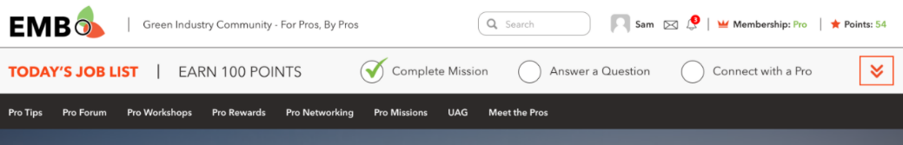

Expanded:

|  |
| --- |
|  |

## Page ‘Home’

Home page can look differently based on [user role/membership](#_Membership_/_User).

It may look like this (for illustration only), included into [Main Template](#_Template_‘Main’).

|  |
| --- |
|  |

Controls description:

|  |  |  |  |  |  |  |  |  |
| --- | --- | --- | --- | --- | --- | --- | --- | --- |
| **Top banner**  Top banner depends on [user role/membership](#_Membership_/_User). [Tech Note: use UM shortcode to show hide content which depends on user role]   |  |  | | --- | --- | | **Membership** | **Banner** | | Free | * Join Free - Link to [Register page](#_Page_‘Join’). It opens in the same tab. * ‘Learn More’ – open [FAQ page](#_Pages_‘About_Us’,) in the same page. * All other is just static content | | Basic | [Note from Angelina Nov 19, 2020: hide two buttons for now]  [Open Issue to Angelina <https://app.asana.com/0/1178924434621079/1199231975176391>: what should be opened by ‘Go Pro’ and ‘Watch Video’ in Phase 1? Maybe hide them?]  [PM: describe membership page for ‘Go Pro’] | | Pro | Any content. Will be managed via admin panel – LiveCanvas. | |
| **Pro Members You May Know**  This section is described in the [chapter Appendix->’Pro Members You May Know’](#_Section_‘Pro_Members). |
| Pro Tips   |  | | --- | | - Static text | | - Static HTML block. Admin can adjust copy manually. [Tech Note: allow to manage it via LiveCanvas]; | | Featured Pro Tip  [Tech Note: this block should be automatically generated based on article. Options:  #1: Add a shortcode into HTML [Discussed with Dima, we’re going to add shortcode]  #2: Code a custom widgets to select article to be displayed in this place]  All block is clickable. It opens same as ‘Watch Video’ (or ‘View Pro Tip’).   * - Pro tip image. * - Pro tip category, if there are more than one category, then display the first one by ascending order. * - Pro tip title. * - Link to the page ‘[Pro Tip Details](#_Page_‘Home’)’. It opens in the same window. Link depends on pro tip type (Video or Article), and can be: * Watch video; * View pro tip. | | Leaderboard  It is described in details in the [section Appendix->‘Leaderboard’](#_Section_‘Get_to). | |
| **Pro Tips**  It is described in details in the [section Appendix->‘Pro Tips’](#_Section_‘Pro_Tips’). |
| **Pro Forum**  It is described in details in the [section Appendix->‘Pro Forum’](#_Section_‘Pro_Forum’). |
| [NEXT VERSION:  **Mission of the Week**   * Mission of the Week – Static text. * ‘Complete your Mission of the Week and Earn Points’ – Static text.   -   * ‘Mission of the Week’ button – Link to the [Pro Mission](#_Pro_Missions) page. It opens in the same tab.   ] |
| **Pro Rewards & Discounts**  It is described in details in the [section Appendix->‘Pro Rewards’](#_Section_‘Pro_Rewards’). |
| **Pro Workshops**  It is described in details in the [section Appendix->‘Pro Workshops’](#_Section_‘Pro_Workshops’). |
| **Pro Networking**  It is described in details in the [section Appendix->‘Pro Networking’](#_Section_‘Pro_Networking‘). |
| **UAG**  It is described in details in the [section Appendix->‘UAG’](#_Section_‘UAG‘). |

## Register / Log In /Profile

[PM: Nov 30, 2020 check and describe these emails. They do not look good and they are sent to users

* Also it includes WordPress inside

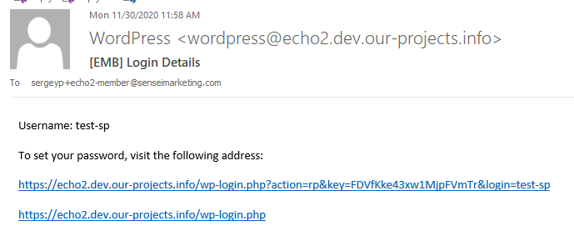

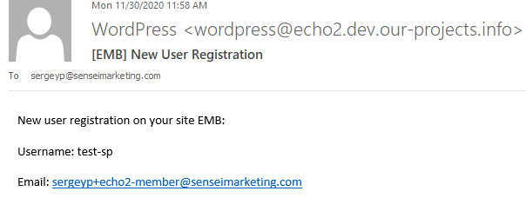]

### Page ‘Log In’

This is page to log in on the website.

This page may look like this:

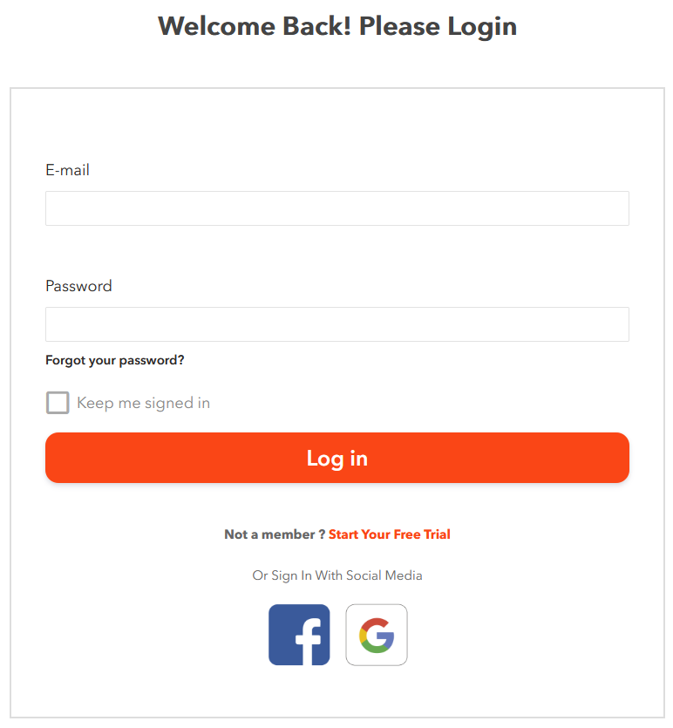

[Tech Note: this page is Ultimate Member plugin]

[PM: we won’t use ‘Sign In’ with LinkedIn so far. ‘Email or Username’ is renamed to ‘Email’]

Controls description:

* ‘Welcome back! Please login’, ‘Not a member?’ – Static text.
  + Email. Textbox. It allows user to enter his email address or username. Mandatory field. ~~Maximum 320 chars~~;
  + Password. Textbox. It allows users to enter his password. Mandatory field. ~~Maximum 30 chars~~.
* ‘Forgot Your Password?’. It follows standard existing WP rules. See [page ‘Forgot Password’](#_Page_‘Forgot_Password’) below;
* ‘Log In’ button. It follows standard existing WP rules.
* ‘Keep me signed in’. Checkmark. Unchecked by default.
* ‘Start Your FREE Trial.’ Link to [Register](#_Forgot_Password) form. It opens in the same window.
* [Sign In with FB](#_‘Log_In’_via). Enables to login with Facebook account, the website can access information user has added on Facebook.
* [Sign In with Google](#_‘Log_In’_via_1). Enables to login with Google account.

#### Page ‘Forgot Password’

This page is used when user clicks ‘Forgot your password?’.

This page may look like this:

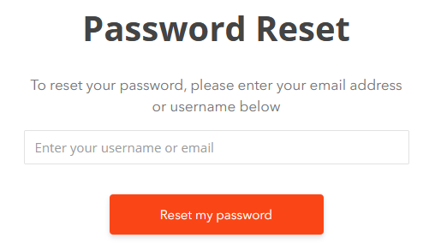

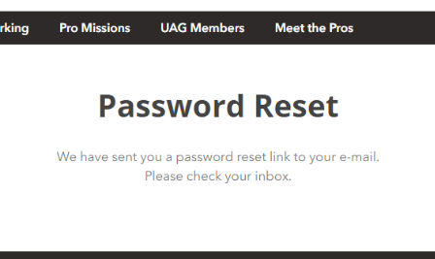

Email:

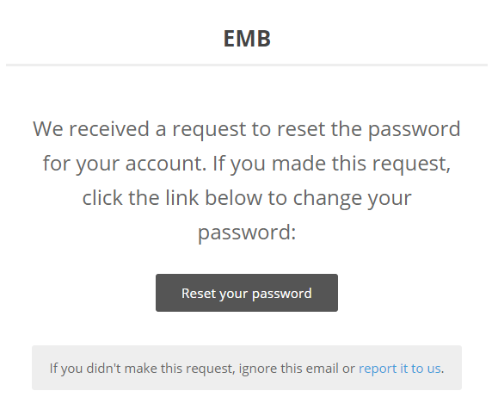

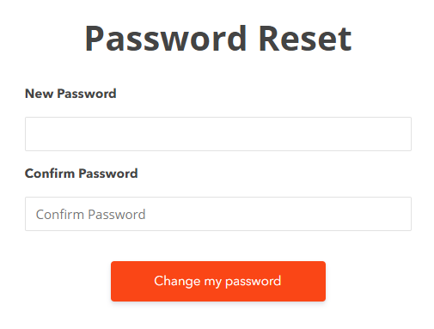

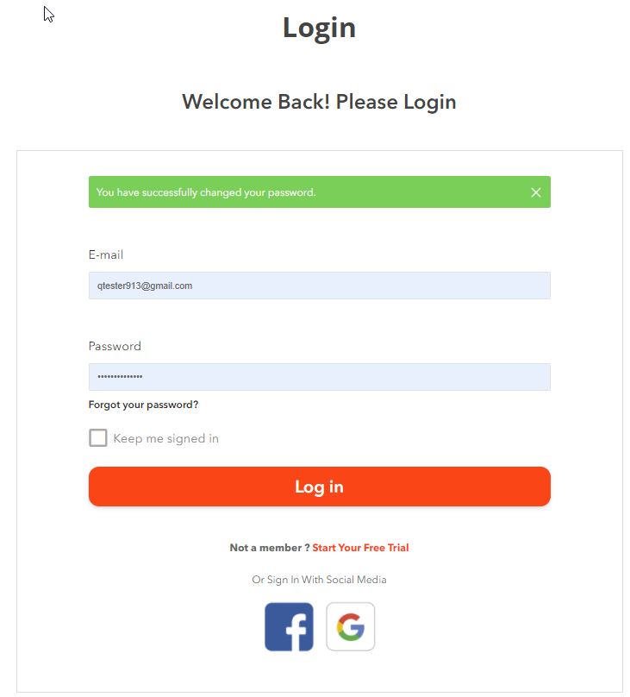

Clicking ‘Reset my password’ does standard validation and the following email is sent [Tech Note: email is configured in the Dashboard->Ultimate Member->Settings->Email->Password Reset Email]:

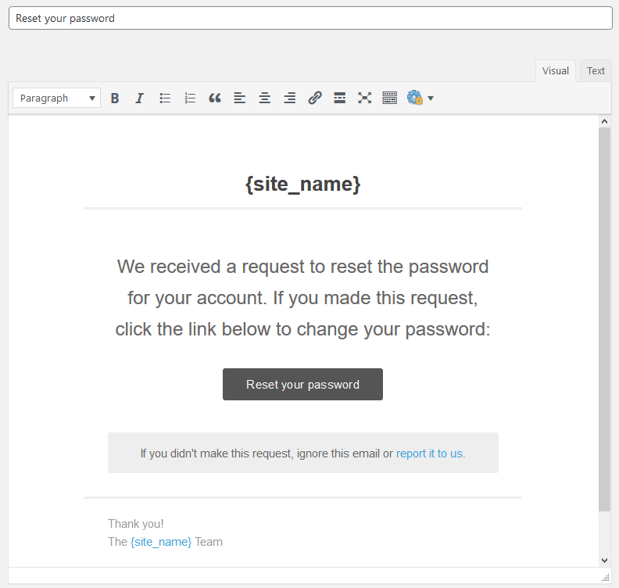

Where:

* ‘report it to us’ is email which is configured in the **Dashboard->Ultimate Member->Settings->Email->Admin Email Address**.

#### ‘Log In’ via Google

Steps how to log in via Google:

|  |  |
| --- | --- |
|  |  |

#### ‘Log In’ via Facebook

Step how to log in via Facebook:

|  |  |
| --- | --- |
|  |  |

### Page ‘Join’

This is page to register on the website.

[Tech Note: registration should be done via email confirmation link]

This page may look like this (for illustration only):

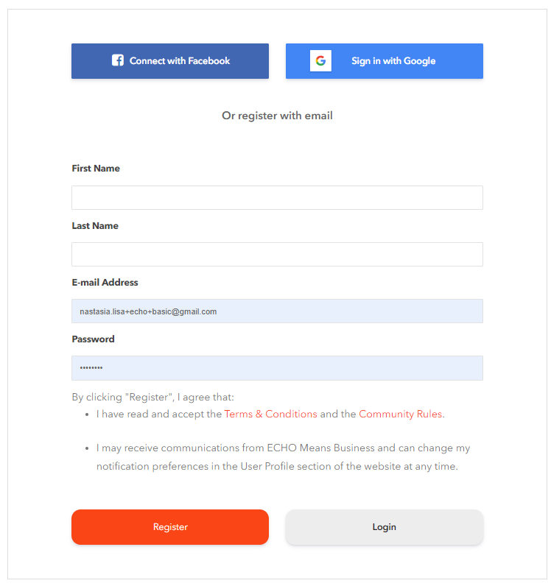

The page for social registration may look like this (for illustration only):

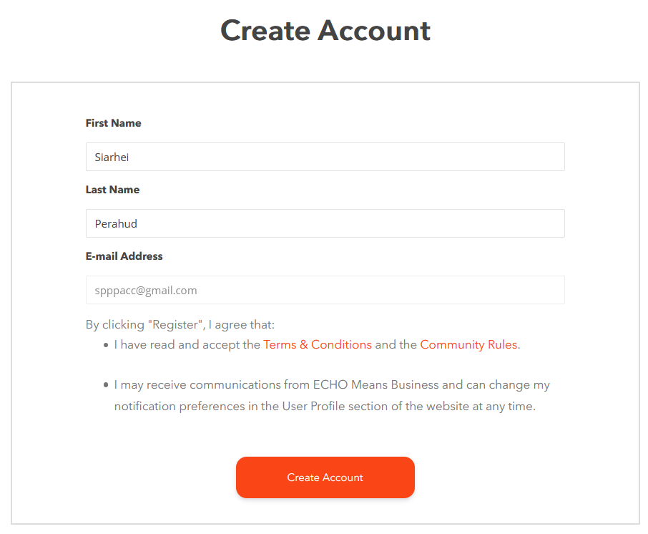

Controls description

* Social registration
  + Instructions: <https://docs.ultimatemember.com/article/20-social-login-facebook-app-setup>

|  |
| --- |
| **URLs for Facebook (TEST website):**  https://echo.dev.our-projects.info/  https://echo.dev.our-projects.info/?provider=facebook  https://echo.dev.our-projects.info/?return\_provider=facebook  https://echo.dev.our-projects.info/login/  https://echo.dev.our-projects.info/login/?provider=facebook  https://echo.dev.our-projects.info/login/?return\_provider=facebook  https://echo.dev.our-projects.info/register/  https://echo.dev.our-projects.info/register/?provider=facebook  https://echo.dev.our-projects.info/register/?return\_provider=facebook  https://echo.dev.our-projects.info/account/social/  https://echo.dev.our-projects.info/account/social/?provider=facebook  **URLs for Facebook (LIVE website):**  https://www.echomeansbusiness.com/  https://www.echomeansbusiness.com/?provider=facebook  https://www.echomeansbusiness.com/?return\_provider=facebook  https://www.echomeansbusiness.com/login/  https://www.echomeansbusiness.com/login/?provider=facebook  https://www.echomeansbusiness.com/login/?return\_provider=facebook  https://www.echomeansbusiness.com/register/  https://www.echomeansbusiness.com/register/?provider=facebook  https://www.echomeansbusiness.com/register/?return\_provider=facebook  https://www.echomeansbusiness.com/account/social/  https://www.echomeansbusiness.com/account/social/?provider=facebook |

* First Name, Last Name are mandatory;
* Email Address. Automatically taken from social profile and pre-populated. Disabled. User cannot change it. [Tech Note: when Email is hidden then 1) plugin automatically creates a random email for this user, which is incorrect; 2) it does not display errors that this email is already registered];
* [Dec 11,2020: Angelina asked to remove it] ~~‘Subscribe ..’ checkmark is optional.~~

Links:

* Terms & Conditions. Opens this page in the same window;
* Community Rules. Opens this page ion the same window.

Registration process:

* Username should be generated automatically based on email address before ‘@’ + sequence index (sequence index is added, if such username already exists, otherwise sequence number is not added). Username must be unique in system. [Tech Note: use **WP->sanitize\_user** function to leave only allowed chars in user name. Source: <https://developer.wordpress.org/reference/functions/sanitize_user/>. Example: ‘mike\_smith+2021@gmail.com’ => ‘mike\_smith2021’]

Clicking ‘Facebook’ or ‘Google’ does the following:

* DO NOT send a confirmation email for social registration => Automatically confirm user registration and send **Account Welcome Email** only

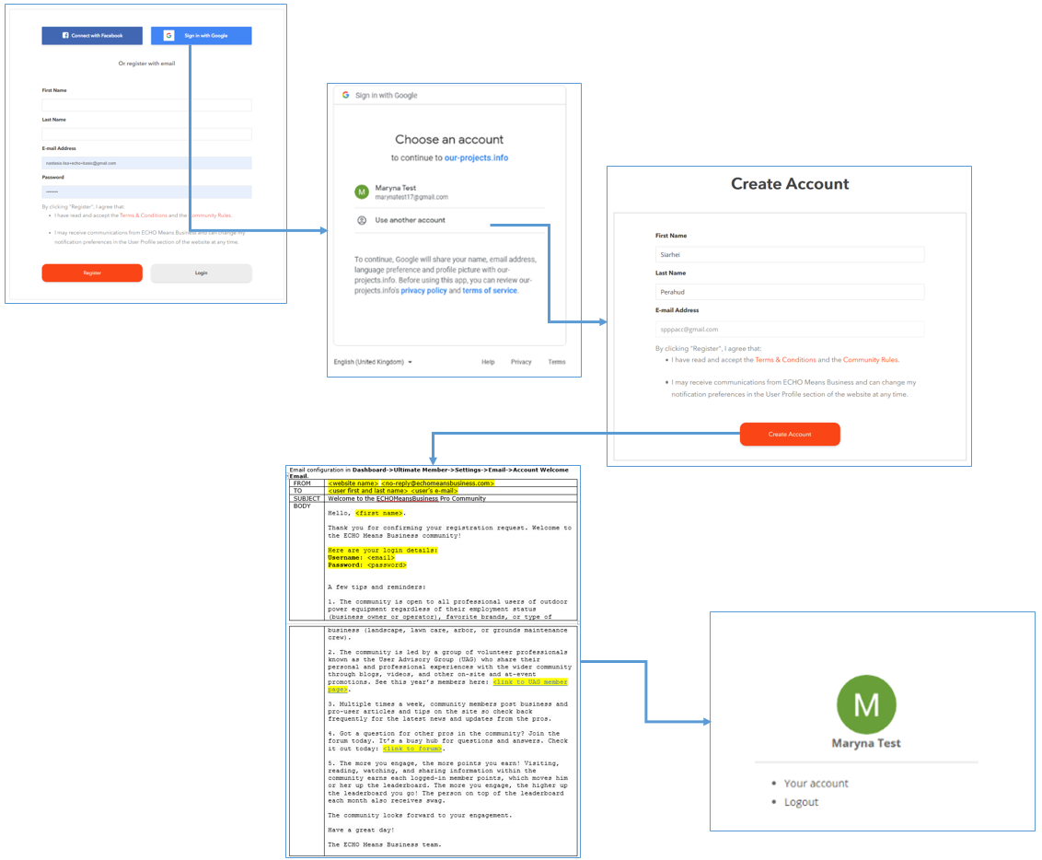

Clicking ‘Login’ opens [‘Log In’ page](#_Page_‘Log_In’) in the same window.

Clicking ‘SUBMIT’ does the following:

* Fields validation,
* Send email to activate account.
  + Email configuration in **Dashboard->Ultimate Member->Settings->Email->Account Activation Email**.

|  |  |
| --- | --- |
| FROM | <website name> <no-reply@echomeansbusiness.com> |
| TO | <user first and last name> <user’s e-mail> |
| SUBJECT | ECHO Means Business Registration Confirmation |
| BODY | Hello <first name>,   Someone with this email has registered a user profile at <www.echomeansbusiness.com>, the premier community and information hub for and by professional users of outdoor power equipment.    If this was you, for security purposes, we need you to confirm your request and user profile. Please click the following link to confirm your registration request: <activation URL>  NOTE: Once you’ve logged in, you can edit your profile name by hovering over your name at the top right of the website and then clicking: “user profile.”  If you didn't request creating an account, just ignore this mail.  Thank you,  ECHO Means Business  <https://www.echomeansbusiness.com> |

* + - Fields in yellow are variables
      * <activation URL> this is link to activate account.
* Shows a message with steps to activate account

|  |
| --- |
| IMPORTANT MESSAGE  Thank you for registering. Before you can login we need you to activate your account by clicking the activation link in the email we just sent you.  **If you don't see the e-mail message in your inbox, look for it in your junk or spam mail folder or check your e-mail again later.** |

Once user activates account then:

* The following page opens:

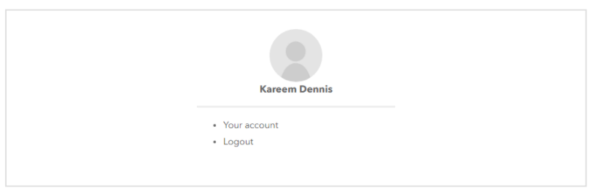

* Confirmation email is sent:
  + Email configuration in **Dashboard->Ultimate Member->Settings->Email->Account Welcome Email**.

|  |  |
| --- | --- |
| FROM | <website name> <no-reply@echomeansbusiness.com> |
| TO | <user first and last name> <user’s e-mail> |
| SUBJECT | Welcome to the ECHO Means Business Pro Community |
| BODY | Hello, <first name>.  Thanks for signing up to ECHO Means Business, a green community created for pros, by pros just like you.  Here are your login details:  **Username:** <email>  **Password:** <password>  As they say, membership has its privileges, and here’s just a few you can look forward to over the next 30 days:   * Pro videos and blogs to help you build your biz * Networking events, forums, and mentorship to grow your opportunities * Exclusive offers, discounts, contests to help you save and have fun * “Pro Points” and badges that reward you for community engagement * Much, much more!   **What you can do right now to get started:**  1. If you haven’t already, **complete your profile**  2. Earn points by **commenting on articles** or engaging with fellow pros in our forum  3. **Redeem special discounts** for shows and sports, theme parks, hotels, and more  *A few tips and reminders:*  1. The community is open to all professional users of outdoor power equipment regardless of their employment status (business owner or operator), favorite brands, or type of business (landscape, lawn care, arbor, or grounds maintenance crew).  2. The community is led by a group of volunteer professionals known as the User Advisory Group (UAG) who share their personal and professional experiences with the wider community through blogs, videos, and other on-site and at-event promotions. See this year’s members here: <link to UAG member page>.  3. Multiple times a week, community members post business and pro-user articles and tips on the site so check back frequently for the latest news and updates from the pros.  4. Got a question for other pros in the community? Join the forum today. It’s a busy hub for questions and answers. Check it out today: <link to forum>.  5. Learn more about our community here: <link to FAQ>  Thanks again for joining our community,  Your ECHO Means Business Team  p.p.s. Any questions? Send us an email. |

* + - Where yellow fields are variables:
      * <here your login details>. This section should be included into email only if user does registration using these ways (*because these options do not require to enter a password*). Otherwise this section should not be included into email.
        + Via mobile app;
        + Via social registration.

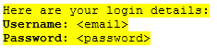

[Tech Note: user password is regenerated in this case, because WP passwords cannot be decoded once saved]

* + - * <link to UAG member page> opens [page ‘UAG Members’](#_Page_‘UAG_Members’);
      * <link to forum> opens [page ‘Forum’](#_Forum_1).
      * <link to FAQ> opens [page FAQ](#_Pages_‘About_Us’,).
      * ‘Send us an email’ opens page <https://www.echomeansbusiness.com/contact-us/>
      * Image at the bottom. [Tech Note: can be taken from here <https://drive.google.com/drive/u/0/folders/1scyJW1Z6JxAR2emkZIQtI5r6a6IJEbmh> ]

#### Page ‘Registration Promo’

This page should be used as a promo for registration process. [Tech Note: it should replace the existing registration page, but still have a possibility to access the standard registration page as well].

This page may look like this (for illustration only):

|  |  |
| --- | --- |
|  |  |

[Open Issue to Angelina: need a content, logo and testimonials <https://app.asana.com/0/0/1199665232895409/f>]

Controls description:

|  |
| --- |
| [Dev note: please use buttons below, because screen above is incorrect]   * - opens page to register with Google.   + URL: ‘**/register/?oauthWindow=true&provider=google**’ [Tech Note: take the right Google link on the Join page]; * - opens page to register with Facebook.   + URL: ‘**/register/?oauthWindow=true&provider=facebook**’ [Tech Note: take the right Facebook link on the Join page]; * - opens standard [Join page](#_Forgot_Password) in the same window. |
| - static content and list of images. No links |
| - static content, no links. |
| - opens the Website Home page in the same window. |

#### Register via Facebook

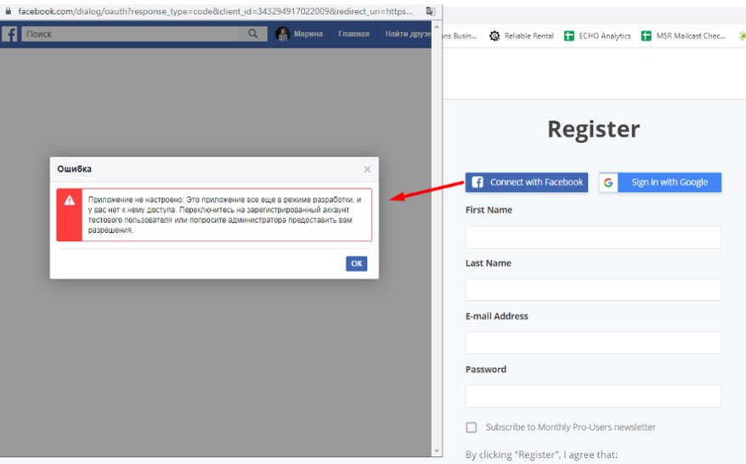

#### Register via Google

Registration via Google includes the following steps:

|  |  |
| --- | --- |
|  | |
| * "privacy policy" - <https://echo2.dev.our-projects.info/privacy-policy/> * "terms of service" - <https://echo2.dev.our-projects.info/terms-conditions/> | [Open Issue: Dima – remove Username] |
|  |  |
|  |  |

#### Adding New User via Admin Dashboard

Steps: [source case <https://app.asana.com/0/607038627868623/1199685257811786> ]

1. Add new Subscriber or member

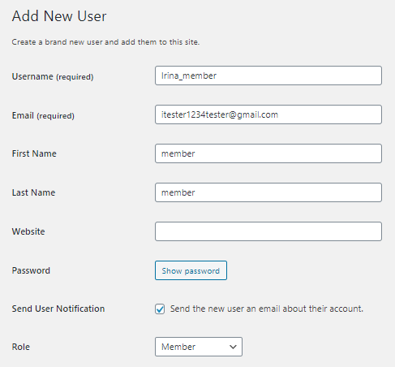

1. User receives the following emails:
   1. First email: WordPress email that his account was created: [PM: Possible need to deactivate it. But there is no such settings in Admin Dashboard. Ask Dima. This is not important, because we are not planning to add users via Admin dashboard]

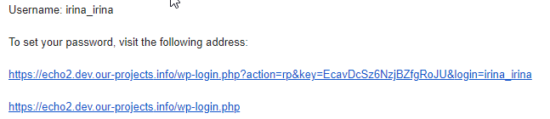

* 1. Second email: UltimateMember sends activation email:

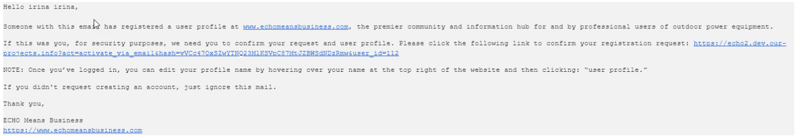

1. After activation user follows the existing registration workflow described above.

### Page ‘User Profile’

Requirements:

* Features:
  + Hide/deactivate the following features:
    - **Messages**, **Reviews**, **Bookmarks**, **Private Content**, Member directory, **Tags**, **Verified User**, **Groups, Posts**
  + Leave active:
    - Comments [Nov 19, 2020 users can leave comments for Pro Tips];
    - About
    - Activity
    - [Jan 19, 2021: I temporary disabled it in Phase 1] Badges
    - Forums
    - [Note Nov 19, 2020: These plugins below were installed by Sam request]
    - [Jan 19, 2021: I temporary disabled it in Phase 1] Friends
    - [Jan 19, 2021: I temporary disabled it in Phase 1] Followers
    - [Jan 19, 2021: I temporary disabled it in Phase 1] Following
    - [NOTE: Dec 26, 2020: I removed messages to avoid possibility for spammers to send messages] ~~Private Messages~~.
* Profile Fields

|  |  |  |  |
| --- | --- | --- | --- |
| **Name** | **Required** | **Privacy / Visibility** | **Type** |
| Business Name | Yes | Only visible to profile owners and admins /  View everywhere (edit and view mode) | Text, 100 chars |
| **Business Address** |  |  |  |
| Country | Yes | -//- | Drop-down with list of countries sorted by name in ascending order |
| Address Line 1 | Yes | -//- | Textbox, 100 chars |
| Address Line 2 | No | -//- | Textbox, 100 chars |
| City | Yes | -//- | Textbox, 100 chars |
| State / Province | No | -//- | Logic and fields:   * If **Canada** was selected, then:   + Drop-down with a list of provinces * If **USA** was selected, then:   + Drop-down with a list of states * Otherwise:   + ‘(no state / province)’.   Items in the drop-downs should be sorted in ascending order by name.  [Tech Note: utilize Edit Field->Choices Callback to return list of choices. Do not use conditional logic, because it will not work in Profile Completeness. Profile Completeness does not support conditional logic] |
| ZIP / Postal Code | No | -//- | Textbox, 20 chars |
| Phone Number | Yes | -//- | Textbox |
| **Occupation** |  |  |  |
| Employment Status | No | -//- | Drop-down, values:   * Default - empty * Owner * Employee |
| Type of Business | No | -//- | Drop-down, values:   * Default - empty * Lawn Service, * Landscape Contractor, * Arborist, * Tree Services, * Commercial Property Maintenance, * Golf Course, * Park Services, * Municipality, * Government Facility Maintenance, * School/Church/Cemetery, * Resort, * Other. |
| Number of Employees | No | -//- | Drop-down, values:   * Default - empty * <4, * 5-10, * 10-25, * >25 |

Example from existing website:

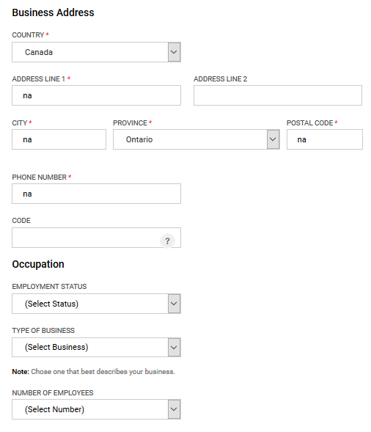

[Nov 10, 2020]

**The changes for User Profile are below:**

* NOTE: do not change button size, style, shape and font.

|  |  |
| --- | --- |
| Background color | * Change background color to #ededed |
| Complete your profile section | Place this block on the bottom right side of the page as shown on the mockup in Zeplin.   * Line: Change color to #7eb945. * Percent and completeness criteria: Change font color to #fa4616. |
| Buttons | * Update Profile button: Change color to #fa4616. The text is #fff. * Cancel button: Change color for the border and the text to #fa4616.   + When user hovers a mouse over this button, make it light-grey or light-orange.     **Important**: do not change button size, shape and font. |
| Messages | * Popup messages: Change color to #fa4616. The text is #fff. * Sens Message button: Change color to #fa4616. The text is #fff. * Border: Change color to #fa4616.      * Username: Change color to #7eb945. |

#### Profile Completeness

Include all fields from [Profile Fields] above into this feature.

* Give 10% for each field, except Address 1 and 2 - 5% each.

#### Email ‘Email Changed’

[Feb 24, 2021: I decided to disable sending these emails from WP]

This email is sent by WP (not by UltimateMember pluign) when user changes email address in the mobile apps

This is how it looks like in WP

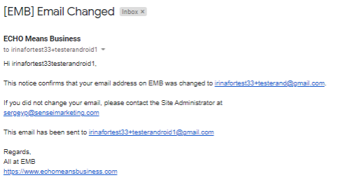

#### Page ‘User Subscriptions’

This page is build using plugin restrict Content pro (<https://restrictcontentpro.com/>) + its Pro Add-ons ‘Ultimate Member Integration’ (which is used to add Subscription into UltimateMember Profile)

[NOTE: for consideration, but not good]

|  |
| --- |
| UM and WooCommerce  <https://docs.ultimatemember.com/article/1493-how-to-change-user-role-after-subscription>  Integrate UM and Restrict Content Pro <https://suiteplugins.com/how-to-monetize-your-ultimate-member-community/>  Plugin for this <https://skillfulplugins.com/plugins/restrict-content-pro-ultimate-member/> |

Subscription may look like this (for illustration only):

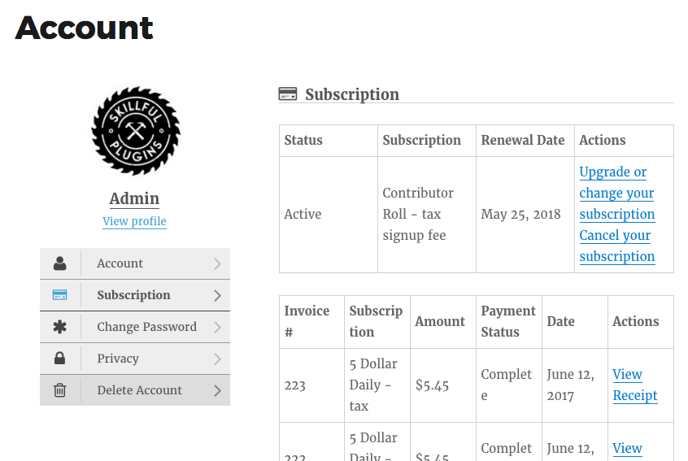

[Open issue to Dima: display ‘Membership Payment’ form if user does not have active subscriptions

<https://app.asana.com/0/1178924434621079/1200050593531093> ]

Clicking ‘Upgrade or Change your subscription’ will open [page ‘Membership Payment’](#_Page_‘Membership_Payment’) in the same page.

Clicking ‘View Receipt’ opens [page ‘View Receipt’](#_Page_‘View_Receipt’) in the same page.

##### Page ‘Membership Payment’

This page is used to buy or upgrade membership.

[Open Issue to Angelina: please confirm what payment gateway will be used? I recommend Stripe. We already have account for GMC]

[Tech Note: some details on this page may depend on a plugin which is used]

It may look like this (for illustration only)

|  |  |  |  |  |  |  |  |  |  |  |  |  |  |  |
| --- | --- | --- | --- | --- | --- | --- | --- | --- | --- | --- | --- | --- | --- | --- |
| **Membership Payment**  If you upgrade or downgrade your account, the new membership will be prorated up to $x for the first payment. Prorated prices are shown below.  Choose your membership level  (\*) Pro Member - $X.XX – 1 Year   |  |  | | --- | --- | |  |  | | Membership | **Amount** | | Pro Member | $X.XX | | Discounts and Fees |  | | Proration Credit | $X.XX | | Total Today | $X.XX | | Total recurring Per Year | $X.XX / Year |   Choose Your Payment Method:  (\*) PayPal ( ) Credit / Debit Card  Name on Card  [\_\_\_\_\_\_\_\_\_\_\_\_\_\_\_\_]  Credit Card  [\_\_\_\_\_\_\_\_\_\_\_\_\_\_\_\_\_\_\_\_\_\_\_\_\_\_\_\_\_\_\_\_\_\_\_\_\_\_]  [X] Auto Renew  Pay Now |

Controls description:

* All these fields are from the plugins and possible we do not have control to adjust them at all.
* [PM: check if possible to adjust the following:
  + Title when user purchase it or when user upgrade it
  + Button name – ‘Pay Now’
  + We do not need ‘Discount Code’

This is existing plugin page:

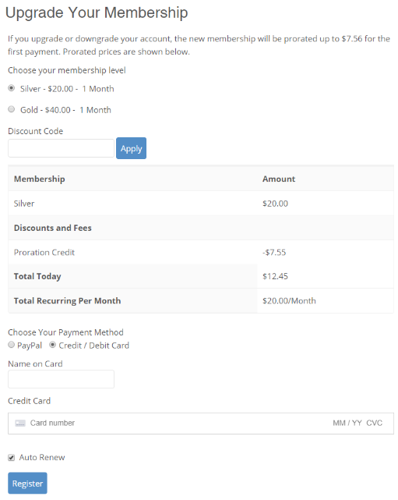]

Once user clicks ‘Pay Now’ then:

1. If there is an error, the it will be displayed on the page;
2. If everything OK then:
   1. User membership should be changed to ‘Pro Member’;
   2. Opens [page ‘Subscription Completed’](#_Page_‘Subscription_Completed’) in the same window.

##### Page ‘Subscription Completed’

This page opens when user completes a payment on the subscription page.

[Open Issue to Angelina: provide content <https://app.asana.com/0/1178924434621079/1200050593531081> ]

This page may look like this (for illustration only):

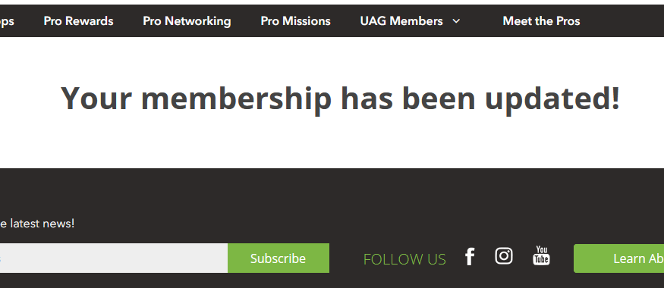

##### Page ‘View Receipt’

This page displays payment details.

[PM:

1. change logo and company name
2. check what BILL FROM should be – what name and address]

This page may look like this (for illustration only)

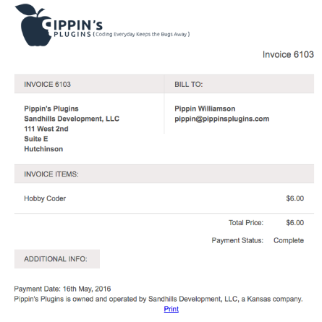

## Page ‘Pro Tips’

[PM: Nov 19, 2020: to me – describe points for Pro Tips – for comments, share and replies]

This is how this page looks like for all users.

It uses fields from a custom post [Pro Tips](#_EMB_Settings).

It may look like this (for illustration only), included into [Main Template](#_Template_‘Main’).

|  |
| --- |
| **[Pro Forum]**  **[Pro Rewards]**  **[UAG]**  **[Banner]** |

Controls description

|  |
| --- |
| **Section ‘Pro Tips’**    It is the same as it is on the [Home page](#_Page_‘Home’_1).  [Dev Note to Dima: if this block will be displayed on many pages, maybe make sense to implement it as shortcode with an option to select a featured article] |
| Sections ‘Latest Pro Tips’, ‘Pro User Tips’ and ‘Pro Biz Tips’ are the same as described in the section ‘Pro Tips’ on the [Home page](#_Page_‘Home’_1). |
| [NEXT VERSION: **Most Popular Tips**] |
| **Section ‘Tips by Category or Keyword’**    This section includes list of all pro tips tags sorted in ASC order. [Tech Note: do NOT add categories here, only pro tips tags].  Do not display this section if no tags  Clicking any tag opens page [‘Pro Tips by Category’](#_Pro_Tips_By) for clicked tag in the same window. |
| Section ‘Pro Forum’, ‘Pro Rewards’ and UAG are the same as on the [Home page](#_Page_‘Home’_1). |
| Section ‘Banner’. Can be provided later and coded like simple HTML block on a page. It does not require any description. |

### Page ‘Pro Tips – Details‘

This page displays pro tip details.

It uses fields from a custom post [Pro Tips](#_EMB_Settings).

[Tech Note: see pro tips fields in the Administrative Interface->[Manage Pro Tips](#_Manage_Pro_Tips)]

[NEXT VERSION: make restricted copy of this page for Public users. See example in Zeplin

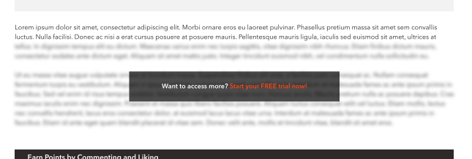

It may look like this (for illustration only), included into [Main Template](#_Template_‘Main’).

|  |
| --- |
| **[Leaderboard]**  **[Pro Rewards]**  **[UAG]**  **[Banner]** |

Controls description:

|  |
| --- |
| **Breadcrumb**    [NEXT VERSION: it is not correct in this creative. No need to display name and one article may have N categories] |
| **Pro Tip header**     * Pro tip title; * Author display name. **Custom Post->UAG Member**; * Published date in format: d mmm yyyy. Example: *3 October 2020.* |
| **Pro Tip details**  This is pro tip HTML content, which may include Text, HTML, Images and embed Video. |
| **Liking section**     * Like / Reset Like. See details in the chapter ‘[Set/Reset Like Status’](#_Set/Reset_Like_Status); |
| **Comment section**  Adding comments:   * This section is controlled by WP and is available for logged in users only. So, WP should display the text for not logged in users: “You must be logged in to post a comment”.   ‘Logged in’ it’s a link to [Login](#_Page_‘Log_In’_1) page.  List of comments may look like this:    See full description in the chapter ‘[List of Comments](#_List_of_Comments)’. |
| [March 30, 2021: from Maxim]  **Transcript section**  This section may look like this [Tech Note: collapse / expand can be similar to accordion on the FAQ page]    This section should be hidden if Post->Transcript is empty  Controls description:   * ‘Transcript’ – static text; * - by default – expanded.   + Clicking this will collapse or expand the transcript content. * [Post->Transcript](#_EMB_Settings). This is transcript content. |
| **Email, Print and Share section**    [NEXT VERSION: Email and Print]   * + List of social networks [Tech Note: not logged in users can share];     - * [Tech Note: examples were taken from this website: <https://www.morganstanley.com/articles/a-veterans-career-transition-to-investment-banking> ];         + LinkedIn.  |  | | --- | | Example:  [**https://www.linkedin.com/shareArticle**?**mini**=true&**url**=https://www.morganstanley.com/articles/a-veterans-career-transition-to-investment-banking&**title**=A%20Veteran%E2%80%99s%20New%20Mission&**summary**=%22Learn%20how%20his%20military%20training%20prepared%20this%20Associate%20in%20our%20London%20office%20to%20take%20on%20the%20fast-paced%20world%20of%20Global%20Capital%20Markets.%22](https://www.linkedin.com/shareArticle?mini=true&url=https://www.morganstanley.com/articles/a-veterans-career-transition-to-investment-banking&title=A%20Veteran%E2%80%99s%20New%20Mission&summary=%22Learn%20how%20his%20military%20training%20prepared%20this%20Associate%20in%20our%20London%20office%20to%20take%20on%20the%20fast-paced%20world%20of%20Global%20Capital%20Markets.%22)  Parameters:   * mini. Always ‘true’; * url. Full path URL on this post; * title. [Post->Title] * summary. [Post->Content]   NOTE: cannot prefill text or pass hashtag |  * + - * + Twitter  |  | | --- | | Example:  [**https://twitter.com/share**?**url**=https://www.morganstanley.com/articles/a-veterans-career-transition-to-investment-banking&**text**=A%20Veteran%E2%80%99s%20New%20Mission](https://twitter.com/share?url=https://www.morganstanley.com/articles/a-veterans-career-transition-to-investment-banking&text=A%20Veteran%E2%80%99s%20New%20Mission)  Parameters:   * url. Full path URL on this post; * text. Pro tip title; |  * + - * + Facebook  |  | | --- | | Example:  [**https://www.facebook.com/sharer/sharer.php**?**u**=https://www.morganstanley.com/articles/a-veterans-career-transition-to-investment-banking](https://www.facebook.com/sharer/sharer.php?u=https://www.morganstanley.com/articles/a-veterans-career-transition-to-investment-banking)  Parameters:   * u. Full path URL on this pro tip;   NOTE: cannot prefill text or pass hashtag |  * + The following content should be shared.     - Metatags details:  |  | | --- | | <meta property="og:title" content="<pro tip title>"/>  <meta property="og:description" content="< pro tip excerpt (if empty then generate excerpt from WP) >"/>  <meta property="og:site\_name" content="<website name from Settings>"/>  <meta property="og:url" content="<full path URL on this pro tip>"/>  <meta property="og:image" content="<full path URL to [image]>"/>  <meta property="twitter:card" content="summary\_large\_image"/>  <meta property="twitter:title" content="<pro tip title>"/>  <meta property="twitter:image" content="<full path URL to [image] as for **og:image**>"/>  <meta property="twitter:description" content="<the same as for **og:description**>"/>  <meta property="twitter:url" content="<full path URL on this pro tip>"/>  <meta property="twitter:creator" content="Echo Means Business"/> | |
| **Tags**    Display list of tags linked with this pro tip.   * If not tags, then do not display label and section * ~~Do not display tag which do not have other articles except this one;~~ * Sort tags by ASC order.   Each tag is a link on the page [‘Pro Tips By Category’](#_Pro_Tips_By) in the same window. |
| **Related Pro Tips**  This section displays 3 pro tips by the following algorithm:   * Get list of this pro tip tags; * Get all pro tips with the same tags, excluding the current pro tip; * Sort these pro tips by published date in descending order. Most recent at the beginning; * Display first 3 pro tips.   This section should be hidden if there are no related pro tips.    Each pro tip has fields described on the [Home page](#_Page_‘Home’_1). |
|  |

### Page ‘Pro Tips by Category’

This page displays list of pro tips for particular category or tag.

It uses fields from a custom post [Pro Tips](#_EMB_Settings).

It may look like this (for illustration only), included into [Main Template](#_Template_‘Main’).

|  |
| --- |
|  |

Controls description:

|  |
| --- |
| **Top section**  - this section displays ‘category name’ or ‘tag name’ and ‘Tips’.  Example:   * Category is ‘*Pro Biz*’, then name will be ‘*Pro Biz Tips*’; * Tag is ‘*Tutorial*’, then name will be ‘*Tutorial Tips*’.   All words should start with a capital char, even if they all lower case. |
| **List of Pro Tips**   * Display all pro tips in the selected category or tags sorted by published date in descending order. Mote recent at the top * Standard pagination. 15 results per page, style similar to the [Search page](#_Search_Results). |
| **Pro Tip**    It is the same as described for the slider on the [Home page](#_Page_‘Home’_1). |

## Page ‘Pro Forums & Fun’

[PM: configure Email FROM/Email for forum emails]

Forum page.

It may look like this (for illustration only), included into [Main Template](#_Template_‘Main’).

|  |
| --- |
| **[Mission of the Week]**  **[Pro Tips]**    **[UAG]** |

Controls description:

|  |
| --- |
| **Top banner**    This is any simple HTML block. Can be edited via page LivaCanvas |
| **List of forums**    This is WPForum plugin.  [Tech Note: Feb 5, 2021: I have to remove search from this section, because does search only forums, not topics or replies. This is how plugin works ☹] |
| **Leaderboard**    The same as described on the [Home page](#_Page_‘Home’_1). |
| Sections ‘Mission of the Week’ and ‘UAG’ are the same as on the [Home page](#_Page_‘Home’_1). |
| **Pro Tips**  It is described in the [section Appendix->‘Pro Tips’](#_Section_‘Pro_Tips’). |
| **Check These Out**  It is described in the [section Appendix->‘Check These Out’](#_Section_‘Check_These).  It should display **these 3 tabs only** on this page:   * Pre Rewards (selected by default), Pro Workshops and ‘Pro Networking’. * All other tabs from this section are hidden on this page. |

### Page ‘Pro Forums & Fun – Details’

It may look like this (for illustration only), included into [Main Template](#_Template_‘Main’).

|  |
| --- |
| [Content of this page will be dynamically build by WPForum plugin for individual Forum and Topics] |

[Note: user can’t delete his own reply, check the task in Asana: <https://app.asana.com/0/1199231975176305/1199683784545181/f> LOW priority task]

### Forum Admin Emails

Creative example from Zeplin: [source case <https://app.asana.com/0/1178924434621079/1199685257811782> ]

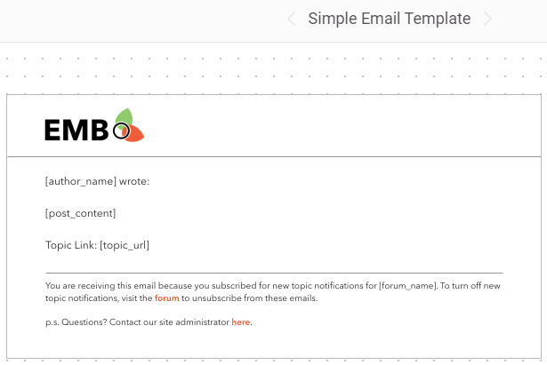

These are emails which will be automatically sent to forum users.

[Tech Note: See Forums->Settings-Emails]

|  |  |
| --- | --- |
| **Email** | **Content** |
| Mentioned |  |
| New Topic |  |
| New Reply |  |

## Page ‘Pro Rewards’

Features:

* This module will allow PRO members to access all negotiated partner offers available.
  + Partners could include non-competitive manufacturers, retailers, entertainment companies, and travel companies.
* Basic members will be given access to 1 or 2 different “sample offers” each month as a teaser for what’s available to PRO members.

It uses fields from a custom post [Offers](#_Offers).

It may look like this (for illustration only), included into [Main Template](#_Template_‘Main’).

|  |
| --- |
| **[Leaderboard]**  **[UAG]**  **[Banner]** |

Controls description:

|  |
| --- |
| **Top banner**  Top banner depends on [user role/membership](#_Membership_/_User). [Tech Note: use UM shortcode to show hide content which depends on user role]  All content. Will be managed via admin panel – LiveCanvas.  [NEXT VERSION: use different top banners for each membership]  [NOTE: Nov 21, 2020: Phase 1. Single banner for all memberships]     * Where [View Offer] is a link on the corresponding [‘Pro Reward – Details’ page](#_Page_‘Pro_Reward) in the same window. |
| **Offers**   * It allows to filter and display list of [published] offers * Filter.   + Category. Drop-down with the following values:     - *All*. Select by default and should be the first in the list. If selected, then all offers are displayed     - *<list of categories>* - all offers categories sorted by category name in ascending order.       * If category does not have [published] offers inside, then do not display this category. * List of [published] offers according the filter, sorted by [published date] in ascending order (recent offers are at the top).   + No pagination. Display all offers whatever filter is selected;   + Offer tile. The whole tile is clickable and opens [‘Pro Reward - Details’ page](#_Page_‘Pro_Reward) in the same window.  |  | | --- | | *Section ‘Offer availability’*    It depends on [Offer->[Availability Mode]](#_Offers) field:   * If ‘Basic and Pro’, then display ‘**ALL MEMBERS**’ block * If ‘Pro Only’, then display ‘**PRO MEMBERS ONLY**’ block | | *Section ‘Offer tile image’*    This is [Offer->[Tile image]](#_Offers). | | *Section ‘Details’*     * Category name. If offer has more than one category, show only one in ASC order; * Offer title; * Button – opens [‘Pro Reward - Details’ page](#_Page_‘Pro_Reward) in the same window. | |
| Section ‘Leaderboard’ and ‘UAG’ are the same as on the [Home page](#_Page_‘Home’_1).   * NOTE: ‘Leaderboard’ should take the whole page width. See creative in Zeplin. |
| Section ‘Banner’. Can be provided later and coded like simple HTML block on a page. It does not require any description. |

### Page ‘Pro Reward - Details’

This page displays offer details.

It uses fields from a custom post [Offers](#_Offers).

It may look like this (for illustration only), included into [Main Template](#_Template_‘Main’).

|  |
| --- |
| [Mar 19, 2021: from Angelina: hide this] **[Check These Out]**  [Mar 19, 2021: from Angelina: hide this] **[Leaderboard]**  **[UAG]**  **[Banner]** |

Controls description:

|  |  |
| --- | --- |
| **Section ‘Details’**   |  | | --- | | *Section ‘Offer availability’*    It depends on [Offer->[Availability Mode]](#_Offers) field:   * If ‘Basic and Pro’, then display ‘**ALL MEMBERS**’ block * If ‘Pro Only’, then display ‘**PRO MEMBERS ONLY**’ block |   - Offer title  - [Offer->[Offer logo]](#_Offers) field. If no offer logo, then do not show it.  - Offer content |
| **Section ‘Redeem’**  Content of this section depends on [user membership](#_Membership_/_User) and Offer->[Availability Mode]:    Redeem Now content:   |  |  |  | | --- | --- | --- | | **Membership** | **Offer Availability Mode** | **Content** | | FREE | - Basic and Pro  - Pro Only | ‘Free’ and ‘Start My Free Trial!’ opens the [Registration page](#_Forgot_Password) in the same window.  [PM: maybe need to open Membership Pricing page. But this page is not ready yet and I am not sure how it is possible to integrate existing registration page and restricted Content Pro pages.  So, in the current version user will register first, and then he/she can upgrade his membership to Pro] | | Basic | Basic and Pro | This button will open [How to Redeem popup](#_Popup_‘How_to).   * Each offer will have individual content inside that popup. | | Basic | Pro Only | ‘Pro Member’ and ‘Join Now’ opens the [‘Membership Subscription’ page](#_Page_‘Membership_Subscriptions’) in the same window. | | Pro | - Basic and Pro  - Pro Only | The same as for [Membership] = Basic and Availability = [Basic and Pro]   * See description above. | |
| **Section ‘Share’**    The same as described on the [page ‘Pro Tips -Details’](#_Page_‘Pro_Tips), but with these parameters   * + - Metatags details:  |  | | --- | | <meta property="og:title" content="<offer title>"/>  <meta property="og:description" content="< offer excerpt (if empty then generate excerpt from WP) >"/>  <meta property="og:site\_name" content="<website name from WP Settings>"/>  <meta property="og:url" content="<full path URL on this offer>"/>  <meta property="og:image" content="<full path URL to [tile image]>"/>  <meta property="twitter:card" content="summary\_large\_image"/>  <meta property="twitter:title" content="<offer title>"/>  <meta property="twitter:image" content="<full path URL to [tile image] as for **og:image**>"/>  <meta property="twitter:description" content="<the same as for **og:description**>"/>  <meta property="twitter:url" content="<full path URL on this offer>"/>  <meta property="twitter:creator" content="Echo Means Business"/> | |
| **Liking section**     * Like / Reset Like. See details in the chapter ‘[Set/Reset Like Status’](#_Set/Reset_Like_Status); |
| **Comments section**  Adding comments:   * This section is controlled by WP and is available for logged in users only. So, WP should display something asking to log in to leave a comment     Comment section is the same as described for the page [‘Pro Tips – Details’](#_Pro_Tips_–).  [NEXT VERSION: add points] |
| [Mar 19, 2021: from Angelina: hide this section]  **Check These Out**  It is described in the [section Appendix->‘Check These Out’](#_Section_‘Check_These).  Display these **4 tabs only** on this page.   * Forum & Fun (*selected by default*), Pre Rewards, Pro Workshops and ‘Pro Networking’. * All other tabs from this section are hidden on this page. |
| [Mar 19, 2021: from Angelina: hide this section]  Section ‘Leaderboard’ and ‘UAG’ are the same as on the [Home page](#_Page_‘Home’_1).   * NOTE: ‘Leaderboard’ should take the whole page width. See creative in Zeplin. |
| Section ‘Banner’. Can be provided later and coded like simple HTML block on a page. It does not require any description. |

#### Popup ‘How to Redeem’

This popup shows instructions how to redeem this offer.

Each offer may have different instructions.

Popup may look like this (for illustration only):

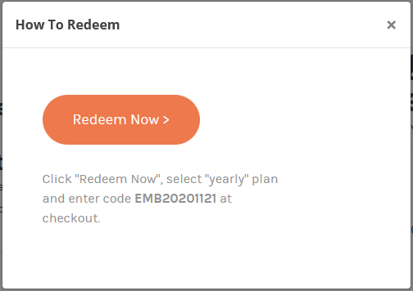

Controls description:

* This content is taken from [Offer->[How To Redeem] field](#_Offers). See details in the [chapter Admin Interface-> Offers](#_Offers).

## Page ‘Pro Workshops’

[Note Nov 21, 2020 from Sam: Just promotional content – no actual videos or functionality available to any member at this time.]

It may look like this (for illustration only), included into [Main Template](#_Template_‘Main’).

|  |
| --- |
| **[Leaderboard]**  **[UAG]**  **[Banner]** |

Controls description:

|  |
| --- |
| The main page content is ‘Coming Soon’.  Actual content and functionality will be provided in Phase 2. |
| Section ‘Leaderboard’ and ‘UAG’ are the same as on the [Home page](#_Page_‘Home’_1).   * NOTE: ‘Leaderboard’ should take the whole page width. See creative in Zeplin. |
| Section ‘Banner’. Can be provided later and coded like simple HTML block on a page. It does not require any description. |

[NEXT VERSION: all description below are for next phase, not for Phase 1 =>

[PM: Nov 19, 2020 from Sam - describe

<https://app.asana.com/0/607038627868623/1199155964593989>

|  |
| --- |
| **Summary of New Functionality:   “Workshops”   General:** Collection of videos posted for paid Pro Members to access, intended to offer educational content to members across a variety of topics.  **List of Workshops** –  Workshops are not date-specific like Networking Events. These are permanent videos posted to the site searchable by category/sub-category. I suggest we also add tags to each for additional filtering options. [Open Issue: I recommend to keep it simple: one category and videos, without sub-category. Usually people do search by keywords, not by category or sub-category]  [SF Thank you, Sergey. However, we will have a lot of videos in a year and we’ll need to have such categorization for a better user experience when browsing the site)]  Example:  PRO WORKSHOPS   [Summary Listing Page]  CATEGORY: BUSINESS  Subcategory: Sales & Marketing  Subcategory: Operations and HR  Subcategory: Billing and Finance  CATEGORY: LAWN CARE  Subcategory: Tools & Maintenance  Subcategory: Planning & Design  CATEGORY: LANDSCAPE  Subcategory: Tools & Maintenance  Subcategory: Planning & Design  CATEGORY: HARDSCAPE  Subcategory: Tools & Maintenance  Subcategory: Planning & Design  AK note: Note that this has to be reflected in our footer  https://lh6.googleusercontent.com/MikFO13i3orDRUBEYRUQsy6CFETkdQy0VNDUscTCxNC7By0rmgy0elD69g8LBS60HNmex8M-eRILPgZhbsyiBNUMRVt63yIM7mT7tCnKhA4QlEKcEJ8JnRXbp5RT4PUkrw7rcVw  Within each sub-category we could have 1 to N videos of various lengths.  Clicking on any of these opens Workshop Detail Page [Open Issue: So, the Details page is for each Video, not for each Sub-category? The page below is a subcategory details page? ]  [SF: For phase one, I think we only need a detail page for the specific video, not for category or subcategory pages. Each PRO Workshop video will be individual and listed under Category/Subcategory. We will not have courses with Lesson 1, Lesson, 2...etc. within as shown in this mock up.  )]  https://lh3.googleusercontent.com/Twc5gduv0VX5xoePHvZi_nkpXIldHe6reCK_RUkPOsOvyMqGnqCZGkrxtuZxOc5gxLYqUi0oLOKyImVzfETsZ9I9h8BjzJ4QsQNVNTTE2LoLSA7alH8g4C5RWWPIkGDtqd4edPE  Each video could have one or more tags associated to it, which are clickable to sort onscreen listing to showcase all videos using that tag, such as “Trimmer” or “Backpack Blower”. Tags should be able to be created by site admin only.  TBD: Hosting platform. We want these videos to only be viewable on our site and only to Pro-Members who are either on trial or permanent Pro member status.  Can this be done with Vimeo? Or do we need a hosting platform?   NOTE: As this is a paid membership access video, we can’t have 3rd party advertising appear before or during the video. [SP>Vimeo should not allow you to download videos. Also paid plan does not display any ads or related videos like YT]  The Workshop Detail page should include: [Open Issue: there is no creative yet. Correct? At least I did not find it in the Zeplin] [SF: Not that I am aware. [Angelina Kwok](mailto:angelina@senseimarketing.com) ]  AK: There is creative but needs to be edited now based on this document. I will get this revised.   * Thumbnail image * Full image (based on page design) * Title * Description * Workshop leader (name of person delivering the workshop) * Length of workshop * [future phase] Recommended for: “Beginner”, “Intermediate”, or “Expert” * [future phase] Preview trailer (short teaser video) * List of recommendations (manually added) * Watch Now button [Open Issue: One workshop - one video only. Is it possible that one workshop can have N videos? If yes, then we need to rethink about structure of workshops and what will be displayed in listing]  [SF: All Workshops will be singular for this year. ] * Share Function * Star Rating ( 1 – 5 star rating) * “Recommend This Workshop”  [Allows user to leave a written testimonial for the Workshop (max 500 characters?).   + When added, user must click “accept terms and conditions” and then “submit recommendation.”   + Recommendations are saved to the database and accessible by admin user   + Admin user can add testimonials to the Workshop detail page per page design   **Accessing Workshops**   * All videos can be accessed by anyone with a Pro Member status. * Public and Basic users can see the page with listings but cannot view the video. (NOTE: In future phases, we may have a video trailer for each workshop video that the public can view) [Open Issue: but they can open Video page details, in other case no sense to share it. Correct?][SF: Yes, all users can open/view the detail page (just like public users can open RLG offer detail page) but only PRO users can click to view videos] AK: Sergey – can you let me know how this page should be mocked-up for public users, if required? * There is no limit to the number of workshops members can have. [Open Issue: Video and workshop are synonyms (the same here)?  [SF: Yes, I’m sorry. “Workshop” is a “Video” ]] * Workshop links/images should be able to be shared via social media, email, etc. like other content; however, the video should not be viewable to anyone who is not a Pro Member. [Open Issue: allow to share video page details, but play video for Pro Members only. Correct?] [SF: Yes, detail page can be shared but only PRO members can open the video. When a non-PRO member tries to view the video, message appears that this Workshop is for PRO members only with link to “Enroll” or “Log In”. [Angelina Kwok](mailto:angelina@senseimarketing.com) I think we need Laura to provide creative for this. [Robert Clarke](mailto:robert@senseimarketing.com) do we need to have a plan to add non-PRO members to contact database? How do we help convert them here? ]   **Poll**   * At the end of the video, Pro Members should be presented with a short poll asking 5 questions about the video they watched. * Question: I would like the poll to ONLY display once the video is fully viewed by the member. Is this possible? [SP: Vimeo provides API to check if people viewed till the end, but they cannot guarantee if a user scrolled to the end or watched till the end. Also, it can confuse people if we open Poll immediately after they watched it, because they may want to watch it again. System should be very flexible. I recommend less restrictions and rules in Phase 1, so we can adjust them later after using a month or more] [SF: Because we are offering points and badges for completing Workshops, we need some mechanism/business rule to know they are not simply clicking on videos or just answering poll without watching video? I’m open to suggestions] * They must complete the poll by answering the questions (either yes/no or multiple-choice answers). [Open Issue: what happens if they do not answer it properly or do not want to answer? Do not allow to watch other videos, other sub-categories? I would recommend to skip it or to move this requirement into NEXT PHASE. If people already paid for videos (for membership), why should we restrict them by Polls?] [SF:This is not a test where a specific grade is required. All Worskshop videos are singular and not dependent on others to be watched or completed (for this year). However, I would like to consider if we can make “successfully answered” poll questions (E.g. only allow one incorrect answer) before the user gets points for completing the Workshop?? ] * The poll would be the same format but different questions for each workshop video * When the survey is completed, the user should get an on screen confirmation and any associated points or badges should be awarded at this point (see points/badges)   AK: Sergey – sometimes polls can be embedded in videos. Is this something Vimeo can support, or shall I get a mock-up for this too? Will it overlay the video? |

]

-//-

[PM: Nov 19, 2020

Recommend this workshop (this will be a written testimonial as opposed to share)

Let's create a pop-up form for this. Include "accept terms & conditions" check box; submit recommendation button

This is only for Pro-users

Public and basic users can see all the info but cannot actually see the video - they must sign-in/register for this. So perhaps this should be a pop-up?

[@Sergey Peregud](https://app.asana.com/0/571416341975099/list) - FYI. I have not included the things for phase 2 (preview workshops, level of workshop (intermediate, beginner, etc). I have also not included the poll as I'm not sure how it will function as discussed in [Workshop Summary](https://app.asana.com/0/0/1199155964593989).

Hi @Sergey Peregud Workshop Details Page has changed and uploaded onto Zeplin if you'd like to review over them. We just changed the top section of this page which you can see in the image references below. We have included a "recommendation pop-up" where if they click the recommendation button - a pop-up will appear and they can submit a review.

Public Users/Basic Member = 1 Screen

Pro Member = 1 Screen

You can find these screens under section: Pro Workshops - Details Page



|  |
| --- |
| **[Pro Tips]**  **[Leaderboard]**  **[UAG]** |



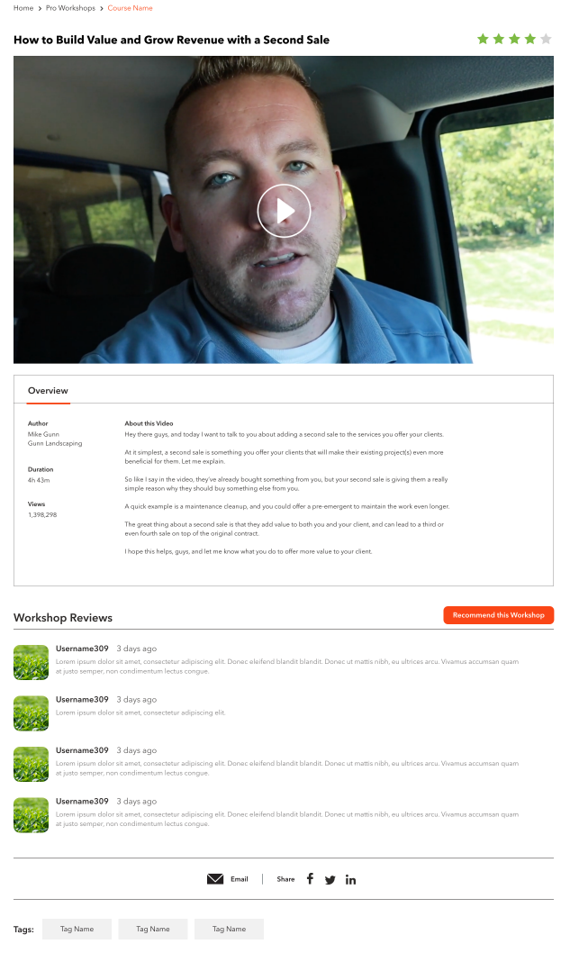

Why do we need this popup:

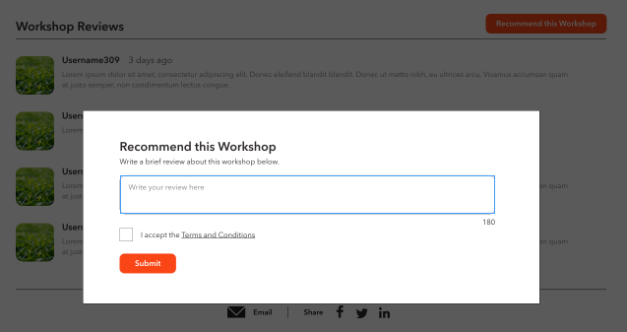

]

Features:

* on-site notices, and push notifications to the Mobile App will alert member of the available course, and remind participants when the next lesson is ready to complete.
* The curriculum will include multi-chapter, multi-lesson courses. Example:
  + **Marketing Course**
    - Lead Generation Lesson / Test [Open Issue: what does it mean ‘TEST’? How it should work?];
    - Website Optimization Lesson / Test
    - Social Media Marketing / Test
    - Referrals and Influence Marketing Lesson / Test
  + **Human Resource Course**
    - Hiring & Managing Students / Test
    - Retaining Staff Throughout Winter / Test
  + **Operational Courses**
    - Maintaining Equipment – Best Practices / Test
    - Maintaining Equipment in the Off Season / Test
* Summaries for each lesson will be available to all;
  + however, each lesson must be completed before the next lesson can be fully accessed and completed. A short survey will be presented at the end of each video lesson to ensure understanding of the concepts presented. [Open Issue: are lessons – only videos? Can it include text and images for example or mix of all? Where videos will be hosted: on website, CDN, Youtube? It is not so important, but can affect fucntionality];
* Lessons can be watched/completed on any device and at any time.
  + There’s no time limit on the curriculum’s completion (unless desired).
* Certificate of completion, which will be awarded to participants in the year the curriculum was completed. [Open Issue: please provide creative how page with a certificate may look like. Also need creative for certificate – is if PDF?];
* Additional rewards such as online badges and website widgets will be developed so that completion of the curriculum may be used as a status and certification on the members website and social media.
* Offer a “lite version” of the curriculum for non-subscribed professionals. [Open Issue: I would recommend to have a ‘lite’ version as a separate curriculum, not like a restricted part of the exiting one. So ‘lite’ version should not be available for PRO members. Correct?]

[Open Issue:

MOBILE:

* please provide creative for mobile:
  + lists
  + curriculum details]

[Oct 1, 2020 from team call]

|  |
| --- |
| Phase 1   * series workshop * one program * series of videos in different categories * can watch on demand * [PM: Do we need a stream video services for video?] * How to track watch video – it depends on a video streaming approach * Want to know who watched till the end * Track when people drop-off * Add poll or survey at the end   + 5-6 questions   + Unlock other video after answers |

## Page ‘Pro Networking’

This page displays active and passed events.

It may look like this (for illustration only), included into [Main Template](#_Template_‘Main’).

|  |
| --- |
| **[Leaderboard]**  **[UAG]**  **[Banner]** |

Controls description:

|  |  |  |  |  |  |  |  |  |  |
| --- | --- | --- | --- | --- | --- | --- | --- | --- | --- |
| **Top banner**  [Mar 9, 2021: temporary use the following banner for all user groups]   |  | | --- | |  |   Top banner depends on user membership:   |  |  | | --- | --- | | **Membership** | **Details** | | FREE | Example:  Clicking ‘Start My Free Trial’ opens [Registration page](#_Forgot_Password) in the same window. | | BASIC | Example:    Clicking ‘Become a Pro member’ opens [‘Membership Subscriptions’ page](#_Page_‘Membership_Subscriptions’) in the same window. | | PRO | NO top banner for this membership for now. | |
| **Upcoming Events**    This section displays all upcoming events.   * Upcoming event mean ([[Event Date] + [Start Time]](#_Events)) > (current date/time). [Tech Note: Event Date and Start Time are in EST for each event. So, need to convert user local time into EST before comparing these date/time]; * If there are no upcoming events, then this section is empty;   + Black horizontal bar is also should not be displayed * Sort events by [[Event Date] + [Start Time]](#_Events) in DESC order. Means show those which will happen soon at the top; * Each event includes. The whole section is a link to open [‘Pro Network - Details’ page](#_Page_‘Pro_Networking) in the same window. See event fields description in [Admin->’Events’ chapter](#_Events):   + Tile Image;   + Event Date and Start Time;      * + - Date format: <short weekday name>, <short month name> <day>     - Time format: 12hr format.   + Event title;   + Tile Short Description;      * + Button ‘Event Details’. This is a link to open [‘Pro Network - Details’ page](#_Page_‘Pro_Networking) in the same window.   + Button ‘Add to Calendar’. It opens [‘Add to Your Calendar’ popup](#_Popup_‘Add_to) to select what type of calendar to use.   + Share. This is the list of social networks:      * Facebook, * Twitter, * Linkedin. |
| **Past Events**    This section displays past event where ([[Event Date] + [Start Time]](#_Events)) >= (current date/time). [Tech Note: Event Date and Start Time are in EST for each event. So, need to convert user local time into EST before comparing these date/time]   * If there are no past events, then this section should be hidden including the black top horizontal bar; * Sort events by [[Event Date] + [Start Time]](#_Events) in ASC order. Recent at the top; * Each event includes. The whole section is a link to open [‘Pro Network - Details’ page](#_Page_‘Pro_Networking) in the same window. See fields description in the ‘*Upcoming*’ section above.   + Tile image;   + Event title;   + Tile short description;   + Button ‘Watch Now’. This is a link to open [‘Pro Network - Details’ page](#_Page_‘Pro_Networking) in the same window. * Show max 5 events * Button ‘View More’. Clicking ‘View More’ opens additional 5 events at the end of the list:      * + Hidden if there are less than 5 events.   + Hidden if all events are collapsed/shown. |
| Section ‘Get to know Pro Members’. It’s described in details in [Section ‘Get to Know Pro Members’](#_Section_‘Get_to_1). |
| Section ‘Leaderboard’ and ‘UAG’ are the same as on the [Home page](#_Page_‘Home’_1).   * NOTE: ‘Leaderboard’ should take the whole page width. See creative in Zeplin. |
| Section ‘Banner’. Can be provided later and coded like simple HTML block on a page. It does not require any description. |
| [NEXT VERSION: add a filter like this or like here: <https://demo.theeventscalendar.com/>    ] |

### Page ‘Pro Networking - Details’

This page displays event details.

Page content depends on [user membership](#_Membership_/_User) and Post->[Availability Mode].

It may look like this (for illustration only), included into [Main Template](#_Template_‘Main’).

|  |
| --- |
| **[Leaderboard]**  **[UAG]**  **[Banner]** |

Controls description:

Legend:

* ***Event State***: [Tech Note: Event Date and Start Time are stored in EST for each event. So, need to convert user local time into EST before comparing these date/time]
  + **Active Event**: ([[Event Date] + [Start Time]](#_Events)) < (current date/time).
    - It means that event is not passed yet;
  + **Past Event**: ([[Event Date] + [Start Time]](#_Events)) >= (current date/time).
    - It means that this event passed.

|  |
| --- |
| - this is post title. |
| this is Post->[Event Date] and Post->[Start Time].  If *Event State* is **Past**, then if it should be a grey like this: |
| **Access section**    This section visibility and content depends on user [Membership](#_Membership_/_User) and Post->[Available Mode].   |  |  |  |  | | --- | --- | --- | --- | | **Membership** | **Post-> [Available Mode]** | **Details** | | | **Active Event** | **Past Event** | | FREE | Any type | [PM: decide what should be displayed later in this section – need say something ‘RSVP this session Now, …’]  [Mar 9, 2021: temporary] Do not display this section | Content of this section should be taken from [Content Blocks](#_Content_Block), because in such case we can easily modify its HTML content via LiveCanvas.  Name of this section in the Content Blocks should be ‘*Pro Networking – Restricted Access – Start Free Trial*’.  Clicking ‘FREE’ or button opens [Registration page](#_Forgot_Password) in the same window. | | BASIC | - Pro Only | [PM: decide what should be displayed later in this section – need say something ‘RSVP this session Now, …’]  [Mar 9, 2021: temporary] Do not display this section | Content of this section should be taken from [Content Blocks](#_Content_Block), because in such case we can easily modify its HTML content.  Name of this section in the Content Blocks should be ‘*Pro Networking – Restricted Access – Join Now*’.  Clicking ‘Pro Member’ or button opens [Membership Subscriptions page](#_Page_‘Membership_Subscriptions’) in the same window. | | BASIC | - Basic and Pro | Do not display this section | | | PRO | Any type | Do not display this section | | |
| **Event content section**  This is Post->[Event Content]. Any HTML content including a video.  Its visibility depends on user [Membership](#_Membership_/_User) and Post->[Available Mode]. See below:   |  |  |  | | --- | --- | --- | | **Membership** | **Post-> [Available Mode]** | **Section ‘Event Content’** | | FREE | Any type | Hidden | | BASIC | Pro only | Hidden | | BASIC | Basic and pro | Visible | | PRO | Any type | Visible | |
| This is Post->[Content]. Any content which describes this post.  It is visible for all users, so it should not include Membership dependable content or details. |
| **RSVP section**  This section is used for Active Events only and allows members to select if they are Going or Not.    Its visibility depends on user [Membership](#_Membership_/_User) and Post->[Available Mode]. See below:   |  |  |  |  | | --- | --- | --- | --- | | **Membership** | **Post-> [Available Mode]** | **RSVP** | | | **Active Event** | **Past Event** | | FREE | Any type | ~~Hidden~~  [Mar 9, 2021: temporary solution below from Sam]  Make these items visible:   * date/time * link on event   + should be hidden if not provided * link on a calendar are visible | Hidden | | BASIC | Pro only | Hidden | Hidden | | BASIC | Basic and pro | Visible | Hidden | | PRO | Any type | Visible | Hidden |   Controls description:   |  | | --- | | - Post->[Event Date] in format: ‘Monday, December 10’. | | - Post->[Start Time] and Post->[End Time] [Tech Note: Convert times from EST to local client time] | | - this is a link on Post->[Event URL] in a new window. Should be hidden if not provided | | opens [‘Add to Your Calendar’ popup](#_Popup_‘Add_to) to select what type of calendar to use. | | **Going/Not Going section**  - These how these buttons look like by default.  When user clicks ‘*Going*’ then:   * System sends [email ‘Event Details’](#_Email_‘Event_Details’) to this user as described in Post->[section ‘Event Details Email’];   + Use these fields from *Post->[section ‘Event Details Email’]* for sending email:     - [FROM Name];     - [FROM Email];     - [Subject];     - [Body]. * System adds this user details into Post->[Attendee] with [Status] = ‘*Going*’, including date/time when email above was sent; * Changes the section on this one:  |  |  | | --- | --- | | If more than one users are going. [Tech Note: you can get how many people are going checking Post->[Attendee]->[Status]]. | This is how it looks like if only this user is going. |  * + Clicking ‘Change your RSVP’ opens a popup to change status. This popup may look like this:      * + - Clicking ‘*Going’* just closes the popup without any changes in RSVP status. This is because user already has ‘*Going*’ status;     - Clicking ‘Not Going’ does the following:       * Changes Post->[Attendee]->[Status] on ‘*Not Going*’ for this user;       * Display RSVP section as described below for ‘*Not Going*’ status;       * Closes the popup.     - Clicking ‘Cancel’ just closes the popup without any changes in RSVP status for this user.   When user clicks ‘*Not Going*’:   * If user does not exist in Post->[Attendee]->[User] yet, then adds a new record, otherwise update [Status] to ‘*Not Going*’ for the existing one:   + [User] – user ID;   + [Status] = ‘Not Going’;   + [Details email sent at] – no changes in this field. If it was previously provided when user set ‘*Going*’, then do not reset it, in other case next time if user clicks *Going,* then system will send event email again to user => as a result user will may receive a lot of duplicated emails. * Section is changed on this one below (‘*Not Going*’ button is selected): | | - this is how many members are going. If there are no going members in Post->[Attendee] (where [Status]=*’Going*’), then do not display this section.   * if one member then ‘1 member is going’; * if 2 or more then ‘X members are going’. | |
| **Share section**    The same as described on the [page ‘Pro Tips -Details’](#_Page_‘Pro_Tips), but with these parameters   * + - Metatags details:  |  | | --- | | <meta property="og:title" content="<post title>"/>  <meta property="og:description" content="< post excerpt (if empty then generate excerpt from WP) >"/>  <meta property="og:site\_name" content="<website name from WP Settings>"/>  <meta property="og:url" content="<full path URL on this post >"/>  <meta property="og:image" content="<full path URL to [tile image]>"/>  <meta property="twitter:card" content="summary\_large\_image"/>  <meta property="twitter:title" content="<post title>"/>  <meta property="twitter:image" content="<full path URL to [tile image] as for **og:image**>"/>  <meta property="twitter:description" content="<the same as for **og:description**>"/>  <meta property="twitter:url" content="<full path URL on this post>"/>  <meta property="twitter:creator" content="Echo Means Business"/> | |
| **Liking section**     * Like / Reset Like. See details in the chapter ‘[Set/Reset Like Status’](#_Set/Reset_Like_Status); |
| **Comments section**  Adding comments:   * This section is controlled by WP and is available for logged in users only. So, WP should display something asking to log in to leave a comment     Comment section is the same as described for the page [‘Pro Tips – Details’](#_Pro_Tips_–).  [NEXT VERSION: add points] |
| **Section ‘Get to Know Pro Members’**    This section is described in the [chapter ‘Section ‘Get to Know Pro Members’’](#_Section_‘Get_to). |
| Section ‘Leaderboard’ and ‘UAG’ are the same as on the [Home page](#_Page_‘Home’_1).   * NOTE: ‘Leaderboard’ should take the whole page width. See creative in Zeplin. |
| Section ‘Banner’. Can be provided later and coded like simple HTML block on a page. It does not require any description. |

[NEXT VERSION: review missing details]

|  |  |
| --- | --- |
| <https://app.asana.com/0/607038627868623/1199155964593988>  **Summary of New Functionality:   “Networking”   General:** List of future Zoom meetings listed for member review and registration. Zoom meetings will be recorded and posted to “Networking” section of the site for review by all Pro Members.  **List of Networking Events** – Presented by Date (most recent), and can follow similar layout to what we did for CPA’s Powered by Payroll  **https://lh3.googleusercontent.com/SUKxUPz6PVyOBwMJDcYCFi-MZtVkn80P47fxy0-TPScOmM162B3kZfpfEn1ikRyOC_KrCLZLDD0Pdfi8LfMXG93oPATsEMvuetuUFOw6DRaRUQVQD0HqSU_mp1wjKRzJ-RIFtqc**  **Setting up Networking Event:** Admin user will create Networking Event via CMS (if possible [SP: Yes]) by adding event name, event description, event host (optional), special guest (optional), date, start time, end time, webinar log in information.  Presentation of the data is based on style guide for the section [SP: I think it is not important how admin interface will look like]. [SF: I didn’t mean admin interface, I meant it should fit in the public-facing site style guide]  **Registration for Events (phase one)** -   1. Pro Member [Open Issue: only Pro Members can register. Corect?] [SF: Correct.]clicks “Register for this Event,” which opens review/confirmation pop up or screen:   You are registering to attend this EMB Pro Networking Event:  Event Name: Event Date: Event Time:   Your Name:  Your Email Address:   <confirm\*>   [Open Issue: why need to ask to confirm email, if they already logged in? I would recommend to use one email for all cases to simplify workflow and functionality] [SF:I am OK removing this. You are correct that we have their email address if they are logged in. My question: Is there any value in pre-populating their email address so we can continuously confirm that we’re using the right email address for them? I’m OK removing it if you don’t think this is necessary]  AK: Note in the future that some events will be available to basic users. Not for phase 1.  \*by confirming your participation, you agree to EMB Community Rules and Terms and Conditions.   1. “Confirmation”    1. Confirmation of event registration appears on screen with details and the following options:       1. Cancel Registration,       2. Save to Calendar,       3. Share to social media,       4. Share to email    2. Email confirmation is sent to the Pro Member with Confirmation of event registration appears on screen with details and the following options:       1. [Open Issue: do we need ‘Cancel Registration’?]  [SF:This would be good option to have if they know they will not attend when we send reminders. It can be phase two if necessary)]       2. Save to Calendar,       3. Share to social media,       4. Share to email    3. 5 days before the event: Reminder Email    4. 1 day before the event: Reminder Email    5. Morning of the event: Reminder Email (can we plan this to be X-hours before the scheduled start of the event?) [SP>yes]   **Past Events (phase one) –**   * When events pass, the status of the event should be changed to “Past Event” and remain on the site. A video will be posted (manually) [Open Issue: until video is loaded we should display a placeholder] [SF: I believe we can create either a default “event replay coming soon” image to use when an event is 1-day old, until a video is uploaded.]to past events with a recording of the event for Pro-Members to see. [Open Issue: recorded events for Pro Members only as well. Correct?]  [SF: Correct, PRO members only.]   https://lh5.googleusercontent.com/tt5kG8xM0A7S_kP8Kj2qEThzseSfH_7pSQcVilyG1I8ThdzrtQEj77SPrUK-5tKqCCeFoh9zux8R95K_L4eZDP0tC_aqHFq1Yg7G5ztHbSyeNlrI4y-V0PBKUfmUhMEFwTJiF-Y   * Samples of this video may be created by Sensei’s team for promotional purposes on the general site (for public viewing) with a link to the full video (but can’t be seen unless they upgrade to Paid Member)   https://lh6.googleusercontent.com/KkXEd5is0vb4Svn0G9N8cSnB8j2_-Rd9E_fZo_3nZiv_Tkhn4Tioc5R8x1oip27BbBltaGCB5Eq25vVpdMkuF0bvKNGHnBzQWHd2XOWg_3sjfv4mW7AA6cld2INlhSlozkC2A_M   * Suggest we add ‘tags’ to all events so that users can sort videos and events by tags   **Other notes:** [SP: next version]  - There is no live broadcast of the Zoom meeting on the website. It will happen on Zoom.  - For phase one, we can have unlimited number of people registering for events. In future phase we may set limit, which means website application must be able to track the number who are registering and present a message “sold out” when  - All events are free to Pro Members. No e-commerce or money is required for registration to networking event.  - Users who register for an event must be tracked with a note in their profile that they registered for the event.  QUESTION/COMMENT: We also need to verify that the user attended the event, which I suspect we’ll have to do manually? What suggestion can be made for this? Have a Sensei admin upload list of those who attended the event? Or manually “check off” those who attended the event in the admin site? [SP: we can track if people attended an event by generating a special link which they click to open a Zoom link. But this will not guarantee that they presented at the event.   [SF: Let’s try it. ]  Yes, via admin interface we can add a feature to select who participated - as an option]  [SF: Yes, please. )] |  |

#### Popup ‘Add to Your Calendar’

This popup is used to display options how user can add event details into his/her calendar.

It may look like this (for Illustration only):

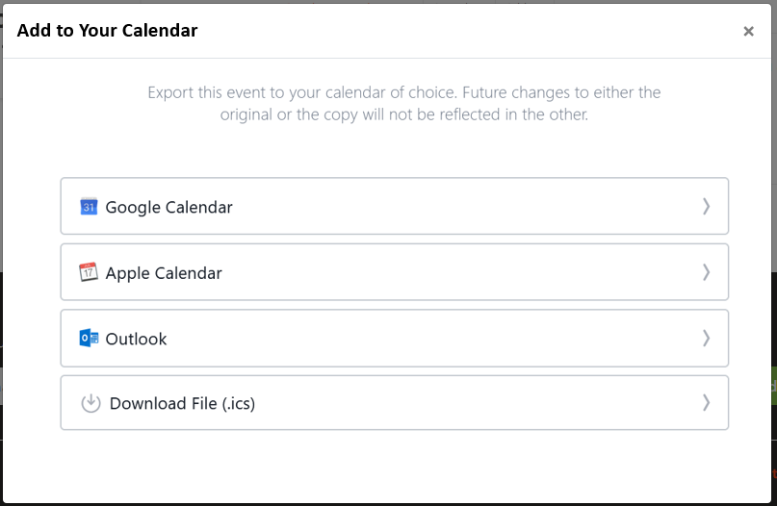

Controls description:

* **Google Calendar** is a link in Google Calendar format in a new window to open Google calendar;
* **Apple Calendar** is a link in Apple Calendar format on a file to open Apple calendar;
* **Outlook Calendar** is a link in Outlook Calendar format on a file to open Outlook calendar;
* **Download File** is a link in .ICS format on a file to download it (do not open Apple or Outlook calendar – just download like a regular file);

Links should be generated automatically by the system for each events when this popup opens.

[IMPORTANT: DO NOU USE 3rd party web services to generate Calendar links, because they may stop working any time. We need to code this on our side or using some plugins]

[Tech Note: here are some webservices to generate links manually

* For Google Calendar: <http://kalinka.tardate.com/>
* For Outlook/Apple and ICS: <https://ical.marudot.com/> ]

Each Link/File should include:

|  |  |
| --- | --- |
| **Calendar Fields** | **Post fields** |
| Event Title | Post->[Title] |
| Date/Time From | Post->[Event Date] + Post->[Start Time]  Set Timezone to EST |
| Date/Time To | Post->[Event Date] + Post->[End Time]  Set Timezone to EST |
| Description | Post->[Content]  Go to Event: [Post->Event URL] |
| Location | Option, can be empty |
| All Day | Optional, can be empty.  If required then use ‘No’ |
| URL | Option, keep empty. If required, then use Post->[Permalink] |

Controls description:

* If [Post->Event URL] is empty, then do not add ‘*Go to Event: [Post->Event URL]*’ into **Description**.

#### Email ‘Event Details’

This is an email which is sent to a user registered on this event.

It may look like this (for illustration only):

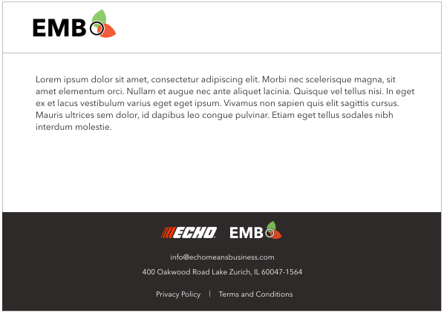

Controls description:

* ECHO – image only, not a link;
* EMB – image, not a link;
* Email ‘info@..’ – text, not a link;
* Address – simple text;
* Privacy Policy. Link to <https://www.echomeansbusiness.com/privacy-policy/>;
* Terms and Conditions. Link to <https://www.echomeansbusiness.com/terms-conditions/>.

## Page ‘Pro Missions’

[PM: describe this from Angelina, Nov 30, 2020

Asana: <https://app.asana.com/0/1178924434621079/1199334175014065>

To confirm, yes, this would be pretty much identical to the CPA challenges, except that we will have other types of Missions (see Points tab under Mission of the Week:

<https://docs.google.com/spreadsheets/d/1nBFBaD2FtEHmWyJ3Zm5aMI1fgdKMMPkUK4o4SHdR69E/edit#gid=0>

]

[MT: Mission of the week banner. It will be the last active posted mission]

Images will be diff.

Available missions and Completed missions.

Default thumbnail

Add a button on the mission of the week

[MT: Where will be the CTA button]

Yes

[MT: Do we need a description for the list of missions]

Yes

[MT: Will unsigned users see the missions? Signed in users?]

Public users can see the page and the submitted results but if they click – they will be sent to the login button

Hide available missions section for now for signed in users.

[MT: when expanded, how many missions to show, is 3 enough? **3 and a button to show more**]

[MT: the button for available missions to participate in] **no, just a link to a mission**

[MT: Shall we use hashtags?]

Yes #ECHOMeansBusiness

**No filter and search**

List of available challenges:

* Types of challenges:
  + Post a response.
  + Share a response.

[PM: to apply this need to follow these procedures:

* + - Admin adds a response under PA Admin user, with right image and text for this challenge.
    - Admin selects this response as source for challenge on a website].

[MT: further types are to be discussed and not planned in the nearest 8 weeks]

* + Poll MOW
  + Social Share
  + Register for an Event
  + Add a Forum Reply
  + Comment on any Pro-Tip Article
* Duration:
  + Weekly – duration is a week.
  + Daily – duration is a day.
  + Custom period – duration indicated.
* Rules:
  + Each user can participate in each challenge just once.

It may look like this (for **illustration** only), included into [Main Template](#_Template_‘Main’).

|  |
| --- |
|  |

Controls description:

|  |
| --- |
| **Section ‘Title and background pic’**   * **-** plain picture with a text ‘Mission of the week’ * - background picture with a text label.   When clicking on image does the following:   * + - If user is NOT **Logged In**, then open [Log In page](#_Page_‘Log_In’_1) in the same window;     - If user is **Logged In**, then open **Open Page URL** /Pro-Missions/Mission\_url/ in the same window. * Below the picture there should be a text above the horizontal line as shown on a screenshot |
| **Section ‘Available Missions’**   * - Title ‘Available Missions’ and s description as shown a picture.   Display 3 or less blocks (image + text + expand button) from /Pro Missions/ = number of active missions the user can participate in and the Button ‘More Missions’ if the number of Active missions is > 3   * + Display 3 missions with location = ‘*Mission Page*’ in the same sort order as in the repeater   + Clicking an image or Text or button does the following:     - The mission will expand below showing 3 tiles of Responses and the button View more below them.     - Clicking ‘View More’ add additional 3 recent responses at the end of the list.     - ‘View More’ can maximum open 198 responses.     - Button View More should not be shown if there are less then 4 responses, or if 198 responses are already opened.     - Clicking on any part of the block will:       * If user is NOT Logged In, then open Log In page in the same window;       * If user is logged in – open the Response page   The response blocks can have either just text, text and video or text and a picture.  - block structure is the following:   * Picture, Video if aaplicable * Title * Description * Author * #EchoMeansBusines hashtag   + Clicking on More Missions button add additional 3 missions at the end of the list.   + ‘More Missions’ can maximum open 198 Missions.   + Button More Missions should not be shown if there are less then 3 active missions, or if 198 responses are already opened. |
| **Section** ‘**Completed Challenges**’   * This section shall be hidden if there are no completed missions. Completed = Expired.   Display 6 or less blocks (image + text + expand button) from /Pro Missions/ = number of active missions the user can participate in and the Button ‘More Mission’ (the name on a pic is wrong) if the number off Expired Mission > 6   * The logic under blocks expanding is the same as in the Section Available Missions * The logic under ‘More Missions’ is the same as in the Section Available Missions |
|  |
|  |
|  |

### Details page

Complete a mission:

[MT can we put a timer?]

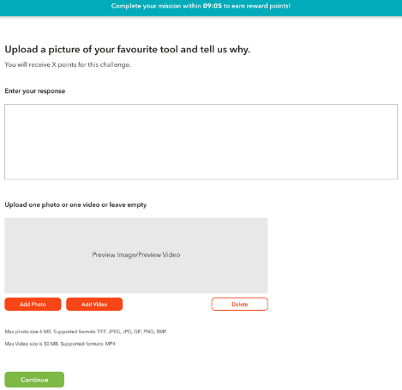

[PM: I think this should be part of the page above – preview mode]

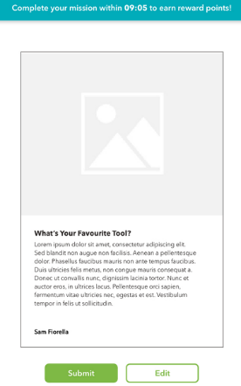

Page with submitted results:  
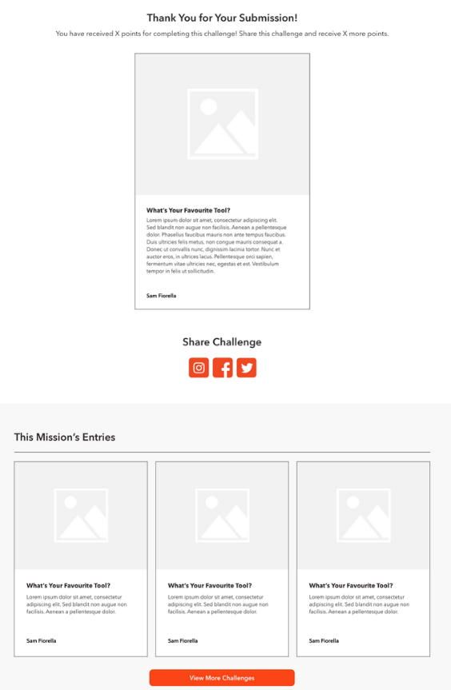

### Creative source

Images for the Pro Missions:

<https://drive.google.com/drive/folders/15wiBcBOM9M8lHyFS_P02_bhrdQhsP1y7>

Copy:

<https://docs.google.com/document/d/1EJQ7-lJbfaHmY_psb5Y4ua8kkT-T6avFS2HS6WqddGU/edit>

## Page ‘Leaderboard’

This page displays list general info about leaderboard, rank users and how to get points.

It may look like this (for illustration only), included into [Main Template](#_Template_‘Main’).

|  |
| --- |
|  |

Controls description:

|  |
| --- |
| **Top banner**   * Simple image and text. Let edit via LiveCanvas as part of page content |
| **Page content**    This is Page->[Content], editable via LiveCanvas. |
| **Your Current Rank section**  This section is placed under This Month/This Year. See the preview below:    All fields are the same as described for the section ***Leaderboard*** below, but for the logged in user.  Section with a logged in user points.   * Do not display this section if:   + [Update Jun 19, 2018] If user is not Logged In;   + If user does not have points for the active tab;   + [Update Nov 28, 2020. I decided always display a user rank]~~User is included into Top 10;~~   + User role is not [Eligible for participating in Leaderboard](#_Section_‘Get_to). |
| **No scores section**    This message is displayed if there are no people for the selected Month, year or Mentor. |
| **Leaderboard section**      Description:   * Tabs ‘This Month’, ‘This Year’, ‘Mentor’ – the same as in [chapter Appendix->‘Leaderboard’](#_Section_‘Get_to).   + Each tab displays 10 users by default. * User data - the same as in [chapter Appendix->‘Leaderboard’](#_Section_‘Get_to) * Link ‘View More’.   + Hidden if there are less than 10 users in the list.   Clicking ‘View More’ adds additional 10 users at the end of the lists   * ‘View More’ can maximum open 200 records. [Tech Note: know issue (which is not a problem): if number of users is multiple of 10, this button will appear, but will not load more members in last click] |
| **Earn Points section**   * This section is part of page content and can be editable via LiveCanvas.     [NEXT VERSION:   * Display this section in Phase 2 or 3: ‘Mission of the Week’]   Links:   * Join. Opens [‘Forum’ page](#_Forum_1) in the same window; * Sing Up. Opens [‘Pro Networking’ page](#_Pro_Workshop_(Public) in the same window; * Redeem. Opens [‘Pro Rewards’ page](#_Pro_Reward_(Partner) in the same window. * ‘.. points here’ opens [page ‘Points and Badges’](#_Page_‘Points_and) in the same window. |

### Page ‘Points and Badges’

This page displays list points and badges.

It may look like this (for illustration only), included into [Main Template](#_Template_‘Main’).

|  |
| --- |
|  |

Controls description:

* Badges images are provided in [chapter ‘Badges’](#_Badges).

## Page ‘Become a Member’

This page may look like this:

|  |
| --- |
| C:\Users\Sergey\AppData\Local\Temp\snap_screen_20170326201943.png  C:\Users\Sergey\AppData\Local\Temp\snap_screen_20170326202012.png |

[Dev Note: we should use v3CATCHA – invisible one]

Controls:

* [Tech Note: use conditional logic from Gravity forms for these fields below]:
  + Country.
    - Drop-down with two values only ‘United States’ and ‘Canada’
      * ‘United States’ should be selected by default
  + State / Province
    - If country ‘United States’, then:
      * Field Label: ‘State’
      * Drop-down values: list of US states, sorted in ascending order, empty by default (if possible)
    - If country ‘Canada’, then:
      * Field Label: ‘Province’
      * Drop-down values: list of Canada provinces, sorted in ascending order, empty by default (if possible)
  + ZIP / Postal Code
    - If country ‘United States’, then:
      * Field Label: ‘ZIP’
      * Textbox, empty by default
    - If country ‘Canada’, then:
      * Field Label: ‘Postal Code’
      * Textbox, empty by default
* Spanish and French.
  + Checkmarks. All unselected by default. Not mandatory

When user clicks SUBMIT then:

* Do validation
* Save results into DB
* Send email to admins

|  |  |
| --- | --- |
| FROM | <website name> <no-reply@website domain> |
| TO | <take emails from form settings, usually admin emails>  **For LIVE only:** barb\_gora@echo-usa.com; Cynthia\_Pilch@echo-usa.com |
| CC | <take emails from form settings, usually admin emails>  **For LIVE only:** sam@senseimarketing.com; se@senseimarketing.com |
| SUBJECT | ECHO Means Business – member application submitted |
| BODY | [Dev Note: I recommend to use a plugin to display values automatically]  ECHO Means Business – member application submitted.  <all fields from the form>  ECHO Means Business |

* + Where:
    - If country ‘United States’, then:
      * Field labels: ‘State’ and ‘ZIP’;
    - If country ‘Canada’, then:
      * Field labels: ‘Province’ and ‘Postal Code’.
* Send e-mail to user who submitted this form

Font: Courier New, 10

|  |  |
| --- | --- |
| FROM | <web site name><no-reply@website domain> |
| TO | <user first and last name> <user’s e-mail> |
| SUBJECT | Your UAG Application |
| BODY | Hello, <first name>.  Thank you for your recent application for membership in the 2021 ECHO User Advisory Group (UAG). Please note that all applications will be reviewed in the fall of 2020.  This program is a 100% volunteer organization of professional landscapers, arborists, and other grounds maintenance pros dedicated to supporting others in the industry with value-added content related to managing their equipment, customers, and businesses.  NOTE: While the UAG is a council of professionals who help lead this community, there are still many opportunities for you to add your experiences, feedback, and content! We encourage you to continue to visit [www.echomeansbusiness.com](https://www.echomeansbusiness.com), log in, and participate in the online forum and other engagement tools we're adding each month.  If you're interested in contributing to ECHO Means Business with blog posts or videos, you may be interested in our Contributor program. If so, please send an email to [angelina@senseimarketing.com](mailto:angelina@senseimarketing.com) and she will follow up on your interest.  Your active participation in the community will be considered during next year's membership selection process.  You can also download the [ECHO Means Business mobile app on Android and iOS](https://www.echomeansbusiness.com/pages/emb-mobile-app), and connect with fellow pros as well as upload photos and videos of your work.  Thank you,  Member Services  The ECHO User Advisory Group |

* + Android: <https://play.google.com/store/apps/details?id=com.sensei.emb.android&pcampaignid=MKT-Other-global-all-co-prtnr-py-PartBadge-Mar2515-1>
  + iOS: <https://itunes.apple.com/us/app/echo-means-business/id1367138226?mt=8>
* Show confirmation message.

|  |
| --- |
| Thank you for your application for membership in the ECHO User Advisory Group (UAG). |

## Page ‘Contributors’

This page displays list of UAG member contributors.

It may look like this (for illustration only), included into [Main Template](#_Template_‘Main’).

|  |
| --- |
|  |

* Section ‘Contributors’.
* ACF, control type: repeater. Elements: users.
* It allows to select ‘Contributor’ members in a given order from the list of all users.

|  |  |  |  |  |  |  |  |  |  |
| --- | --- | --- | --- | --- | --- | --- | --- | --- | --- |
| |  |  |  | | --- | --- | --- | |  | **Contributors** |  | | 1 | <User 1> | ⮿ | | 2 | <User 2> | ⮿ |   Add Contributor |

* User details. The same as on the ‘[UAG members’ page](#_Page_‘UAG_Members’_1).
* Links ‘Apply for 2021 Membership’ and ‘become a contributor here’. The same as on the ‘[UAG members’ page](#_Page_‘UAG_Members’_1).
* Button ‘Request info’ has the same link as ‘become a contributor here’.

## Page ‘UAG Members’

This page displays list of UAG members.

It may look like this (for illustration only), included into [Main Template](#_Template_‘Main’).

* Content example: <https://www.echomeansbusiness.com/client/user-advisory-group.jsf>)

|  |
| --- |
|  |

Content description:

* Section ‘UAG Council Members’.
* ACF, control type: repeater. Elements: users with the checkmark ‘UAG member’.
* It allows to select ‘Council’ members in a given order from the list of all users with the checkmark ‘UAG member’.

|  |  |  |  |  |  |  |  |  |  |
| --- | --- | --- | --- | --- | --- | --- | --- | --- | --- |
| |  |  |  | | --- | --- | --- | |  | **Council members** |  | | 1 | <UAG member 1> | ⮿ | | 2 | <UAG member 2> | ⮿ |   Add Council member |

* + User details:

|  |
| --- |
| This section may look like this: |
| - User photo. This is **Users->Gallery Image**.  User photo should be a link to user’s profile. Clicking on the photo should open a link https://www.echomeansbusiness.com/user/{username}/ |
| - User name. This is **Users->Display Name**.  The name should be a hyperlink with a related style. Hovering over should add an underline to the text. Clicking on it should open a link to https://www.echomeansbusiness.com/user/{ username }/ |
| - user business name. This is **Users-> Business Name**. |
| - user networks.  This is a list social networks from **Users->Social Links**.  All links should open pages in a new tab.  Display only those links where URL is provided, otherwise do not display.   * For example: this user does not have Twitter – this its URL is not displayed |
| - user’s posts on this or 3rd party websites.  ~~This list is taken from~~ **~~Users->Posts~~**~~.~~   * ~~Clicking name should open article in a new tab.~~   Display most recently added top 5 Pro Tips for each user.   * Link users and Pro Tips using Pro Tips->UAG Member field.   If user does not have posts **~~Users->Posts~~,** then this section including its name should not be displayed.  - user first name, plus **‘s.** Must be taken from **Users -> First Name**. |

* Section ‘User Advisory Group Members’.
* ACF, control type: repeater. Elements: users with the checkmark ‘UAG member’.
* It allows to select ‘UAG members’ in a given order from the list of all users with the checkmark ‘UAG member’.

|  |  |  |  |  |  |  |  |  |  |
| --- | --- | --- | --- | --- | --- | --- | --- | --- | --- |
| |  |  |  | | --- | --- | --- | |  | **User Advisory Group members** |  | | 1 | <UAG member 1> | ⮿ | | 2 | <UAG member 2> | ⮿ |   Add User Advisory Group member |

*  - Link to [‘Become a Member’ page](#_Page_‘Get_the). It opens in the same tab.
*  - Link to [mailto:angelina@senseimarketing.com?subject=Contributor Program](mailto:angelina@senseimarketing.com?subject=Contributor%20Program).

## Page ‘Member Directory’

[PM: Nov 19, 2020

<https://app.asana.com/0/607038627868623/1199159747519125>

|  |  |  |  |  |  |  |  |  |  |  |  |  |  |  |  |  |  |  |  |  |  |  |  |  |  |  |  |  |  |  |  |  |  |  |  |  |  |  |  |  |  |  |  |  |  |  |  |  |  |  |  |  |  |  |  |  |  |
| --- | --- | --- | --- | --- | --- | --- | --- | --- | --- | --- | --- | --- | --- | --- | --- | --- | --- | --- | --- | --- | --- | --- | --- | --- | --- | --- | --- | --- | --- | --- | --- | --- | --- | --- | --- | --- | --- | --- | --- | --- | --- | --- | --- | --- | --- | --- | --- | --- | --- | --- | --- | --- | --- | --- | --- | --- | --- |
| **Summary of New Functionality:   “Meet the Pros”   General:** Listing of all member profiles (summary listing and details) with options to connect and chat with other members.  **Meet the Pros Workflow:**   1. Basic or Pro Members can open Meet the Pros within navigation to view a list of all Pros (summary listing page). [Open Issue: Pros - are they all registered users? If not, please clarify] [SF: Pros are enrolled/logged in members (Basic or Pro)] basic – subscriber, pro – member.   **\_\_!!!\_\_ Default sorting is by the field Last login (time) \_\_!!!\_\_**   1. Filter options for this listing [Doc for all filters: <https://docs.ultimatemember.com/article/1513-member-directories-2-1-0> ]    1. By State [Open Issue: they allow you to do it by location, including State. Demo: <https://ultimatememberdemo.com/members/?map_zoom_2d7fb=4&map_sw_2d7fb=19.440131131418923%2C-145.60418624974042&map_ne_2d7fb=41.873206489480495%2C-54.54949874974043&location_search_2d7fb=Texas%2C%20USA&view_type_2d7fb=grid> ] AK: If possible, that would be great!      * 1. By Type [Open Issue: what does it mean TYPE?] [SF: In member user profile, in addition to name, email and password, we’d like to ask the following:  Role: Business Owner \_\_ Operator \_\_ Services Provided: Lawn Care \_\_ Landscape\_\_ Hardscape\_\_ Arbor\_\_   In this or next phase, we hope to allow logged in member to sort the view of other members by “type” which is “Role” or “Services Provided” ]   [MT: Role = Employment Status and Services provided = Type of business fields in the user account.]  View:     1. Sorting. By most Points by default. By name and by last login as other options.  View: AK: First and Last Name should be 2 different sort types. Do you think we can have UAG as a sort type?   First and Last names are now 2 diff sort types. UAG check with Sergey.     1. Search function. Looks like it is enabled for all fields in the user profile.     Summary listing of each pro to include basic info such as Name, Short “about” summary, head show, point level, most recent badge award. Members can click to view profile. AK: as discussed, can we have also user type, i.e. basic or pro? View with or without background is okay – whatever is easiest to code MT: no such setting for the user membership type, I assume coding needed + double check.   |  |  |  | | --- | --- | --- | | **Field** | **Yes/No** | **Comment** | | Name | Yes |  | | Short about summary | Yes |  | | Head shot | Yes |  | | Point level | No | Open issue to dev team. | | Most recent badge | no | Not yet implemented | | Business name |  |  |   View: with a background pic.    Without:    Business name:  **Option 1:**   * 1. (Viewing profile (based on design by Laura), information to include: “about” “posts” “comments” “activity” “messages” “Badges” and “Friends” as outlined in functional specification for “Ultimate Member” )  |  |  |  | | --- | --- | --- | | **Field** | **Yes/No** | **Comment** | | About | Yes | “About” | | Posts | Yes |  | | Comments | No | Included in activity. | | Activity | Yes |  | | Messages | no |  | | Badges | Yes | Once developed badges feature | | Friends | Yes |  |   View:    Below features are TBD when the relevant features (points&badges) are ready.   1. User sends a message to another Pro who responds 2. User sends Friend request to another Pro and is accepted 3. Badges are earned when completed, see spreadsheet with Badges  |  |  | | --- | --- | | Connector Level 1 | Messages and “Friends” 5 pros | | Connector Level 2 | Messages and “Friends” 25 pros | | Connector Level 3 | Messages and “Friends” 100 pros | | Note | 1 pro is considered returned message and accepted friend request to same Pro user |  1. Points earned when completed (see point spreadsheet)  |  |  |  |  | | --- | --- | --- | --- | | Profile | Meet a Fellow Pro | Points awarded when member Messages (must be two-way communication) with another member AND becomes friends with them. (both actions have to be taken) | 200 |   [SP: I am not sure yet how to implement checking for #4,5,6 and 7 above. It can be easy, or may require extensive coding. Cannot estimate until we start this. May take 2-3weeks for coding] [SF: Let us know. If we have to move this to phase two, I would be OK with that although I would prefer to keep it in phase one because it’s important to getting engagement on site]  **[Example from Demo**  [**https://ultimatememberdemo.com/members/?map\_zoom\_2d7fb=4&map\_sw\_2d7fb=19.440131131418923%2C-145.60418624974042&map\_ne\_2d7fb=41.873206489480495%2C-54.54949874974043&location\_search\_2d7fb=Texas%2C%20USA&view\_type\_2d7fb=grid**](https://ultimatememberdemo.com/members/?map_zoom_2d7fb=4&map_sw_2d7fb=19.440131131418923%2C-145.60418624974042&map_ne_2d7fb=41.873206489480495%2C-54.54949874974043&location_search_2d7fb=Texas%2C%20USA&view_type_2d7fb=grid) **]**  This is how Member directories looks like    [SF: This is OK. I don’t think we need to include star rating for individuals however. I see it has a search feature/filter (drop down), which is great. We don’t need to search by “gender” but can we add filter searches for “State” “Role” and “Services Offered”? |

]

[Open Issue: please provide details:

* what should be opened by clicking ‘View more’
* need to discuss other features like ‘Chat’

### Public User – Gateway (please login pop-up)

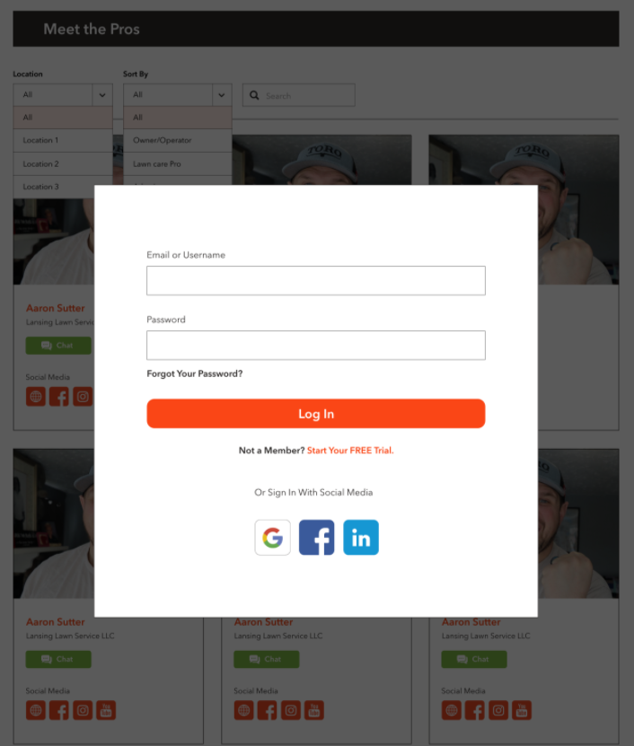

### Public, Basic & Pro User

|  |
| --- |
|  |

## Page ‘Pro Resources’

General information:

* File types - PDF, Images (jpeg, png)
* Only available for download for pro members - if basic and public users go on the page, they can view all items but they cannot download.
* Download button requests a Login

This page may look like this (included into the [Main template](#_Home_Page)):

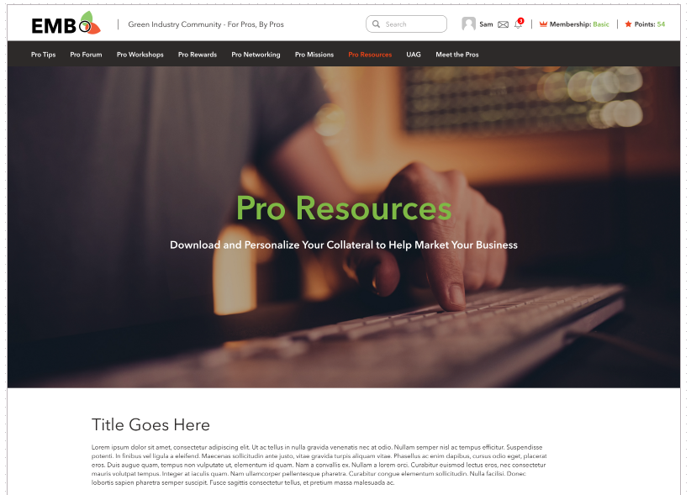

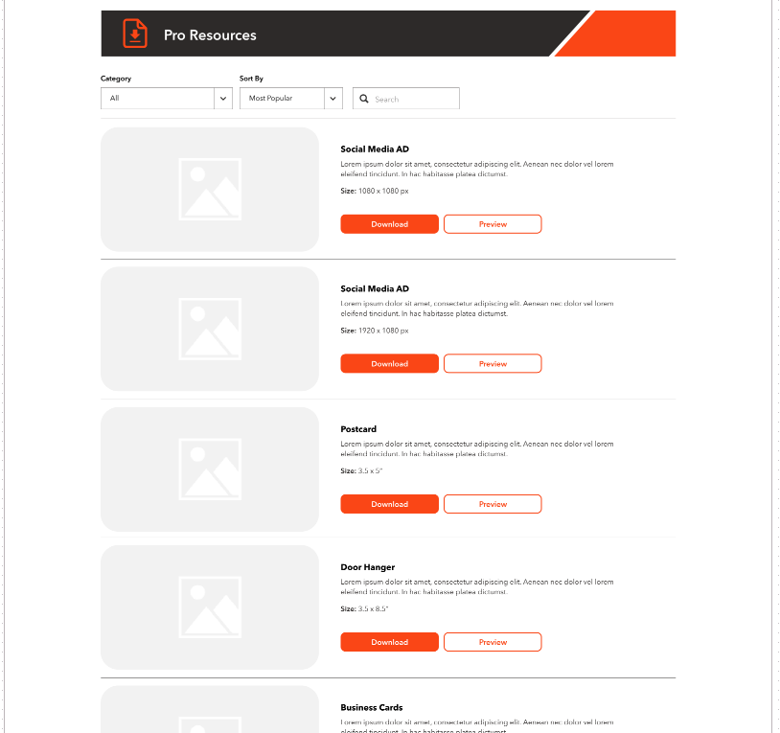

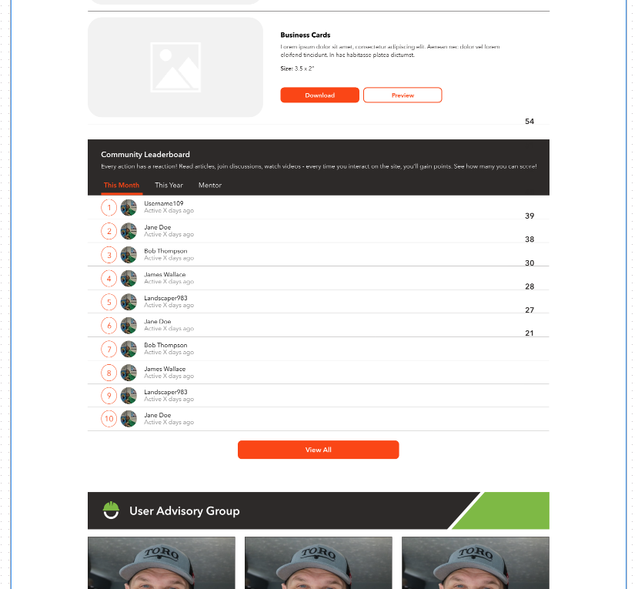

Controls description

* Banner. This page will have an individual banner, different then a banner on other pages;
* Title and description on the page.
* Category Filter [MT: Later, Next Phase]
* List of downloads. Managed in Admin -> Resources;
  + Sorted by [Published date] in descending order – recently added on the top;
  + Display all items without any pagination and ignore [Tech Note: internal scrolling for downloads on creative above];
  + Resources items:
    - Thumbnail. This is Post->Featured Image;
    - Title. This is Post->Title;
    - Description. This is Post->Content;
    - New field (if possible): Size. Post -> Size. Text field for the dimension information.
  + Actions:
    - Download button 
      * If user is NOT **Logged In**, then open [Log In page](#_Page_‘Log_In’) in the same window*.*
      * If user is **Logged In**, then download an item like a regular file in a browser;
    - Preview button 
      * Both logged in and not logged in user CAN see the preview of the file.   
        The preview will open in a pop up box with adjusted quality and no possibility for the user to download the file by Brower functions [Is it possible?]  
        [How to open preview of the PDF files?]

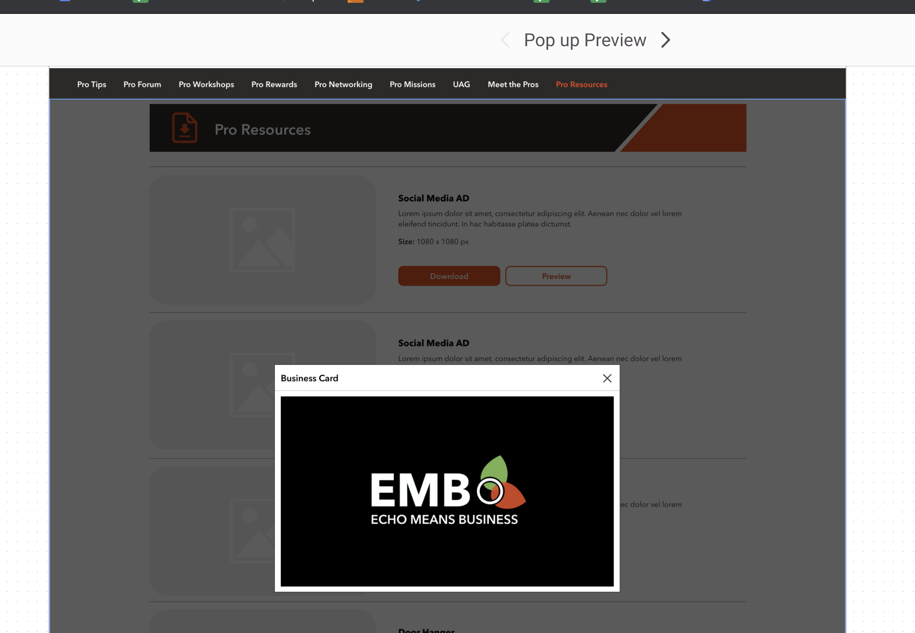

* + - Social share button (not on the mockup).  - but in EMB style.

Allow to share downloads directly from this list.

* + - * Social networks:
        + LinkedIn. URL are as an example only.

|  |
| --- |
| Example:  [**https://www.linkedin.com/shareArticle**?**mini**=true&**url**=https://www.morganstanley.com/articles/a-veterans-career-transition-to-investment-banking&**title**=A%20Veteran%E2%80%99s%20New%20Mission&**summary**=%22Learn%20how%20his%20military%20training%20prepared%20this%20Associate%20in%20our%20London%20office%20to%20take%20on%20the%20fast-paced%20world%20of%20Global%20Capital%20Markets.%22](https://www.linkedin.com/shareArticle?mini=true&url=https://www.morganstanley.com/articles/a-veterans-career-transition-to-investment-banking&title=A%20Veteran%E2%80%99s%20New%20Mission&summary=%22Learn%20how%20his%20military%20training%20prepared%20this%20Associate%20in%20our%20London%20office%20to%20take%20on%20the%20fast-paced%20world%20of%20Global%20Capital%20Markets.%22)  Parameters:   * mini. Always ‘true’; * url. Full path URL on this post; * title. [Post->Title] * summary. [Post->Content]   NOTE: cannot prefill text or pass hashtag |

* + - * + Twitter

|  |  |  |
| --- | --- | --- |
| Example:  [**https://twitter.com/share**?**url**=https://www.morganstanley.com/articles/a-veterans-career-transition-to-investment-banking&**text**=A%20Veteran%E2%80%99s%20New%20Mission](https://twitter.com/share?url=https://www.morganstanley.com/articles/a-veterans-career-transition-to-investment-banking&text=A%20Veteran%E2%80%99s%20New%20Mission)  Parameters:   * url. Full path URL on this post; * text. Format: [Post->Title][space][#echomeansbusiness]  |  |  | | --- | --- | | **English** | #ECHOMeansBusiness |   [Tech Note: encode ‘#echomeansbusiness into ‘%23 echomeansbusiness in URL] |

* + - * + Facebook

|  |
| --- |
| Example:  [**https://www.facebook.com/sharer/sharer.php**?**u**=https://www.morganstanley.com/articles/a-veterans-career-transition-to-investment-banking](https://www.facebook.com/sharer/sharer.php?u=https://www.morganstanley.com/articles/a-veterans-career-transition-to-investment-banking)  Parameters:   * u. Full path URL on this post;   NOTE: cannot prefill text or pass hashtag |

* + - * Meta details provided below.

[Tech Note: allow to share downloads for not logged in user, but they will not receive points];

Metatags details:

|  |
| --- |
| <meta property="og:title" content="<Post->Title>"/>  <meta property="og:description" content="<up to 280 chars from Post->Content>"/>  <meta property="og:site\_name" content="<website name from Settings>"/>  <meta property="og:url" content="<full path URL on this post>"/>  <meta property="og:image" content="<full path URL to Post->Featured Image>"/>  <meta property="twitter:card" content="summary\_large\_image"/>  <meta property="twitter:title" content="<Post->Title>"/>  <meta property="twitter:image" content="<the same as **og:image**>"/>  <meta property="twitter:description" content="<up to 130 chars from Post->Content>"/>  <meta property="twitter:url" content="<full path URL on this post>"/> |

* Community leaderboard section. The same as described in [leaderboard](#_Section_‘Get_to) section;
* User Advisory Group section. The same as described in [UAG](#_Section_‘Pro_Members) section;

## Pages ‘About Us’, ‘Privacy Policy’, ‘Terms’, ‘Community Rules’, ‘FAQ’

All pages are included into the [Main Template](#_Home_Page).

Privacy Policy page:

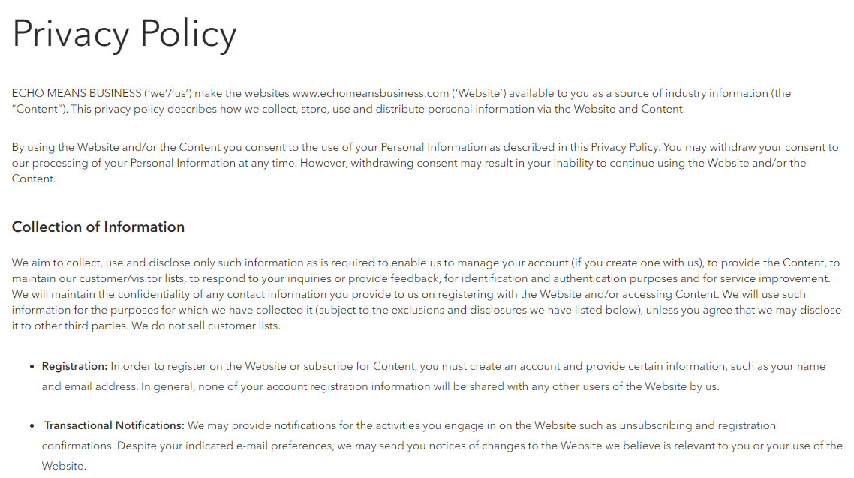

About page:

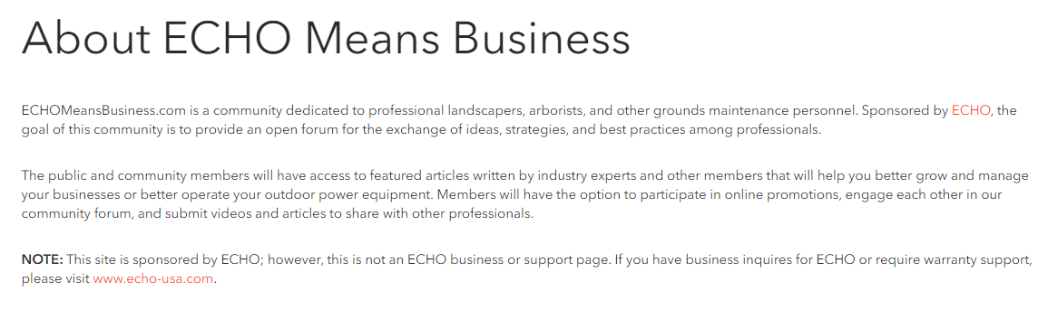

Terms & Conditions page:

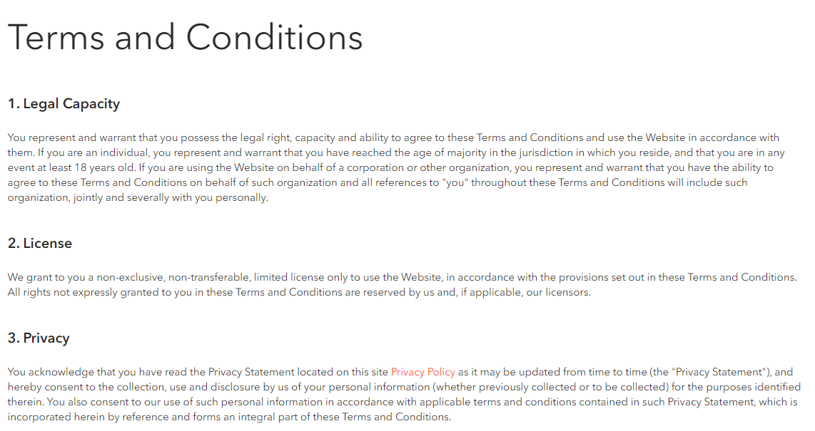

Community Rules page:

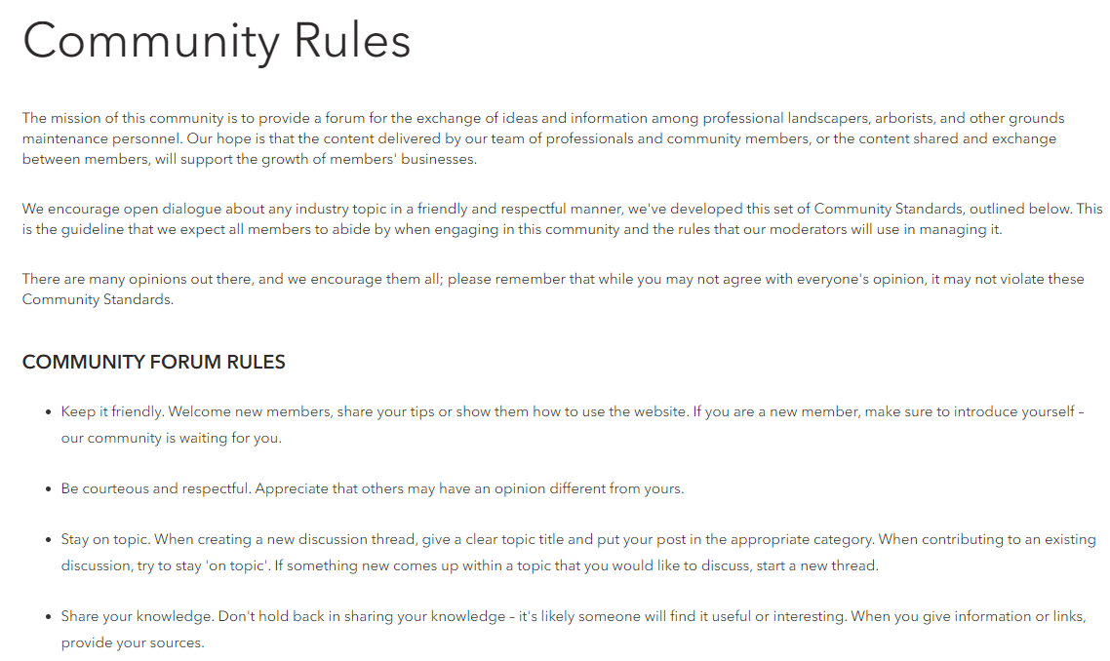

FAQ:

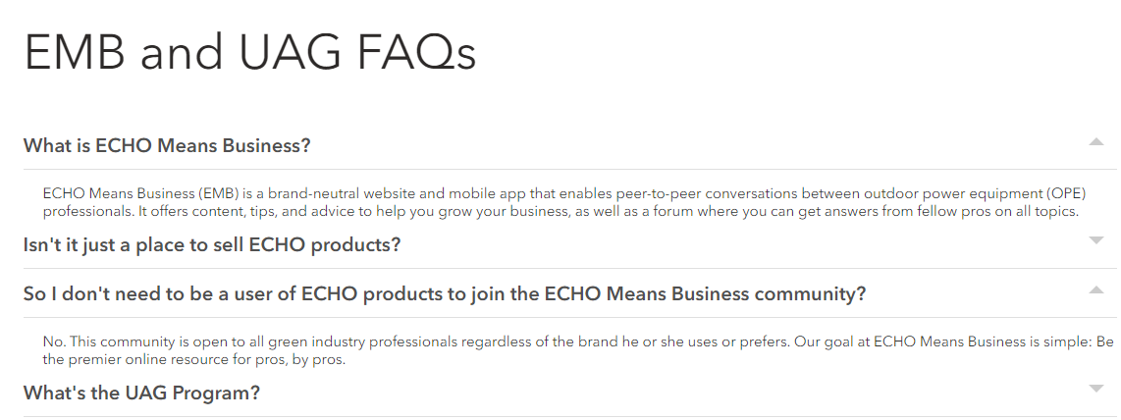

## Page ‘Get Mobile App’

This page may look like this

<https://www.echomeansbusiness.com/pages/emb-mobile-app>

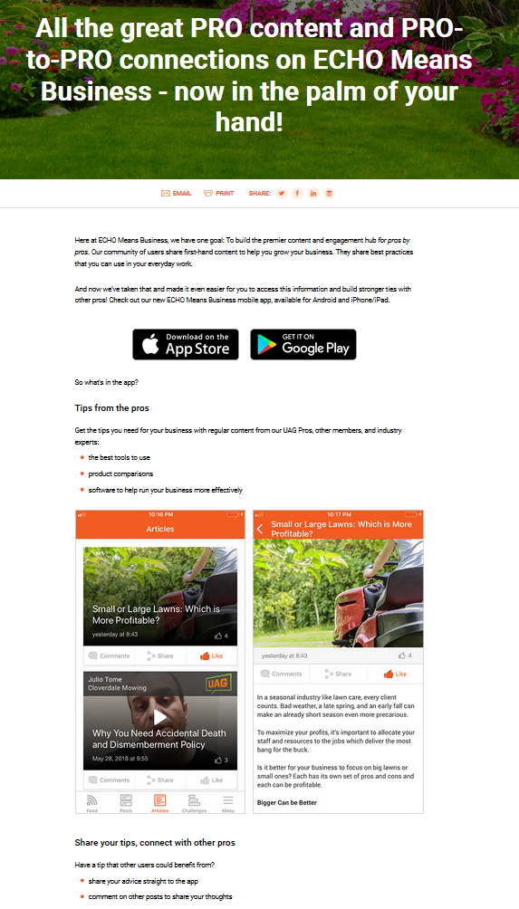

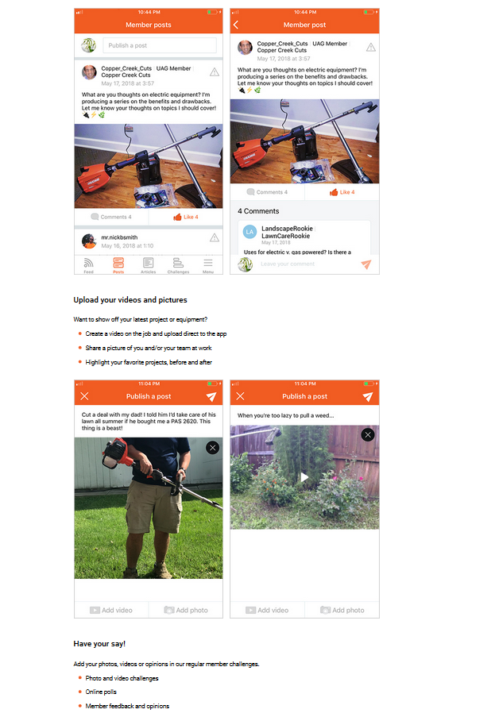

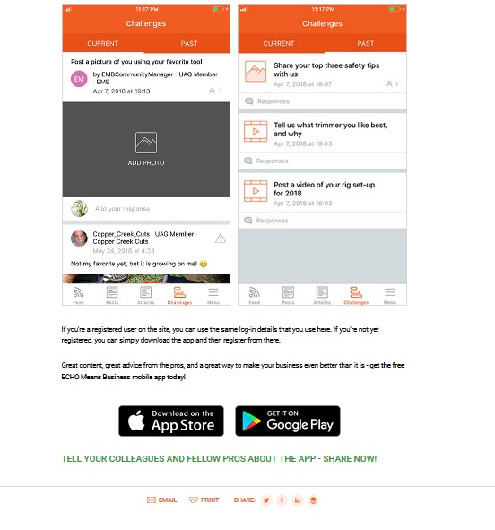

## Page ‘Membership Pricing’

This page displays list of available membership options.

Location in the footer



It may look like this (for illustration only)

|  |  |  |  |  |  |  |  |  |  |  |
| --- | --- | --- | --- | --- | --- | --- | --- | --- | --- | --- |
| **Membership Pricing**  First block is membership types description with price, may look like this:    The button {dynamic name} will be different based on the type of user  <FREE user> -  Start My Free Trial!  <BASIC user> -  Become a Pro Member!  <PRO MEMBER TRIAL user> -  Buy Now!  <PRO MEMBER not TRIAL user> - NO BUTTON  The table with key features comparison may look like this.    Controls description:   |  |  | | --- | --- | | [User Role](#_User_Roles) | Description | | FREE | Show a button ‘*Start My Free Trial!*’   * Clicking this button will open the [registration page](#_Forgot_Password) in the same window. | | BASIC | Show a button ‘*Become a Pro Member*’   * Clicking this button will open the [Membership Payment page](#_Page_‘View_Receipt’) in the same window. | | PRO MEMBER (Trial) | Show a button ‘*Become a Pro Member*’   * Clicking this button will open the [Membership Payment page](#_Page_‘View_Receipt’) in the same window. | | PRO MEMBER  (none trial) | NO button | |

## Page ‘Unsubscribe’

This page is used to unsubscribe from Mailcast emails.

[Tech Note: this can be a regular static page with URL /unsubscribe-confirmation/]

It may look like this (for illustration only):

|  |
| --- |
| **You’ve Unsubscribed**  You’ll no longer receive emails from us. |

[Tech Note:

**Existing Unsubscribe URL:**

https://<OLD LIVE domain>/unsubscribe/unsubscribe.jsf?uid=XXX

New Unsubscribe URL for emails:

<LIVE or TEST domain>/API?action=unsubscribe&uid=XXX

Where XXX is encoded user’s email (the same as it work in JAVA mailcasts)

Once this URL is executed, then

* Execute JAVA API to unsubscribe user
  + ignore any errors/success status from JAVA;
* Show static page above (redirect to https://<ACTUAL domain>/unsubscribe-confirmation/);

]

# Administrative Interface

## Page ‘EMB Settings’

These are settings which will be used across the website.

It may look like this:

|  |  |  |  |  |  |  |  |
| --- | --- | --- | --- | --- | --- | --- | --- |
| **EMB Settings**   |  |  | | --- | --- | | **Pro Rewards** |  | | **Featured Pro Rewards**  *List of offers to be displayed on all pages*   |  |  |  | | --- | --- | --- | | Existing offers | ->  <- | Selected featured offers | | | |

Controls description:

* Tab ‘Pro Rewards’
  + Featured Pro Rewards. This section is used to choose what offers to display in this section on the website:

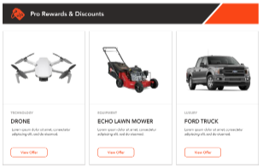

## Users

Section for UAG members. This section will include the following fields:

|  |  |  |
| --- | --- | --- |
| **Field Name** | **Field Type** | **Description** |
| UAG Member | ACF | This is a checkmark:   * Default value is unselected; * If this checkmark selected, then it means that this user is UAG member. |
| Social links | ACF | This is a list of users’ social networks.  NOTE: some users may have two channels on one platform.  ACF Repeater. Fields:   * Social Network Name. Textbox, optional, empty by default.   + Default list of Networks:     - Website     - Facebook     - Instagram     - Twitter     - YouTube     - TikTok * Network URL. Webpage URL, optional, empty by default.  |  |  |  |  |  |  |  |  |  |  |  |  |  | | --- | --- | --- | --- | --- | --- | --- | --- | --- | --- | --- | --- | --- | | **Social links**   |  |  |  |  | | --- | --- | --- | --- | |  | **Name** | **URL** |  | | 1 | <social network 1> | <network URL 1> | ⮿ | | 2 | <social network 2> | <network URL 2> | ⮿ |   Add social link | |
| Posts | ACF | User’s posts on this or 3rd party websites.  NOTE: user may do not have posts, or one post or more.  ACF repeater. Fields:   * Post Name. Textbox, mandatory, empty by default. * Post URL. Webpage URL, mandatory, empty by default.  |  |  |  |  |  |  |  |  |  |  |  |  |  | | --- | --- | --- | --- | --- | --- | --- | --- | --- | --- | --- | --- | --- | | **Posts**   |  |  |  |  | | --- | --- | --- | --- | |  | **Post Name** | **Post URL** |  | | 1 | <post name 1> | <post URL 1> | ⮿ | | 2 | <post name 2> | <post URL 2> | ⮿ |   Add user post | |
| Gallery Image | ACF | This image will be used on UAG and Contributor galleries. It may be different than profile avatar image.  ACF Image.   * Description for ACF: ‘*This image is for UAG and Contributor galleries. It may be different than profile avatar image*.’ * Optional.   Example from UAG page: |

## Pro Tips

Pro Tips is a custom post with standard Categories and Tags.

Pro tips ACF properties

|  |  |  |
| --- | --- | --- |
| **Field Name** | **Required** | **Details** |
| **Image** | Yes | This is image on a tile  Example:    [Tech Note: old images will have a grey block at the top, but new images will not have it. The grey block will be displayed if UAG Member was provided]  [Tech Note: we can use this field for mobile as well, but in such case article images on the mobile will not have this section , because this section is added automatically for the website tiles only. In JAVA website this section was added manually for each image] |
| **Presentation Mode** | Yes | Radio button:   * Article. Should be selected by default * Video   Based on this field we display a play button over a tile. Example for Video: |
| **Transcript** | No | ACF WYSWYG editor  Empty by default  It is used to display content transcript separately from the main content below the comments. |
| **Mobile Content** | No | This is HTML editor  Empty by default.  It is used for displaying pro tip on mobile devices, because mobile devices cannot display reach HTML properly from Custom Post->Content property. |
| **UAG Member** | No | User ACF control.  If provided then this block below will be displayed above the image |

## Content Blocks

Content Block is a custom post, which will be used for visual coding HTML blocks via LiveCanvas.

Custom post properties:

* Not public. Should not be available by a post URL on public website;
* No indexing. Should not be indexed and included into search results.

WP Content Block List:

* Add a new column to display a shortcode for each block, like this

|  |
| --- |
| **Shortcode** |
| [emb-content-block id=<X>]  Where <X> is object ID |

WP properties (no Advanced Custom Fields are required)

|  |  |  |
| --- | --- | --- |
| **Field Name** | **Required** | **Details** |
| **Tile** | Yes | This is name for block.  It will not di displayed anywhere on the website. We will use it to identify blocks.  Example: ‘*All pages - Pro Networking*’ |
| **URL** |  | We are not planning to use it.  WP will create URL automatically. |
| **Content** | Yes | This content will be used like shortcode in places where we want to display this content. |

## Events

Event is a custom post with standard Categories and Tags.

Properties

|  |  |  |  |
| --- | --- | --- | --- |
| **Field Name** | **Type** | **Required** | **Details** |
| **Title** | **WP** |  | This is event name |
| **Permalink** | **WP** |  | This is URL on the [Pro Networking - Details page](#_Page_‘Pro_Networking) |
| **Content** | **WP** |  | This is event description which will be visible for all users: FREE, Basic and Pro |
| **Event Content** | **ACF,**  **HTML** | No | This is an event video (embedded code of video player) or demo video or ‘coming soon’ message. It depends on what we decide to add here.  Visibility of this section depends on Availability mode and Event Date/Time. See [chapter ‘Pro Networking - Details’](#_Page_‘Pro_Networking) for rules. |
| **Availability Mode** | **ACF** | Yes | This is radio button with two options:   * **Pro Only** (selected by default) * **Basic and Pro**   This mode regulates who can access this event and how it will look like. |
| **Tile Image** | **ACF, Image** | Yes | This is image which will be displayed in the list of event  Recommended size: 455 x 259px  Example: |
| **Tile Short Description** | **ACF,**  **HTML** | No | This is a short content on a tile. Can be plain or HTML  Example: |
| **Event Date** | **ACF,**  **Date Picker** | Yes | Date control to select date when event starts in EST timezone. |
| **Start Time** | **ACF,**  **Time Picker** | Yes | This is time when event starts in EST |
| **End Time** | **ACF,**  **Time Picker** | Yes | This is time when event ends in EST |
| **Attendee** | **ACF,**  **Repeater** | No | This repeater will contain those who is Going or Not Going on this event.  It includes:   * **User**. Control to select a user name;   + Empty by default * **Status**. Empty by default. Drop-down with options:   + Going   + Not Going * **Details email sent at**. This is date/time in EST when ‘Event Details’ email was sent to this user. This field is required to avoid situations of sending this email more than one time if user changes ‘*Status*’.   + Once email is sent then this field date/time is not changed even if user changes his status from Going to Not Going and back.   [NEXT VERSION: when admin adds user into this list and sets status to ‘Going’ then system should send ‘Event Details’ email, the same way as it is if user does it on public website] |
| **Event URL** | **ACF,**  **URL** | Yes | This is 3rd party URL for event.  It can be Zoom link or any other link. |
| **Sub-section ‘Event Details Email’**  This section defines what email will be sent to user when user first time changes event status on ‘Going’. | | | |
| **FROM Name** | **ACF,**  **Textbox** | Yes | This FROM name.  Default value: **Echo Means Business** |
| **FROM Email** | **ACF,**  **Textbox** | Yes | This is FROM email address.  Default value: **no-reply@echomeansbusiness.com** |
| **Subject** | **ACF,**  **Textbox** | Yes | Subject name.  Default value: **EMB Event details** |
| **Body** | **ACF,**  **HTML** | Yes | Email body.  This should be Plain HTML, without complicated hierarchy, because standard HTML editor may break email structure. |

## Offers

Offer is a custom post with standard Categories and Tags.

Properties

|  |  |  |  |
| --- | --- | --- | --- |
| **Field Name** | **Type** | **Required** | **Details** |
| **Title** | **WP** |  | This is offer title |
| **Permalink** | **WP** |  | This is URL on the [Pro Reward-Details page](#_Page_‘Pro_Reward) |
| **Content** | **WP** |  | This is offer details |
| **Category** | **WP** |  | List of categories   1. Rewards Categories 2. Automotive 3. Services 4. Entertainment 5. Family 6. Tickets 7. Health & Wellness 8. Kids 9. Retail 10. Home 11. Sports 12. Technology 13. Travel 14. Finance 15. Work 16. Apparel 17. Food & Dining |
| **Availability Mode** | **ACF** | Yes | This is radio button with two options:   * **Pro Only** (selected by default) * **Basic and Pro**   This mode regulates who can see redeem this offer and how it will look like. |
| **Tile Image** | **ACF** | Yes | Tile image  Example: |
| **Tile Short Description** | **ACF** | Yes | Text on a tile  Example: |
| **Offer Logo** | **ACF** | No | This is an image this will be displayed below the title.  Example (in red):    [Tech Note: even if logo is look like a text, it is an image. Let convert text into image and apply for offer. No need to support two logos: image and text. Text logos will be quite rarely] |
| **How To Redeem** | **ACF** | Yes | This is a link on item from [Content Blocks](#_Content_Blocks).  Example:    We will add redemption instructions for each offers as HTML inside Content Blocks with names ‘*Offer – How to redeem - <offer name>*’ and select which one will be used in a popup on [Pro-reward-Details page](#_Page_‘Pro_Reward).  When How to Redeem popup is displayed then we will read HTML from Content Block and display it inside popup. |

## Plugin ‘Restrict’

### Settings ‘Settings->Emails’

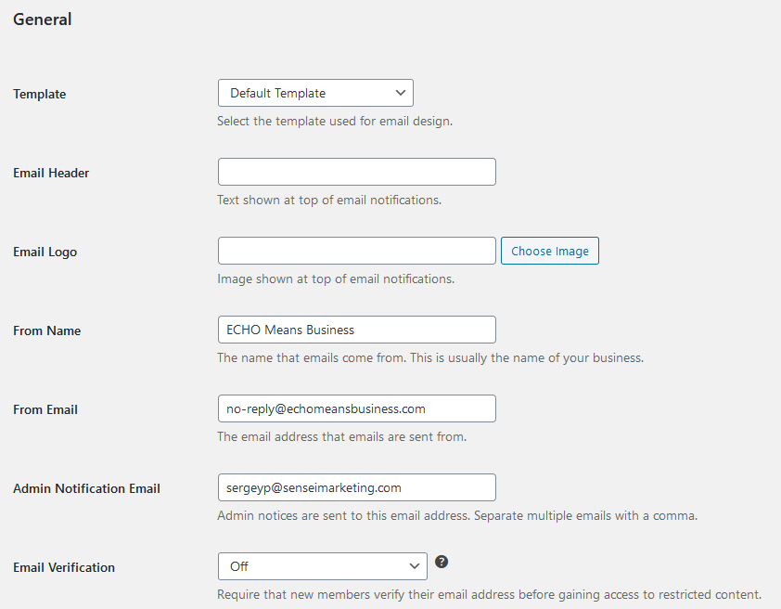

Email template:  


Controls description:

* ECHO – image only, not a link;
* EMB – image, not a link;
* Email ‘info@..’ – text, not a link;
* Address – simple text;
* Privacy Policy. Link to <https://www.echomeansbusiness.com/privacy-policy/>;
* Terms and Conditions. Link to <https://www.echomeansbusiness.com/terms-conditions/>.

Available variables for the templates.

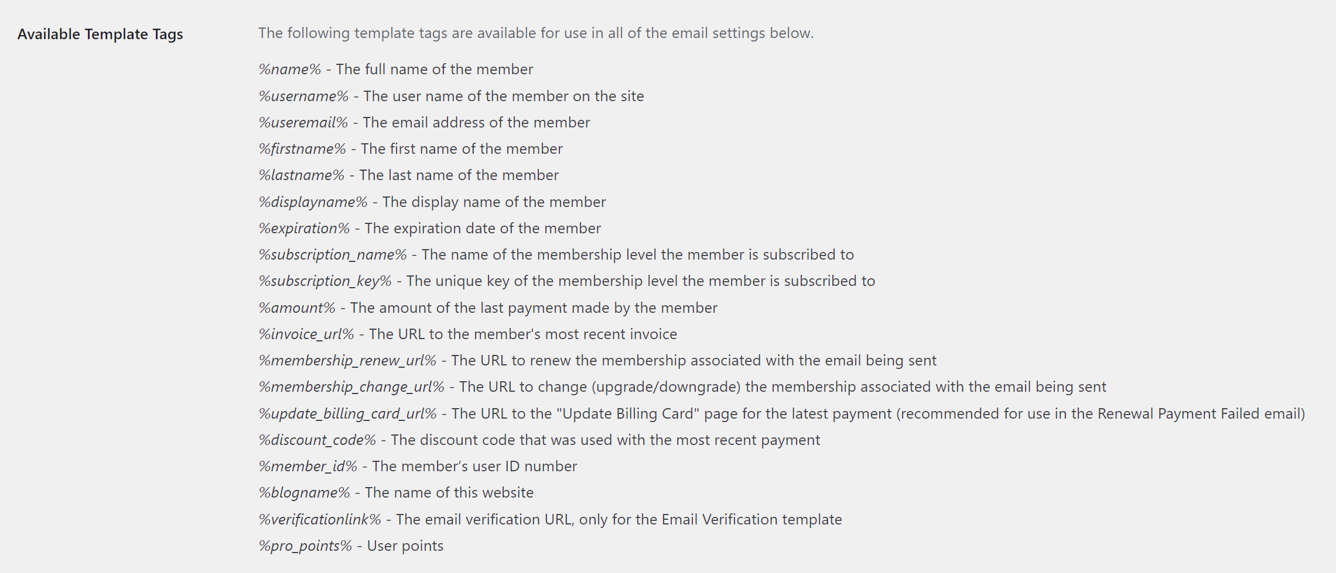

Drip Marketing Campaign

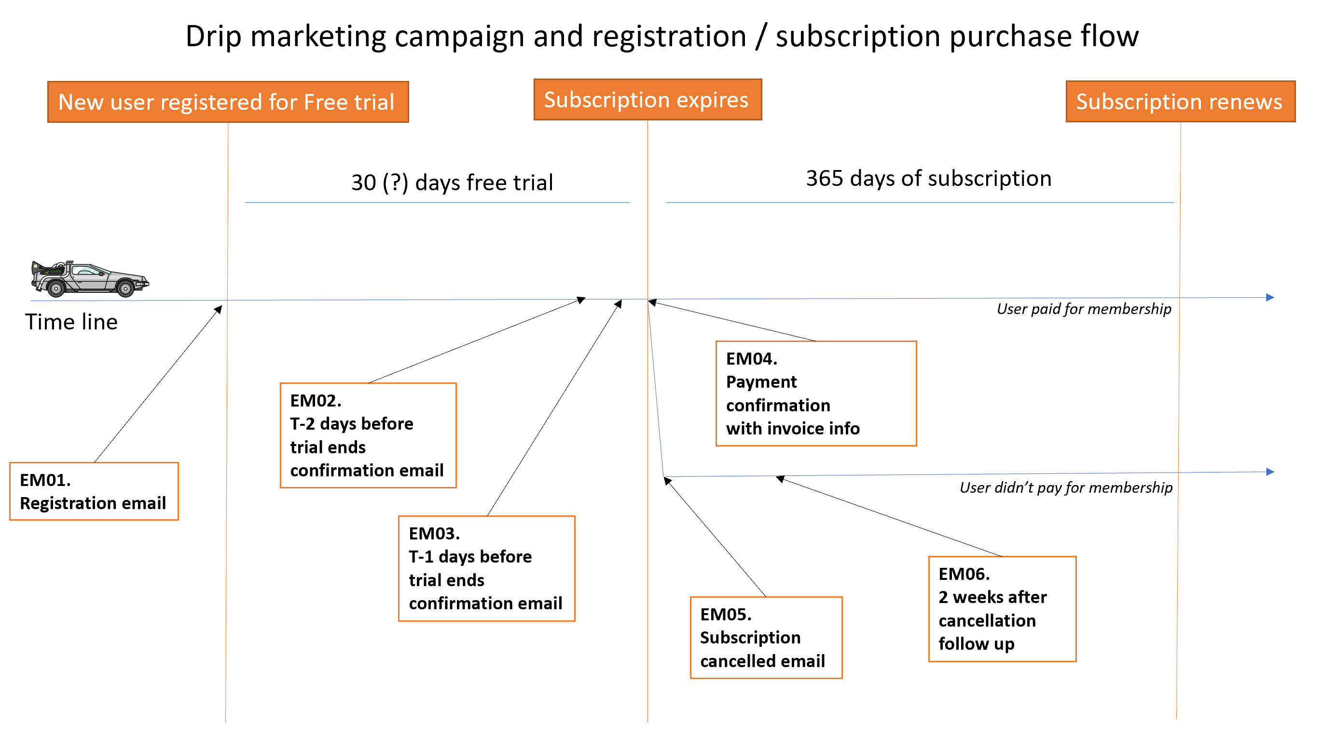

Enable/Disable member and Admin notifications:

|  |  |  |
| --- | --- | --- |
| **Notification** | **Member** | **Admin** |
| Paid Membership Activation Email | Disabled | Disabled |
| Free Membership Activation Email | Disabled | Disabled |
| Trial Membership Activation Email | Disabled | Disabled |
| Cancelled Membership Email (since not possible to cancel on your own) | Disabled | Disabled |
| Expired Membership Email (EM05)  FROM: <website name> <no-reply@echomeansbusiness.com>  TO: <user first and last name> <user’s email>  SUBJECT: Sorry to see you go  BODY:  Hello <first name>  This email is to confirm that your Pro Membership to ECHO Means Business has been cancelled.  You are still able to participate in the community but with limited access to certain features.  And of course, you can update your membership any time.  Thanks again,  Your ECHO Means Business team | Active | Disabled |
| Expiration Reminders (EM06, EM02 and EM03 as they appear in the list)    EM06:  Subject Line: <first name>, a fellow Pro has a super simple tip for growing your biz  Shape, rectangle  Description automatically generated  Hello <first name>  My name is <UAG member name> from <company name>, I’m a member of the User Advisory Group (UAG) here at ECHO Means Business.  I have one super simple tip for growing your business: *get to know fellow Pros*.  From fellow pros I’ve learned things like what equipment to use (and not to use), shortcuts and best practices, how to find and hire the right people, and how to market my business and get more leads.  And here’s maybe the best part…other pros have been a top source for new business.  And the ECHO Means Business community is the best place to meet, network, and learn from fellow pros.  Consider a Pro Membership Today. Learn more about membership types here.  Any questions, feel free to ask. (link to their UAG profile on website)  All the best,  <UAG member name>  **Check out some of our rewards partners:**  LOGOS - Kujo - Jobber - Hotel Engine - eReplacementParts (logos link to specific offer) | Active | N/A |
| Renewal Remind | Disable | N/A |
| Payment Received Email (EM04)  FROM: <website name> <no-reply@echomeansbusiness.com>  TO: <user first and last name> <user’s email>  SUBJECT: Congrats <first name>, you are now a Pro Member!  BODY:  Hello <first name>  Congratulations, you are now a Pro Member of the ECHO Means Business community!  You now have full access to everything ECHO Means Business has to offer, including:   * All special offers and discounts on many of your favorite brands * VIP access to special events and workshops * Access to networking and mentoring from fellow pros who can help you grow your biz * Much more!   Please note that your Pro Membership is valid until <expiration date>. We’ll send you a reminder before it expires.  Attached is your receipt for the ECHO Means Business Pro Community.  Please keep this receipt for your records as it may be used as a business expense for tax purposes (please confirm with local laws).  Thanks again, we look forward to having you as a Pro Member.  Your ECHO Means Business team  <insert receipt info> | Active | Disabled |
| Renewal Payment Failed Email | Disabled | Disabled |
| New User Notifications | N/A | Disabled |

### Settings ‘Settings->Invoices’

[Open issue to Angelina: please provide details <https://app.asana.com/0/1178924434621079/1200050593531070> ]

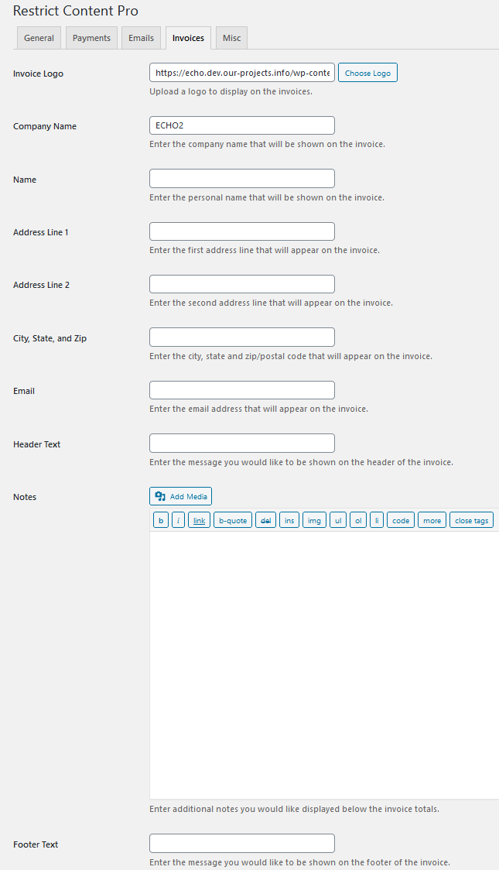

### Settings ‘Settings->Misc’

Use default values of plugin. No changes

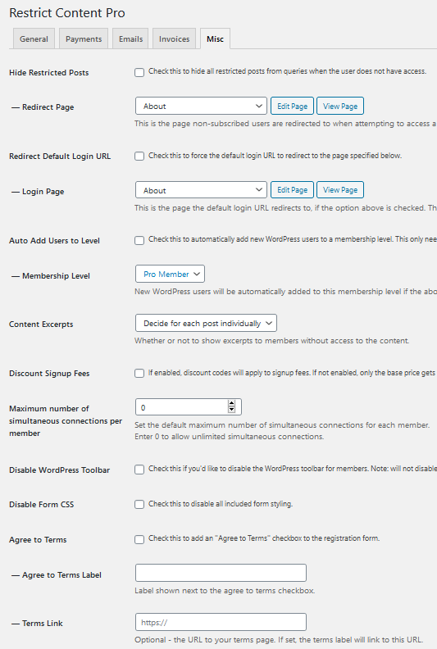

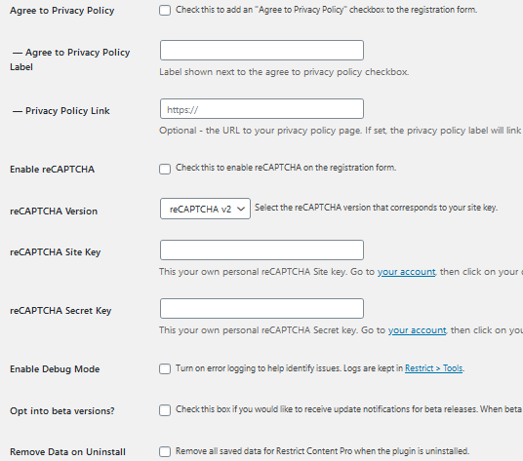

# Appendix

## General Website Sections

These are sections which are often used on more than one page across the website.

[Tech Note: I recommend to add these sections into Content Blocks are reuse across the website like shortcodes. Shortcodes may use parameters to manipulate sections content]

### Section ‘Leaderboard’

Features:

* Sorting rules by points
  + If points are equal, then sort by Activity Date/Time. Example:

|  |
| --- |
| Place 1. Points: 100. Last Active: 3 months  Place 2. Points: 100. Last Active: 10 days  Place 3. Points: 100. Last Active: 3 hours |

**Eligible** user – it’s a user role ‘Subscriber’ and ‘Member’.

Only eligible users are displayed in the Leaderboard.

This section may look like this

|  |  |
| --- | --- |
| This is how it looks like if it is in left or right sidebar | This is how it looks like by all website width: |

Description:

* ‘*Community Leaderboard Every action has a reaction! Read articles, join discussions, watch videos - every time you interact on the site, you’ll gain points. See how many you can score!*’ – Static text;
* ‘FULL LIST’ – Link to [page ‘Leaderboard’](#_Page_‘Leaderboard’). It opens in the same window.
* Leaderboard displays on [Eligible](#_Leaderboard) users;
* Tabs:
* [NEXT VERSION: Mentor]

|  |
| --- |
| Description:   * Total points earned based on the following activity:   1. Responding to Forum Questions   2. Responding to AMAs   3. Participation in Networking Events |

* This Month. Active by default. It shows top 5 users with max points during the current month;
  + [Tech Note: run CRON to reset monthly points to 0 for all users on FIRST day of each month at 00:00:00 GMT];
* This Year. Active by default only if there are no users on the ‘This Month’ tab. It shows top 5 users with maximum points during the current year;

Notes:

* If there are no users on a tab then display this message ‘*Leaderboard scores are updated daily.*’
* [Nov 30, 2020: I decided include such user and display their username instead] ~~Include only those users into the list who has at least First or Last name completed.~~ 
  + ~~If user do not have First and Last names, then do not include his/her into the list.~~

User data:

* Number. It’s a position in the Leaderboard;
* User avatar;
* User name from **Users -> First and Last Name**;
  + If both First and Last are empty, then display **User->Username**;
* Active:
* Note: [Last Active] – it’s number of seconds/minutes/hours/days/months/years when user last time earned points. Always round down towards the nearest integer. For example, 5,99 -> 5.
* Note 2: For '1 second, minute, hour, day, month, year' do not add 's' at the end.
* If [Last Active] < 60sec, then show ‘X seconds’.
* If 60 sec <= [Last Active] < 60 min, then show ‘X minutes’.
* If 60 min <= [Last Active] < 24 hours, then show ‘X hours’.
* If 24 hours <= [Last Active] < 1 month, then show ‘X days’.
* If 1 month <= [Last Active] < 1 year, then show ‘X months’.
* If 1 year <= [Last Active] < n-years, then show ‘X years’.
* Otherwise: do not show.
* Points. Summary for this month or for this year, based on the active tab.

### Section ‘Get to Know Pro Members’

This section may look like this:

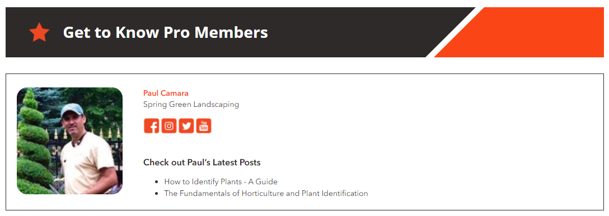

Controls description:

* This section **randomly** displays some UAG member details. New UAG member is displayed each time when page is refreshed;
* User photo. This is **Users->Gallery Image**.
  + IF it’s empty, then use **Users->Profile Picture**
  + Otherwise - do not display an image.
* Section/user details are described in the [chapter ‘UAG Members’](#_Page_‘UAG_Members’_1).

### Section ‘Pro Members You May Know’

This section is displayed for users with [Free membership](#_Membership_/_User) only. [Tech Note: use UM shortcode to show/hide it]

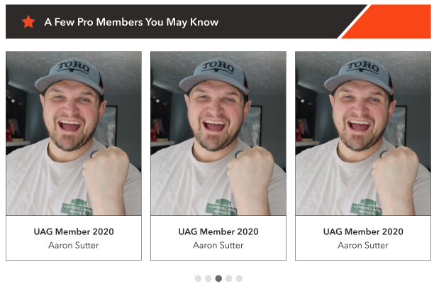

[Design Note: avatars are 150x150px. So need to modify creative for square photos]

Controls description:

* Randomly display 5 UAG members. These are users who has **[UAG Member] = True** in profile. [Tech Note: Algorithm: 1) get amount of UAG members; 2) choose randomly a number from 1 to [UAG amount-5]; 3) then display next 5 members starting from this number].
* User tile. NOT a clickable tile, just a carousel
  + User avatar;
  + User company name
  + User name

Task: <https://app.asana.com/0/607038627868623/1197821910033353>

[Angelina, Oct, 15, 2020: At this stage, we hope that this section will be randomized profiles of any basic + pro member (no click-through)]

[NEXT VERSION: display user details by clicking on it tile

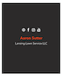]

### Section ‘Listen to the EMB Podcast’

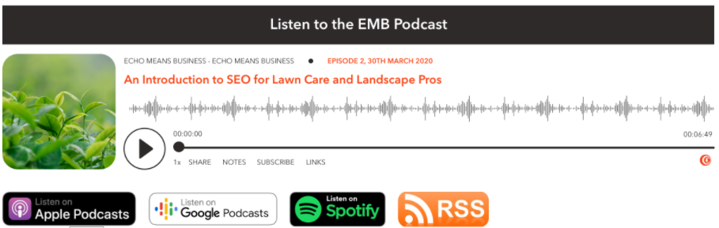

[Tech Note: code it like a shortcode or widget]

* ‘Listen to the EMB Podcast’ – Static text.
* Buttons:
* Listen on Apple Podcasts – Link to <https://podcasts.apple.com/ca/podcast/echo-means-business/id1502311446>. It opens in the new tab.
* Listen on Google Podcasts – Link to <https://podcasts.google.com/feed/aHR0cHM6Ly9mZWVkcy5jYXB0aXZhdGUuZm0vZWNoby1tZWFucy1idXNpbmVzcy8>. It opens in the new tab.
* Listen on Spotify – Link to <https://open.spotify.com/show/0NWOFOeWIlw7Ts2WGxfNVb>. It opens in the new page.
* RSS - Link to <https://feeds.captivate.fm/echo-means-business/>. It opens in the new tab.

### Section ‘Pro Tips’

[Tech Note: I recommend to add this section into Content Blocks like ‘*All pages – Pro Tips*’. HTML will include top horizontal section and shortcode to display categories and slider]

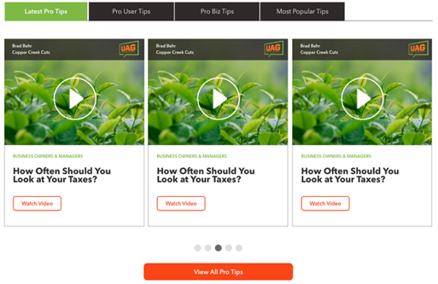

|  |
| --- |
| **Categories**  List of categories:    This section should include only the following items:   * **Latest Pro Tips**. Includes 5 recently added pro tips, sorted by date/time in descending order;   List of the categories which have at least one pro tip. The category name which is shown includes the name and ‘ Tips’ (dash and ‘Tips’).  NOTE: do not show the category, if it doesn’t have pro tips.   * **Pro User Tips**. Includes max 5 recently added pro tips into ‘*Pro User*’ category, sorted by date/time in descending order; * **Pro Biz Tips**. Includes max 5 recently added pro tips into ‘*Pro Biz*’ category, sorted by date/time in descending order; * [NEXT VERSION: **Most Popular Tips**].   Clicking these items changes slider with pro tips below. [Tech Note: use AJAX to update slider without reloading the page] |
| **Slider**    Slider includes:   * 5 pro tips based on selected category. Each pro tip includes: * The whole block is clickable. It opens same as ‘Watch Video’ (or ‘View Pro Tip’);   + Image; [Tech Note: User name, company name and UAG icon are part of image].   [NEXT VERSION: display user name, company and UAG icon automatically];   * + - If pro tip type is ‘*Video*’, then display play icon above the image;       * No hover ;       * Hover     - If **Pro Tips->UAG Member** was provided, then we show grey overlay with First and Last user name, Business Name, and UAG image.      * + Category name. If article has more than one category, show only one in ASC order;   + Pro Tip title;   + Button - Link to the page ‘[Pro Tip Details](#_Pro_Tips_–)’ It opens in the same window. Link depends on pro tip type (Video or Article), and can be:     - Watch video;     - View pro tip. * - Slider navigation. Clicking these items scrolls to particular pro tip; * Button to open page [‘Pro Tips by Category’](#_Pro_Tips_By) with all pro tips in the selected category.   + Button name should be ‘**View All**’ for all categories [Tech Note: I do not want to change button name based on the select category in this phase].   + DO NOT display this button when ‘**Latest Pro Tips**’ section is selected [Tech Note: this section is not a WP category, so it can be difficult or unclear what to display when ‘View All’ button is clicked]. |
| p |

### Section ‘Pro Forum’

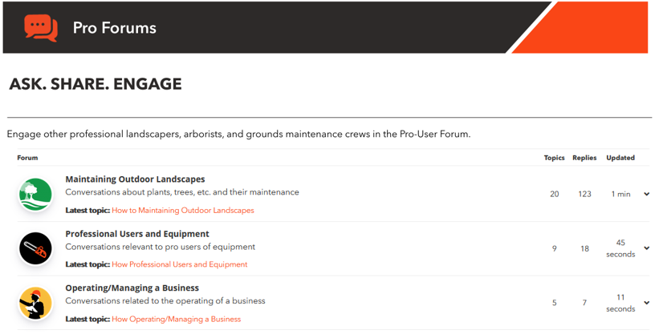

[Tech Note: this is WPForum plugin]

[Tech Note: Feb 5, 2021: I have to remove search from this section, because does search only forums, not topics or replies. This is how plugin works ☹]

### Section ‘Pro Rewards’

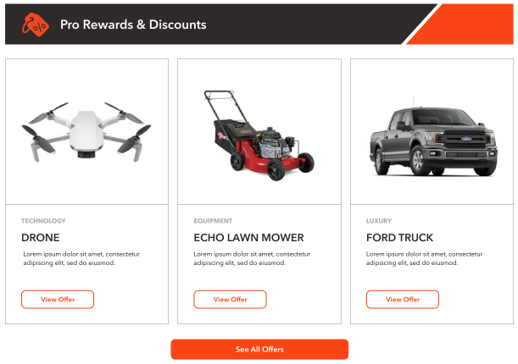

Controls description:

* Section title is static HTML;
* List of pro rewards is taken from [EMB Options->Pro Rewards->Featured Pro Rewards](#_Page_‘EMB_Settings’).
  + It displays items in the same order as in EMB Options;
  + It can have 1 or more items, not exactly 3. [Testing Note: check that this section will properly display 1,2,3,4,5,6 items];
  + Item. The whole tile is a link the same as ‘View Offer’
    - [Tile Image](#_Pro_Reward);
    - Category, e.g., ‘*Technology’*, ‘*Luxury’*;
      * If there is more than one category for pro reward, then display only the first one sorted by category name in ASC order;
    - [Tile Short Description](#_Pro_Reward);
    - View Offer. Opens [‘Pro Reward - Details’ page](#_Page_‘Pro_Reward) in the same window.

‘See All Offers’ button – Link to the [Pro Rewards page](#_Pro_Reward_(Partner) in the same window.

### Section ‘Pro Workshops’

[Nov 30, 2020: this is temporary copy for Pro Workshop section (in Zeplin):

* No links
* Just image and content

]

It may look like this:

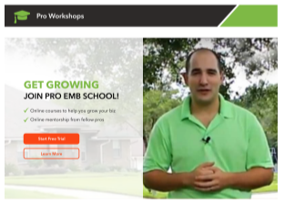

This is HTML block can be customized via [Content Blocks](#_Content_Block).

* Learn More. Opens [‘Pro Workshops’ page](#_Page_‘Pro_Rewards’) in the same window.

[Open Issue to Angelina: provide copy for Phase 1: <https://app.asana.com/0/1178924434621079/1199242527772224> ]

[NEXT VERSION: add links on actual workshops]

### Section ‘Pro Networking‘

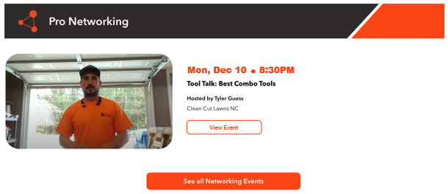

Controls description:

* Display one event where (Event->[Event Date] and Event->[Start Time]) < (the current date/time).
  + If there are > 1 such events, then sort events by **[Event Date and Start Time]** in ASC order and choose the 1st one. Means display event which will start soon;
  + If there are no such events, then display this:



* Event details are described on the [page ‘Pro Networking’](#_Pro_Workshop_(Public).

‘See all Networking events’ button – Link to the [‘Pro Networking’ page](#_Page_‘Pro_School’) in the same tab.

### Section ‘UAG‘

It may look like this:



This is HTML block can be customized via [Content Blocks](#_Content_Block).

* ~~The whole block should be a link on~~ [~~page ‘Get Mobile App’~~](#_Page_‘Get_Mobile) ~~in the same window;~~
* Google Play link: <https://play.google.com/store/apps/details?id=com.sensei.emb.android&pcampaignid=MKT-Other-global-all-co-prtnr-py-PartBadge-Mar2515-1>
* App Store link: <https://itunes.apple.com/us/app/echo-means-business/id1367138226?mt=8>

### Section ‘Check These Out’

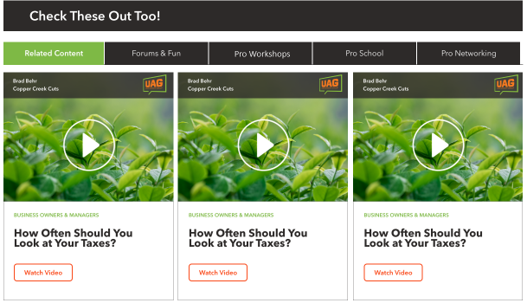

In general this section includes 5 tabs:

[Tech Note 1: we will use Content Blocks for some of these tabs/blocks below. But Content Blocks will include the horizontal bar with section name as well. So, maybe we can use a special parameter in a shortcode which will show or hide the horizontal bar based on where this block is displayed]

[Tech Note 2: some tabs will not be displayed on some pages. For example ‘Forum & Fun’ should not be displayed on the ‘Forum’ page]

* [NEXT VERSION: Related Content. It takes time to describe and code how articles will relate to offers and visa versa. This is why I moved into the next version]
* **Forum & Fun**.
  + Clicking this tab opens the same content as described on the [Hope page for the Forum](#_Page_‘Home’_1). It may look like this (for illustration only)

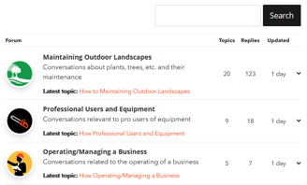

* **Pro Rewards**. This tab is selected by default.
  + Clicking this tab opens the same content as described on the [Hope page for the Pro Rewards](#_Page_‘Home’_1). It may look like this (for illustration only)

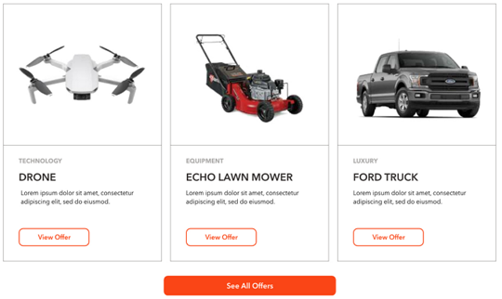

* + - NOTE: Button at the bottom of this block should be displayed as well
* **Pro Workshops**. Clicking this tab opens the same content as described on the [Hope page for the Pro Workshops](#_Page_‘Home’_1). It may look like this (for illustration only)

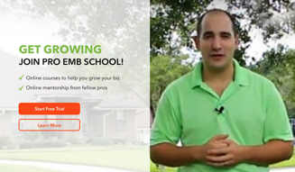

* **Pro Networking**. Clicking this tab opens the same content as described on the [Hope page for the Pro Networking](#_Page_‘Home’_1). It may look like this (for illustration only)

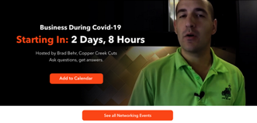

* + - NOTE: Button at the bottom of this block should be displayed as well

## Membership / User Roles

Website membership roles:

|  |  |  |
| --- | --- | --- |
| **Membership** | **Name on the main website** | **Description** |
| Free | Not applied | Not logged in user |
| Basic | Basic | Logged in user, but WP membership role is ‘Subscriber’ |
| Pro | Pro | Logged in user, and WP membership role is ‘Member’ |

[Notes from Sam]

|  |  |  |  |  |
| --- | --- | --- | --- | --- |
|  | **FUNCTIONALITY** | **PUBLIC USER** | **BASIC**  **(previous ‘GREEN’)** | **PRO** |
|  | **FREE MEMBERSHIP** | **FREE MEMBERSHIP** | **PAID MEMBERSHIP** |
|  |  | \*with online registration |  |
|  |  |  |  |  |
| **1** | **PRO TIPS & ADVICE** |  |  |  |
|  | Pro Articles & Content | LIMITED ACCESS [Open Issue: does it mean admin can decide what articles will be available for public? If not – please clarify] | VIEW/COMMENT | VIEW/COMMENT |
|  | NEW Pro Forum | READ ONLY | READ/COMMENT | READ/COMMENT |
|  | Leaderboard & Contests | READ ONLY | EARN / WIN | EARN / WIN |
|  |  |  |  |  |
| **2** | **PRO BENEFITS** |  |  |  |
|  | Business Offers/Experiences | VIEW ONLY | 1 FEATURED OFFER/MONTH | UNLIMITED ACCESS TO ALL OFFERS |
|  | Personal Offers/Experiences | VIEW ONLY | 1 FEATURED OFFERED/MONTH | UNLIMITED ACCESS TO ALL OFFERS |
|  |  |  |  |  |
| **3** | **PRO SCHOOL** |  |  |  |
|  | ONLINE COURSES | NO ACCESS | ACCESS TO ONE “MINI-COURSE” | FULL ACCESS TO ON-DEMAND COURSES |
|  | Plus ONLINE MENTORSHIP  [Open Issue: is it the same as online course in terms on functionality OR this is LIVE event? How it shudl work?] | NO ACCESS | NO ACCESS | 1 SESSION PER MONTH INCLUDED |
|  | LIVE EVENTS  [Open Issue: it looks like a duplication from Networking. If not – please clarify functionality] | NO ACCESS | ONLINE LIVE STREAMING OF EVENTS; FULL PRICE TICKETS IF SPACE AVAILABLE | EARLY BIRD ACCESS WHILE SPACE AVAILABLE, DISCOUNTED TICKETS |
|  |  |  |  |  |
| **4** | **PRO NETWORKING** |  |  |  |
|  | ONLINE VIDEO CHATS | NO ACCESS | VIEW ONLY (LIVE)  [Open Issue: I think this is regulated on 3rd party software side, not on the website. Correct?] | JOIN/PARTICIPATE  [Open Issue: I think this is regulated on 3rd party software side, not on the website. Correct?] |
|  | LIVE EVENTS | NO ACCESS | ONLINE LIVE STREAMING OF EVENTS; FULL PRICE TICKETS IF SPACE AVAILABLE | EARLY BIRD ACCESS WHILE SPACE AVAILABLE, DISCOUNTED TICKETS |
|  |  |  |  |  |
|  | MEET UP APP (FUTURE) | N/A | VIEW ONLY | CREATE & ATTEND  [Open Issue: please provide more details about this. Maybe future phase] |
|  |  |  |  |  |

## Secure dialog for Admin

In WordPress we had an issue with basic authentication dialog not working for /wp-admin/index.php.

We tried to solve this issue with NGINX configuration, but had no success.

In the end we changed all redirects from /wp-admin/index.php to just /wp-admin.

Redirect Admin users to /wp-admin so there is a basic authentication dialog box prompts for additional username and password?

[Oct 12, 2020 from Dima]

|  |
| --- |
| //---------------------------------------------------------------------------  // Redirect /wp-admin/index.php -> /wp-admin/  //---------------------------------------------------------------------------  add\_action( 'admin\_init', 'redirect\_index\_to\_wp\_admin' );  function redirect\_index\_to\_wp\_admin() {  if(strpos($\_SERVER['REQUEST\_URI'], '/wp-admin/index.php') !== false) {  wp\_redirect( admin\_url() );  exit;  }  } |

## Search Results

This page lists the relevant results according to the search query.

[Tech Note: It will use standard WP functionality and does search in all objects which WP indexes.]

This page may look like this (included into the Main template):

* **No results found**:

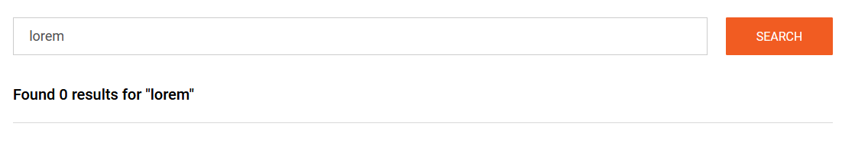

* **Some results found**:

|  |
| --- |
|  |

Controls description:

* 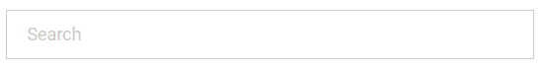 - search box. It’s a single-line textbox. Max length 300 chars. Placeholder ‘Search’
  + [NEXT VERSION: add auto-completion feature]
* Search button. It returns search results based on standard WP algorithms.
  + Searched text should remain in the textbox for quick correction.
* Section ‘Results’.
  + If no results found, then see how page should look like above in ‘**No results found**’.
  + If some results found, then page may look like above in ‘**Some results found**’.
    - List of results.
      * Most relevant results at the top [Tech Note: it should be done by WP, no extra coding required];
      * Title. This is a page, forum, article and other custom post titles; [Dev Note: In what objects WP can do search?].
        + This is a link on the found object in the same window;
      * Short fragment. [Tech Note: it should be done by WP, no extra coding required].
        + [Dev Note: does WP highlight searched phrase in the content? If NO – is it easy to implement?].
    - Page navigation. [Tech Note: use standard WP page navigation. Display 10 items per page].

## Video Hosting Service

[Open Issue to Angelina:

* What next steps. We recommend to buy Vimeo – Business Plan]

[Oct 30, 2020 from Andrei Stepasuk]

|  |
| --- |
| 1. Question about ability to track percent of video viewed progress.  In accordance with Vimeo documentation this option is available after Google Analytics integration in Business and Premium plans - https://vimeo.zendesk.com/hc/en-us/articles/224980588-Integrating-with-Google-Analytics  Also (as I understood for cheaper plans) there is article how to write custom code, that allows you to track video progress - <https://www.urbaninsight.com/article/tracking-progress-embedded-vimeo-videos>  2. About a way of embedding video on the page. In accordance with their Player SDK you have different ways:  a) To embed video with iframe tag, but you have full control on a player.  b) to embed video with any other HTML tag and also have full control on a player.  Examples - <https://developer.vimeo.com/player/sdk/basics>  3. About Wordpress plugins. There are several Vimeo Wordpress plugins, that allows to create galleries with Vimeo videos or show them in modal window or list of videos in a slider. But I think they are not useful for your goal.  <https://vimeo.com/upgrade> |

## Set/Reset Like Status

[Tech Note: I like how this works and looks here <https://wpulike.com/templates/> 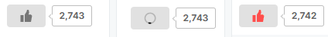]

Like visibility:

* It is visible for all users: logged in and not logged in.

Actions:

* Only logged in users can LIKE or RESET their likes.
* If NOT logged in user clicks LIKE icon, then redirect on the [Log In page](#_Page_‘Log_In’_1) in the same window.

Control description:

* Not liked yet by this user:
  +  - no likes for this item;
  + 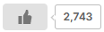 - there are some likes from other users;
* Liked by logged in user
  + 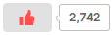- this is how it should look like when user liked this item.

Clicking LIKE or RESET like should display a quick pre-loader similar to this: 

## Date/Time format for Comments

Comments will use simplified date/time format.

[Tech Note: Note: date/time must be re-calculated and displayed in user local date/time, because date/time in DB is in GMT]

Date/Time format. Note: [Time Ago] = [Current Date/Time] - [Date/Time]

* If [Time Ago] < 24hr, then <time>. Example: ‘3:12’.
* If 24hr <= [Time Ago] < 48hr, then ‘yesterday’.
* Else - <date>. Example: Dec 01, 2020.

## List of Comments

List of comment displays comments from Old to New.

* New at the top, Old at the bottom.

This section may look like this (for illustration only):

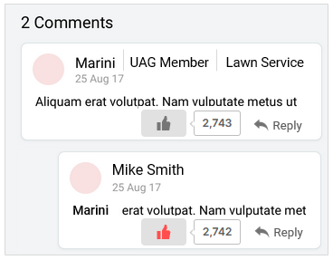

‘<N> Comments’:

* if there 1 comment the display 'Comments'
* if there are > 1 comments then display '<N> Comments'

Comment description:

* User avatar or placeholder if there is no avatar;
* Display Name;
* <user role>. If user role is UAG then ‘*UAG member*’, else – do not display role;
* <user Business Name>. If user has a Business Name then display it, else – do not display;
* Date/time when comment was posted. See [Date/time format for comments](#_Date/Time_format_for_1).
* Comment;
  + There are 2 levels only
    - All replies are displayed like the 2nd level, even if user replied on a reply
    - Example:

|  |
| --- |
| Comment 1  Reply 1.1 on comment 1  Reply 1.2 on comment 1  Reply 1.3 on reply 1.2  Comment 2  Reply 2.1 on comment 2  Reply 2.2 on reply 2.1  Reply 2.3 on reply 2.2  Comment 3  Comment 4  … |

* + If text includes words which begins with ‘www.’, ‘http://’ or ‘https://’ then they should look like links and be clickable to open an external browser. Links should look like links: echo brand orange color and underlined.
  + If this is a REPLY, then <username> to whom it was replied, should be displayed before the comment, see example:

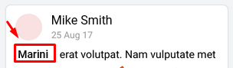

*  - Like action.
  + Disabled if 1) user is not logged in or 2) user is logged in and this comment belongs to this user (cannot like own comments).
  + SET / NOT SET icon status described in the [chapter ‘Set/Reset Like Status’](#_Set/Reset_Like_Status).
*  - Reply action
  + Disabled if 1) user is not logged in;
  + Clicking this icon opens the comment section.

List of comments is Empty if there are no comments.

## Points

Points are awarded ~~to all user roles, but only~~ [Jan 26, 2021: It was decided do not add points for Admins and others not eligible users which will simplify the SQL for getting points and increase page speed] to [eligible users](#_Section_‘Get_to) only. ~~are displayed in the Leaderboard~~.

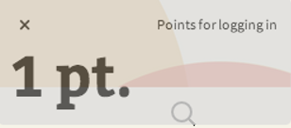 - This pop-up notification about getting X point(s) user will see at the top right or bottom corner.

Table with points:

[PM: add points for new features such as offers, school and networking]

[PM: review points for new activities and new table from Angelina

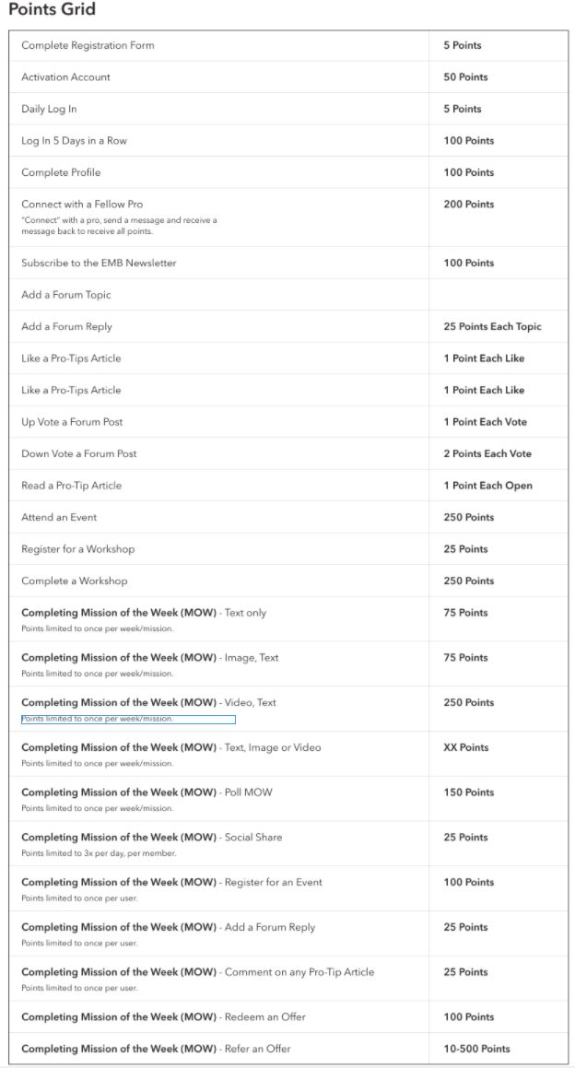]

[Open Issue to Angelina: This action cannot be applied, because this user may not exist yet. I recommend to remove it

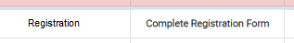]

Points [Feb 23, 2021 updated]

|  |  |
| --- | --- |
| **Actions** | **Points**  **Earned** |
| **FORMAT**   * It shows how and where [Notification] will be displayed | |
| *[Status: implemented]*  ***Activate account***   * *User activates account after the registration process*   **Notification:**  *‘activating account’* | 50 |
| *[Status: implemented]*  ***Daily Log In***   * *Logs in to site. Points awarded once per day for this action.*   Rule:   * Max 1 point per day * Record this point when user logs in or auto-logs in via website/mobile * It adds point independent from Mobile app log in actions   **Notification:**  *‘logging to site’* | 5 |
| *[Estimate ~2hr]*  ***Log In 5 Days in a Row***   * *Logs in once per day for 5 consecutive days. Points can be awarded every set of 5 - consecutive log in, no maximum points*   Rule:   * Max 100 point per 5 days * Count user log in or auto-log in via website/mobile   *[Tech Note: reset counter every time when points added. Example:*   * *Day 1-4: user logged in every day* * *Day 5: user logs and system adds 100 points;* * *Day 6-9: user logged in every day: do not add 100 points yet, because no 5 consecutive days yet* * *Day 10: user logs in and system add another 100 points]*   **Notification:**  *‘logging in 5 days in a row’* | 100 |
| *[Status: implemented]*  ***Complete profile***   * *Completes all fields in their user profile completeness form.*   **Notification:**  *‘completing profile’* | 100 |
| *[NEXT VERSION ?]*  ***Connect with a Fellow Pro***   * *Points awarded when member Messages (must be two way communication) with another member AND becomes friends with them. (both actions have to be taken)*   **Notification:**  *‘connecting with a fellow pro’* | 200 |
| *[NEXT VERSION: there is no option to subscribe during registration. All automatically subscribed. I recommend to remove this from a website.*  *NOTE: according mailcast rules – user must be in database to be able receive emails. We can manually add users into mailcast database who completes the form ‘Sign up to get the latest news’ in the footer]*  ***Subscribe to the EMB Newsletter***   * *Subscribes to newsletter(s), either on registration or on site post-registration*   **Notification:**  *‘subscribing to the EMB newsletter’* | 100 |
| *[Status: implemented]*  ***Add a forum topic***   * *Adds a topic to the forum (points awarded to max 3 topics per day = 75)*   **Notification:**  *‘adding a forum topic’* | 25 each topic |
| *[Status: implemented]*  ***Add a forum reply***   * *Adds a reply to forum post (points awarded to max 7 responses per day = 175)*   **Notification:**  *‘adding a forum reply’* | 25 each reply |
| *[Estimate ~2hr]*  ***Up / Down Vote a Forum Post***   * *Up / Down Votes forum posts by members (points awarded to max 10 per day)*   [Tech Note: check if user already Up/Down particular post this day, then do not add point for Up/Down action. User can Up / Down this post next day.  So, technically we allow cheating on the next day, but not inside the current day.  Trying to avoid cheating at all will slow down system significantly. This is why I decided to allow cheating on the next day]*.*  **Notification:**  *‘voting a forum post’* | 1 per vote |
| [Mar 11, 2021. I decided to merge it with Up voting]  ***~~Down Vote a Forum Post~~***   * *~~Down Votes forum posts by members (points awarded to max 10 per day)~~* ~~[Tech Note: need to code algorithm which will prevent people to UP/DOWN on the same reply to gain points]~~*~~.~~*   **~~Notification:~~**  *~~‘down voting a forum post’~~* | ~~1 per vote~~  ~~[note: I used 1 instead of 2, to make up/down equal]~~ |
| *[Estimate ~1hr]*  ***Like a Pro-Tips Article***   * *Likes content posted to the site (articles, etc). (points awarded to max 10 per day)*   [Tech Note: check if user already Liked particular post this day, then do not add point for this action action. User can Unlike and Like this post next day.  So, technically we allow cheating on the next day, but not inside the current day.  Trying to avoid cheating at all will slow down system significantly. This is why I decided to allow cheating on the next day]*.*  **Notification:**  *‘liking a pro-tips article’* | 1 per like |
| *[Estimate ~2hr. I added this. It was not in the original list of tasks]*  ***Like a Pro-Tips Comment***   * *Likes comment of any Pro-Tip. (points awarded to max 10 per day)*   Rule:   * The same cheating rules as for ‘***Like a Pro-Tips Article***’   **Notification:**  *‘liking a pro-tips comment’* | 1 per like |
| *[Estimate ~1hr]*  ***Read a Pro-Tip Article***   * *Points awarded when logged in user opens an article*   Rule:   * Even if user opens the same article N times, he/she gets only 1 point   [Tech Note: save point for this in MyCRED table. Do search by UserID and PointID and then parse JSON to see if this article was visited or not]  **Notification:**  *‘reading a pro-tips article’* | 1 per open |
| *[NEXT VERSION: because in this version I removed ‘Email’ feature]*  ***Share a Pro-Tip via Email***   * *Up to 3 per day per member, points earned per email sent.*   Rule:   * Maximum 75 points (3 x 25) per day * Even if user clicks send N times for the same article, he/she gets only 25 points   **Notification:**  *‘sharing a pro-tip via email’* | 25 per email |
| ***Share a Pro-Tip on Any Social Platform***   * *Up to 2 per day per member*   Rule:   * Maximum 50 points (2 x 25) per day * Even if user clicks different SHARE icons N times for the same article, he/she gets only 25 points * We can track clicks on SHARE icon, we cannot track if he/she actually shared or not   **Notification:**  *‘sharing a pro-tip on any social platform’* | 25 per share |
| ***Comment on any Pro-Tip Article***   * *Maximum 5 per day per member*   Rule:   * Maximum 125 points (5 x 25) per day * [Dev Note: it is preferable to check that comments during a day for different articles, not for a single one];   **Notification:**  *‘commenting on pro-tip article’* | 25 per comment |
| *[NEXT VERSION: because user can register and then unregister for any event]*  ***Register for an Event***  **Notification:**  *‘registering for an event’* | 25 |
| *[NEXT VERSION: this can be tracked manually only]*  ***Attend an Event***  **Notification:**  *‘attending as event’* | 250 |
| *[NEXT VERSION: there are no workshops in phase 1]*  ***Register for a Workshop***   * *Workshops will be pre-recorded videos. "Alerts" will be available weeks before the video is posted to the site. Members will get points when they subscribe to the alert feature for this video. An email will be sent to all those who are subscribed when the video is posted live. Points are awarded when they register for alert. Removed if they unsubscribe to the alert.*   **Notification:**  *‘registering for a workshop’* | 25 |
| *[NEXT VERSION: there are no workshops in phase 1]*  ***Complete a Workshop***   * *Watched recorded video till the end.*   **Notification:**  *‘completing a workshop’* | 250 |
| *[NEXT VERSION: there are no MOW in Phase 1]*  ***Missing of the Week.***   * ***Text only (mandatory)*** * ***Image (mandatory) , Text (optional)*** * ***Video (mandatory), Text (optional)*** * ***Text (optional), Image OR Video (mandatory)***   *Rule:*   * Points limited to once per week/mission   **Notification:**  *‘completing a mission of the week’* | 75 |
| *[NEXT VERSION: there are no MOW in Phase 1]*  ***Missing of the Week.***   * ***Poll*** *[Open Issue to Angelina: what is this, please explain?]*   *Rule:*   * Points limited to once per week/mission   **Notification:**  *‘completing a poll of a mission of the week’* | 150 |
| *[NEXT VERSION: there are no MOW in Phase 1]*  ***Missing of the Week.***   * ***Social Share***   *Rule:*   * Points (not action) limited to 3x per day, per member   **Notification:**  *‘social sharing of a mission of the week’* | 25 |
| ***Redeem Offer***   * *For select offers only (Offer of the Week). Points earned when user clicks "redeem" on the select "offer of the week." Points earned once per week per user.*   **Notification:**  *‘<X> points – redeem offer’* | 100 |
| *[NEXT VERSION: there is not such feature]*  ***Refer a Friend***   * *Points: 10 points for every email sent through referral (max 5 per day); if referree enrolls points earned: 500 per referred member.*   **Notification:**  *‘refering a friend’* | 10 / 500 |

Existing points:

|  |  |
| --- | --- |
| **Actions** | **Points**  **Earned** |
| [Jan 22, 2020. Added for new job]  NOTE: I decided do not include clicks on SHARE buttons, because it is difficult to track such clicks and check if it was actual shared or not | |
| WEBSITE. LOG IN or AUTO-LOGIN  Rule:   * Max 1 point per day * Record this point when user log in or auto-log in via website * It adds point independent from Mobile app log in actions   **Notification:**  *‘<X> points – logging to site’* | 1 |
| MOBILE APP. LOG IN or AUTO-LOGIN  [Tech Note: develop separate API for mobile app to call action when Login/Auto-Login occurs]  [Tech Note: save login date from mobile app in a separate field in database, separate from last login date from website]  Rule:   * Max 1 point per day * Record this point when user log in or auto-log in via mobile app * It adds point independent from Website log in actions | 1 |
|  |  |
| MOBILE APP. CHALLENGE. ADD **RESPONSE**  Rule:   * No Max points limitations, because user can post only one response per one challenge | 3 |
| MOBILE APP. CHALLENGE **RESPONSE**. LIKE RESPONSE  Rule:   * 1 point per response. It means that even if user liked, then disliked, then liked again and so on – system should count only 1 point for this particular response.   + Even if user likes response today and dislikes and likes it again the next day – system will assign 1 point the day when he first time liked the response * Max 3 points per day. If user likes 3 different responses.   [Tech Note: Dislike will not deduct points. Technically it is quite complicated. I decided do not code this feature] | 1 |
| MOBILE APP. CHALLENGE **RESPONSE**. ADD COMMENT or REPLY TO COMMENT  Rule:   * 2 points per response per day. It means that even if user adds 2 (or more) separate comments inside one response the same day – system should count only 2 points for this particular response.   + Example:     - Today user added 3 comments for response #1 and 2 comments for response #2 - system adds 4 points this day:       * 2 points for response #1       * and 2 points for response #2.     - Next day this user adds 4 comments for the response #1 – system adds 2 points for this day. * Max 10 points per day. If user comments in 5 different responses. | 2 |
| MOBILE APP. CHALLENGE **RESPONSE**. LIKE COMMENT  Rule:   * 1 point per response per day. It means that even if user liked, then disliked the same comment or different comments inside the same response the same day – system should count only 1 point for this particular response within this day.   + Example:     - User likes 5 comments in response #1 and 3 comments in response #2 this day – system adds 2 points: 1 point for response #1 and 1 point for response #2.     - The next day user likes other comments or (dislikes and likes again the same comment) in response #1 – system add 1 point that day * Max 3 points per day. If user likes comments in 3 different responses.   [Tech Note: Dislike will not deduct points. Technically it is quite complicated. I decided do not code this feature] | 1 |
|  |  |
| MOBILE APP. ADD **POST**  Rule:   * Max 9 points per day. Means only first 3 posts per day will give user points | 3 |
| MOBILE APP. **POST**. LIKE POST  Rule:   * The same as for ‘***CHALLENGE RESPONSE. LIKE RESPONSE***’ | 1 |
| MOBILE APP. **POST**. ADD COMMENT or REPLY TO COMMENT  Rule:   * The same as for ‘***CHALLENGE RESPONSE. ADD COMMENT or REPLY TO COMMENT***’ | 2 |
| MOBILE APP. **POST**. LIKE COMMENT  Rule:   * The same as for ‘***CHALLENGE RESPONSE. LIKE COMMENT’*** | 1 |
|  |  |
| MOBILE APP. **ARTICLE**. LIKE ARTICLE  Rule:   * The same as for ‘***CHALLENGE RESPONSE. LIKE RESPONSE***’ | 1 |
| MOBILE APP. **ARTICLE**. ADD COMMENT or REPLY TO COMMENT  Rule:   * The same as for ‘***CHALLENGE RESPONSE. ADD COMMENT or REPLY TO COMMENT***’ | 2 |
| MOBILE APP. **ARTICLE**. LIKE COMMENT  Rule:   * The same as for ‘***CHALLENGE RESPONSE. LIKE COMMENT’*** | 1 |

## Badges

Badges may look like this (for illustration only):

* All images are located in Project Drive here:  
  <https://drive.google.com/drive/u/0/folders/1JDvzkOtmbx14S066xhJ723riQXYY6D7c>

[Jan 20, 2021 from Angelina] Display badges step by step as soon they are available <https://app.asana.com/0/1178924434621079/1199686181349958>

We do not have Posts:

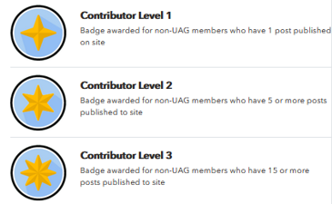

I disabeld messages for now to avoid SPAM messages which I do not know how to control for now

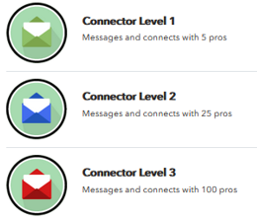

There are no Workshops

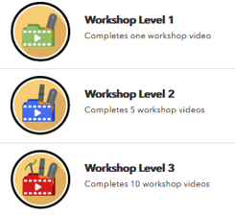

This cannot be added, because there are no related badges

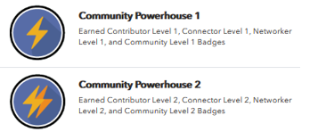

]

[Open Issue: with Angelina

<https://app.asana.com/0/1178924434621079/1199686181349951>

[Jan 16, 2021 from Angelina: We will need to clarify with NALP how many documents they are providing before we decide how this works. Hide for phase 1. I will come back to you once Sam provides me with more info.]

]

This is how badges may look like on a website:

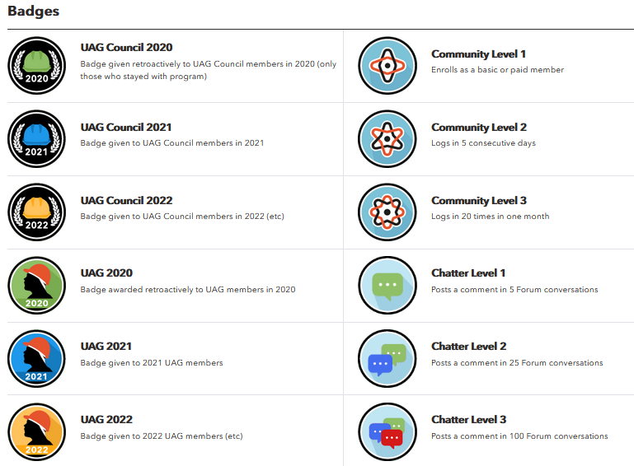

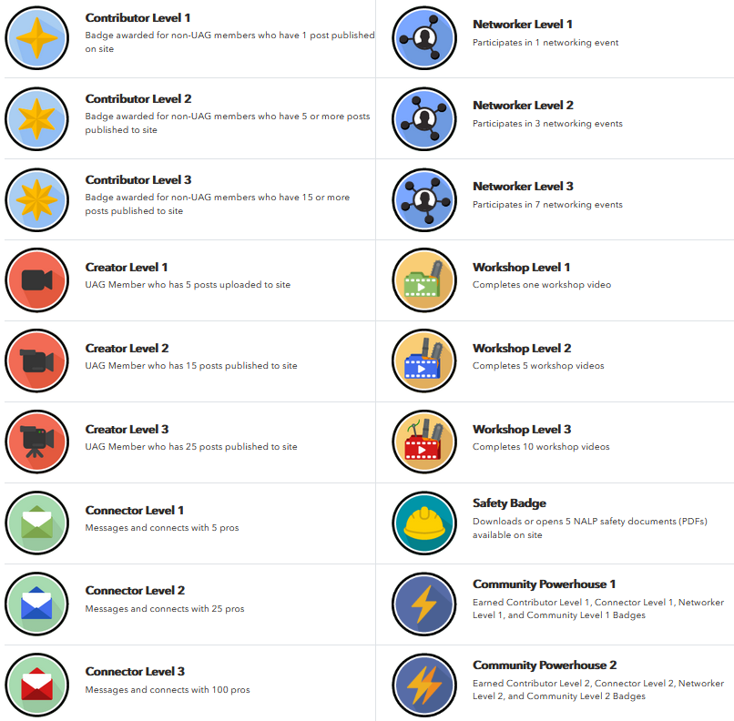

Rules:

* All rules are described here: <https://docs.google.com/spreadsheets/d/1nBFBaD2FtEHmWyJ3Zm5aMI1fgdKMMPkUK4o4SHdR69E/edit#gid=1653892273>

|  |  |
| --- | --- |
| **BADGE NAME** | **DESCRIPTION** |
| UAG Council 2020 | Badge given retroactively to UAG Council members in 2020 (only those who stayed with program) |
| UAG Council 2021 | Badge given to UAG Council members in 2021 |
| UAG Council 2022 | Badge given to UAG Council members in 2022 (etc) |
| UAG 2020 | Badge awarded retroactively to UAG members in 2020 |
| UAG 2021 | Badge given to 2021 UAG members |
| UAG 2022 | Badge given to 2022 UAG members (etc) |
| Contributor Level 1 | Badge awarded for non-UAG members who have 1 post published on site |
| Contributor Level 2 | Badge awarded for non-UAG members who have 5 or more posts published to site |
| Contributor Level 3 | Badge awarded for non-UAG members who have 15 or more posts published to site |
| Creator Level 1 | UAG Member who has 5 posts uploaded to site  UAG Members has a POST, if   * **User->UAG Member** = True * Field [**Pro Tip->UAG Member**](#_EMB_Settings) = this user id     Automatically assign a badge once admin adds or updates Pro Tip and sets this user id into UAG Member field.  NOTE: even if later admin will change or removes this UAG from the article, badge is not removed  NOTE 2: Write a script to assign these badges to those who already added 5, 15 and 25 posts   * + RULE:     - If user has 25 and more posts, then assign all 3 badges: Creator Level 1, Creator Level 2 and Creator level 3     - If user has 15-24 posts, then assign: Creator Level 1, Creator Level 2     - If user has 5-14 posts, then assign: Creator Level 1 |
| Creator Level 2 | UAG Member who has 15 posts published to site  The same as for ‘*Creator Level 1*’ but for 15 posts |
| Creator Level 3 | UAG Member who has 25 posts published to site  The same as for ‘*Creator Level 1*’ but for 15 posts |
| Connector Level 1 | Messages and connects with 5 pros |
| Connector Level 2 | Messages and connects with 25 pros |
| Connector Level 3 | Messages and connects with 100 pros |
| Community Level 1 | Enrolls as a basic or paid member |
| Community Level 2 | Logs in 5 consecutive days |
| Community Level 3 | Logs in 20 times in one month |
| Chatter Level 1 | Posts a reply in 5 Forum conversations  Check Forum->Replies:   * If user added 5th reply into a forum topic, then assign this badge. Count all replies even if they are in the same forum topic.   NOTE: Write a script to assign these badges to those who already added 5, 25 and 100 replies   * + RULE:     - If user has 100 and more replies, then assign all 3 badges: Chatter Level 1, Chatter Level 2 and Chatter level 3     - If user has 25-99 replies, then assign: Chatter Level 1, Chatter Level 2     - If user has 5-24 replies, then assign: Chatter Level 1 |
| Chatter Level 2 | Posts a reply in 25 Forum conversations  The same as for ‘*Chatter Level 1*’ but for 25 replies |
| Chatter Level 3 | Posts a reply in 100 Forum conversations  The same as for ‘*Chatter Level 1*’ but for 100 replies |
| Networker Level 1 | Participates in 1 networking event |
| Networker Level 2 | Participates in 3 networking events |
| Networker Level 3 | Participates in 7 networking events |
| Workshop Level 1 | Completes one workshop video |
| Workshop Level 2 | Completes 5 workshop videos |
| Workshop Level 3 | Completes 10 workshop videos |
| Safety Badge | Downloads or opens 5 NALP safety documents (PDFs) available on site |
| Community Powerhouse 1 | Earned Contributor Level 1, Connector Level 1, Networker Level 1, and Community Level 1 Badges |
| Community Powerhouse 2 | Earned Contributor Level 2, Connector Level 2, Networker Level 2, and Community Level 2 Badges |

## UltimateMember Settings

This section describes settings for UltimateMember plugin

### Email

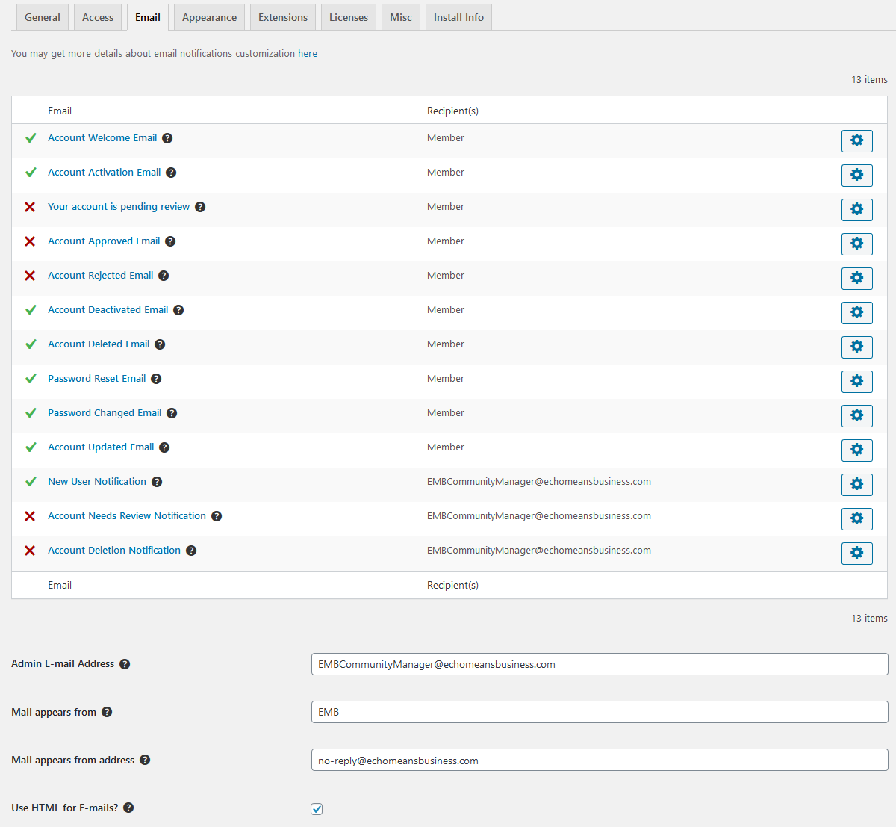

[Jan 22, 21. I used the following settings for now]

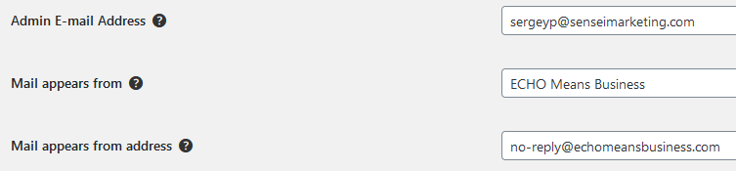

### Registration Form

Settings:

* Do not request strong password
* Do not add confirm password field

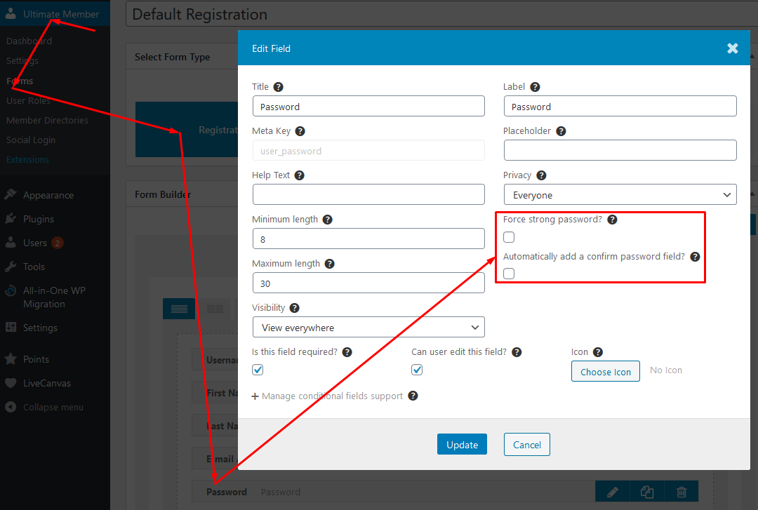

### User Roles

These settings require people to confirm their registration and automatically log in after confirmation.

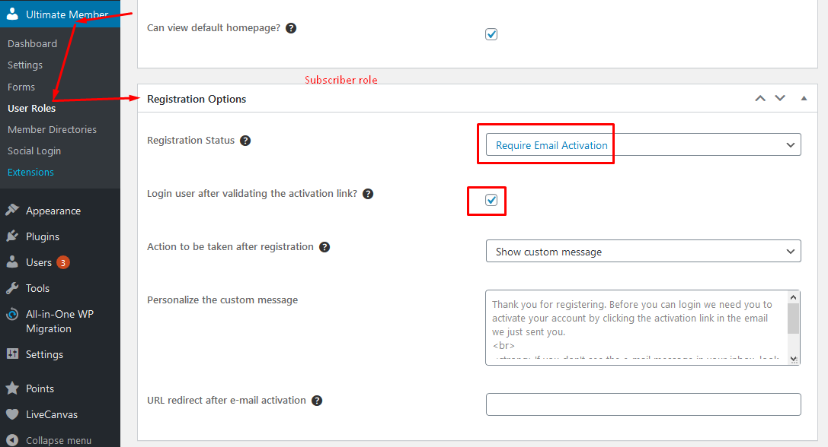

### Pages Tab

### Users Tab

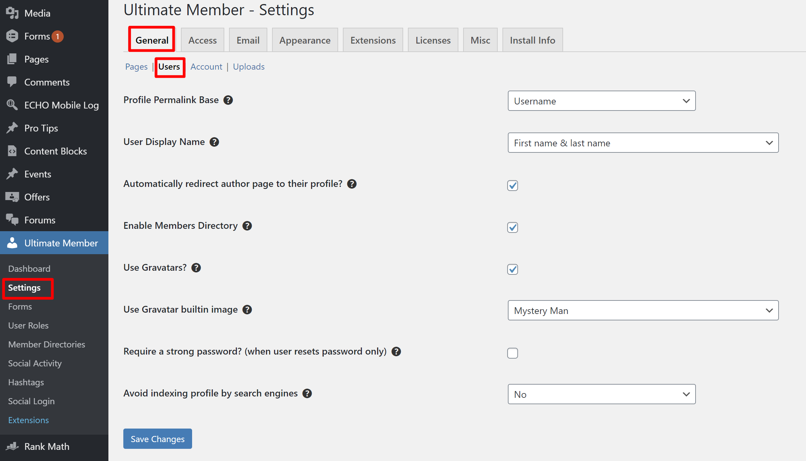

### Account Tab

Do not display Account tab inside My Account section for logged in user

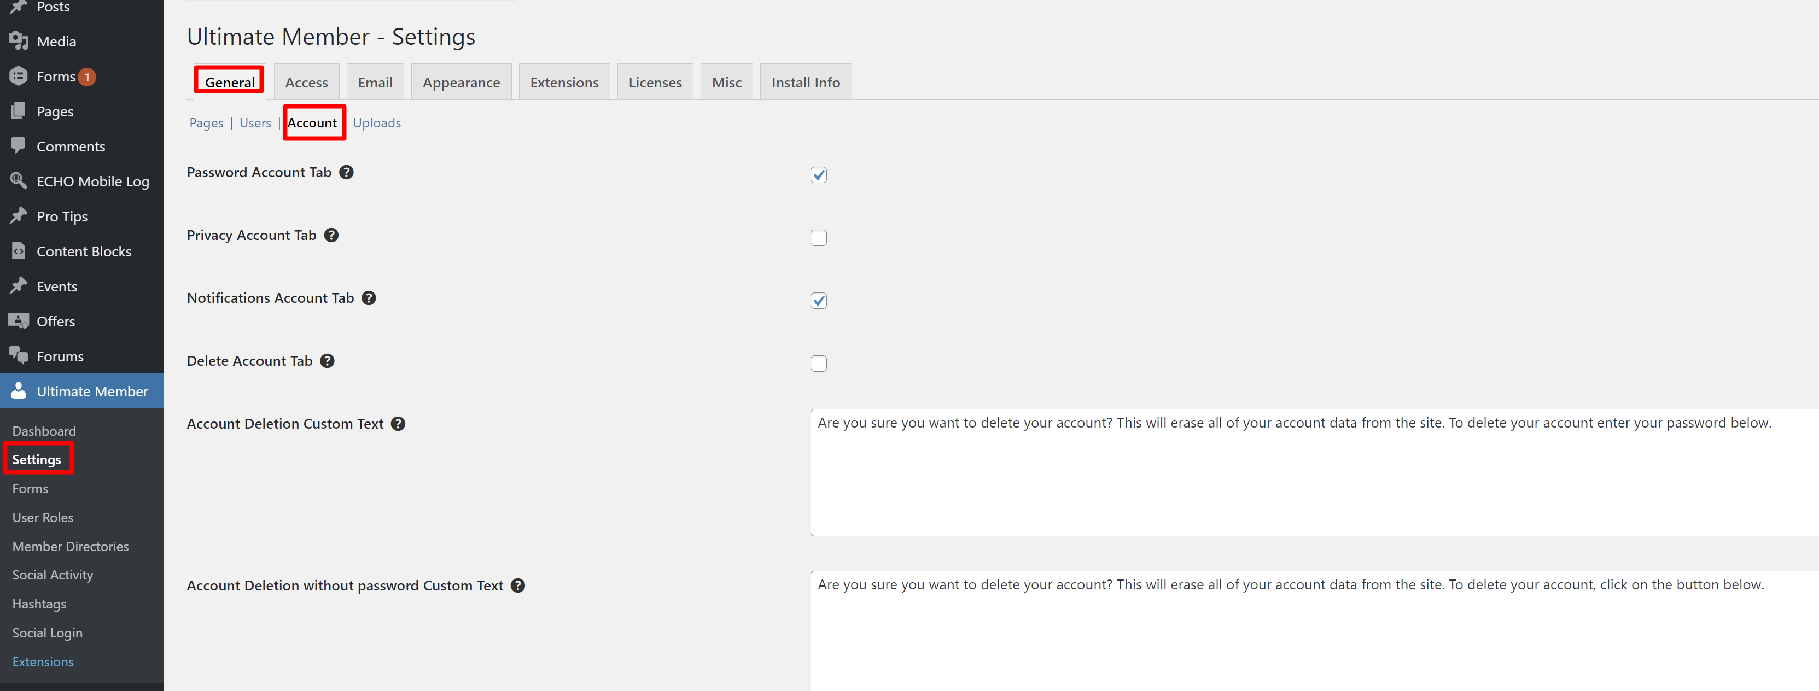

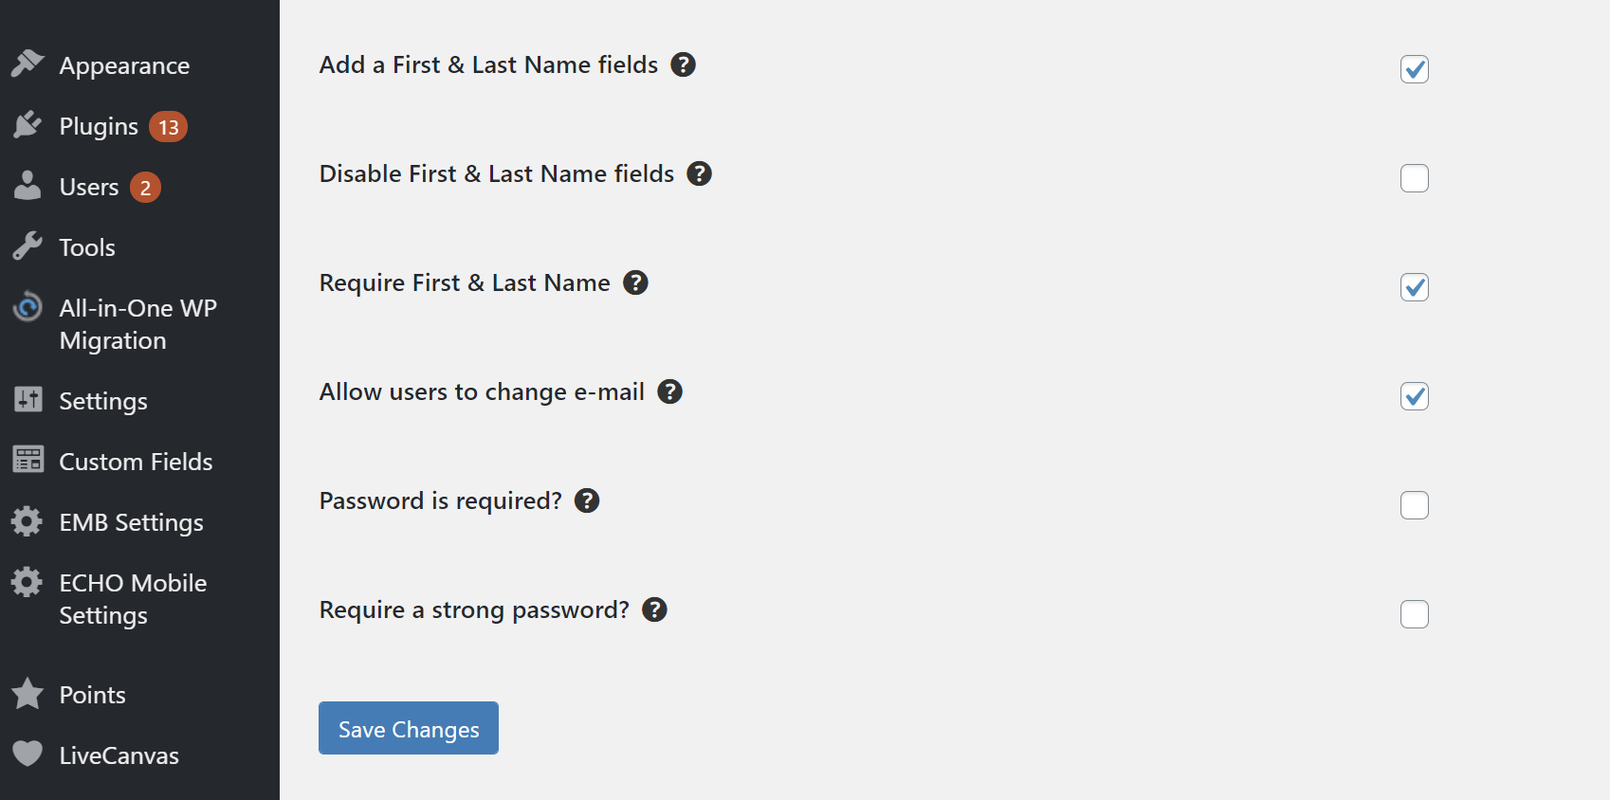

### Uploads Tab

### Access -> Restriction Content Tab

### Access -> Other Tab

### Appearance -> Profile

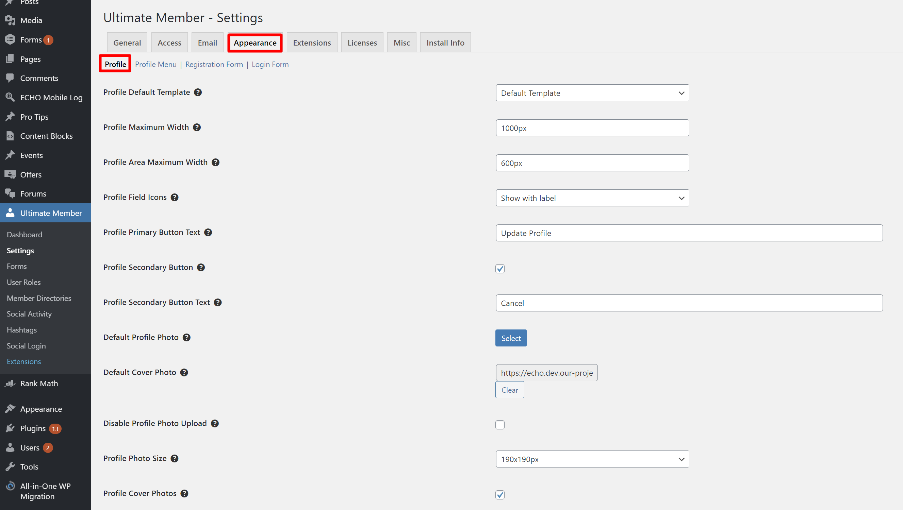

Apply this for the cover photo.

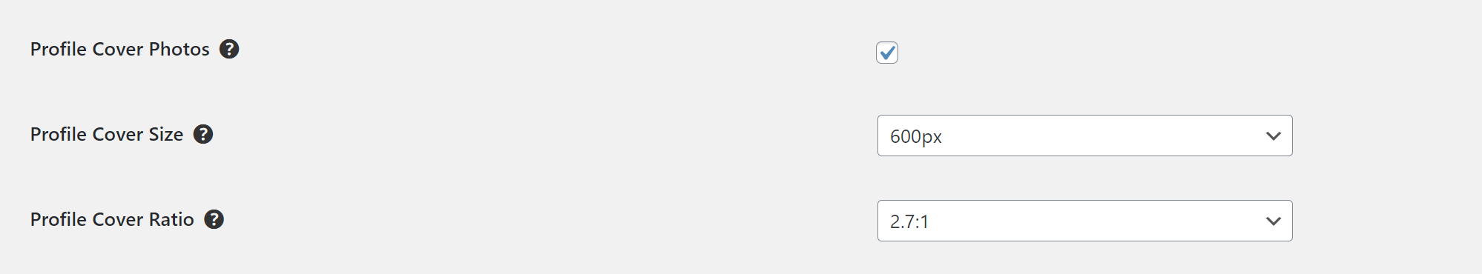

Default Cover Photo is provided by Laura <https://drive.google.com/drive/u/0/folders/1-wdVf4xiXO0mBHAjB6qxftv60QuE9Ss_>

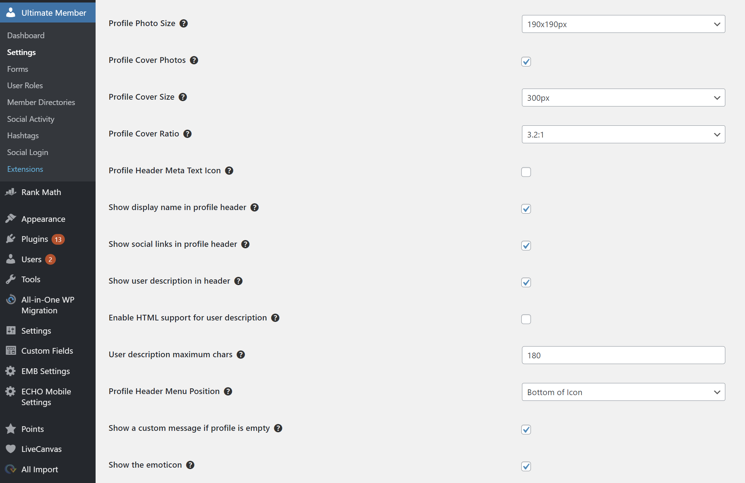

### Appearance -> Profile Menu

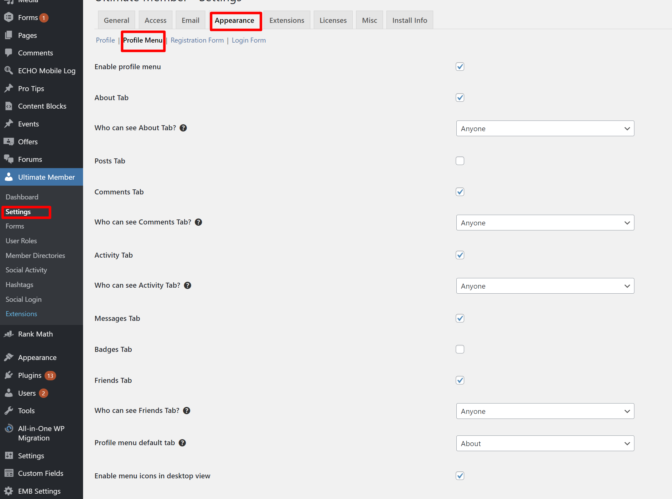

### Appearance -> Registration form

### Appearance -> Login form

### Extensions -> Friends

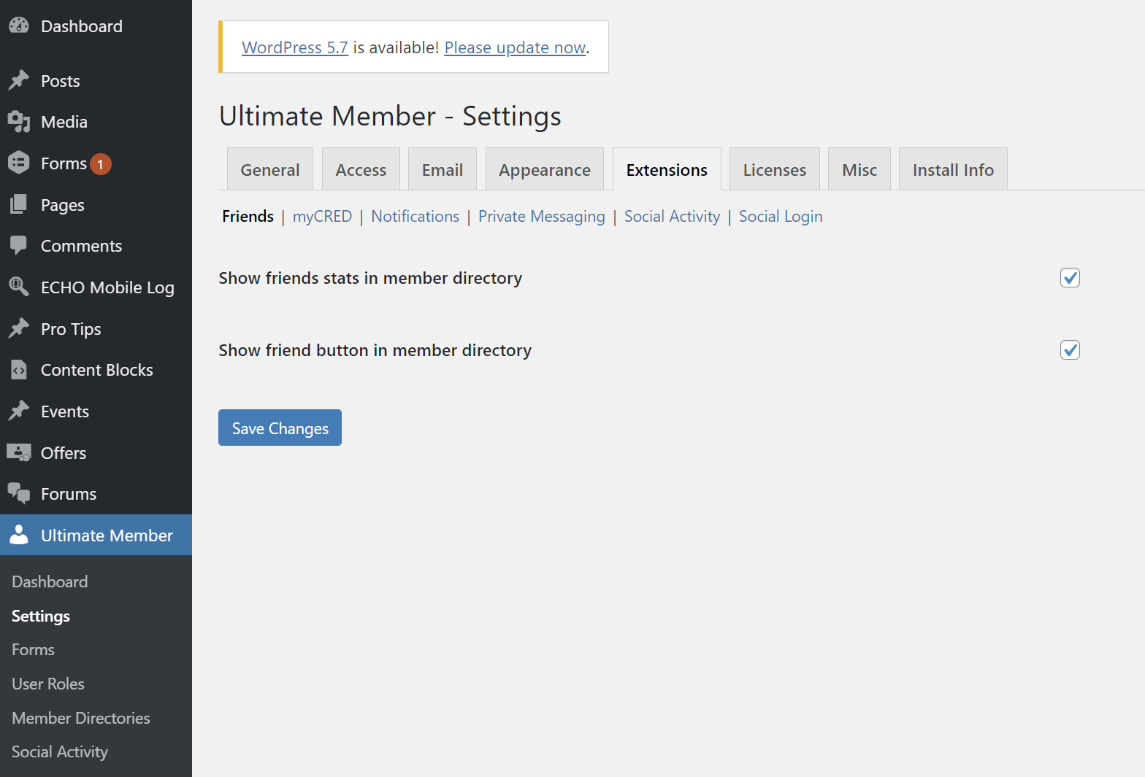

### Extensions -> myCRED

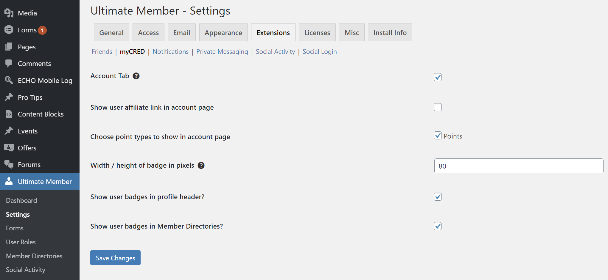

### Extensions -> Notifications

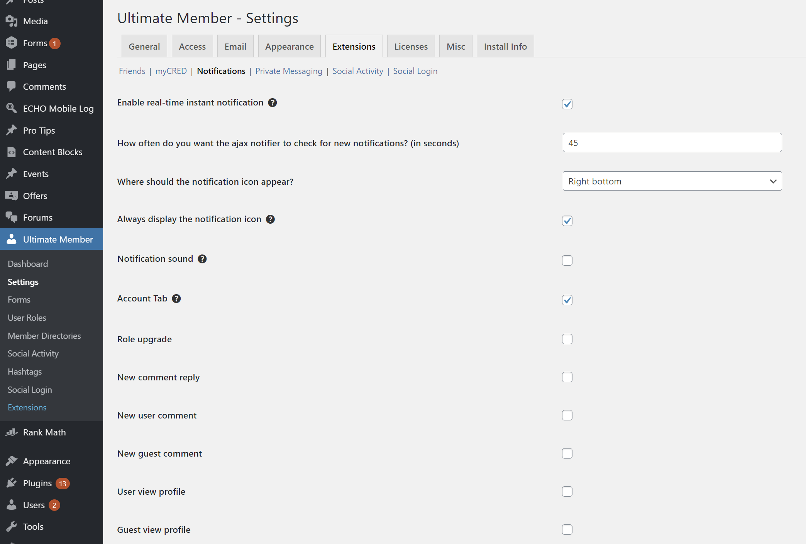

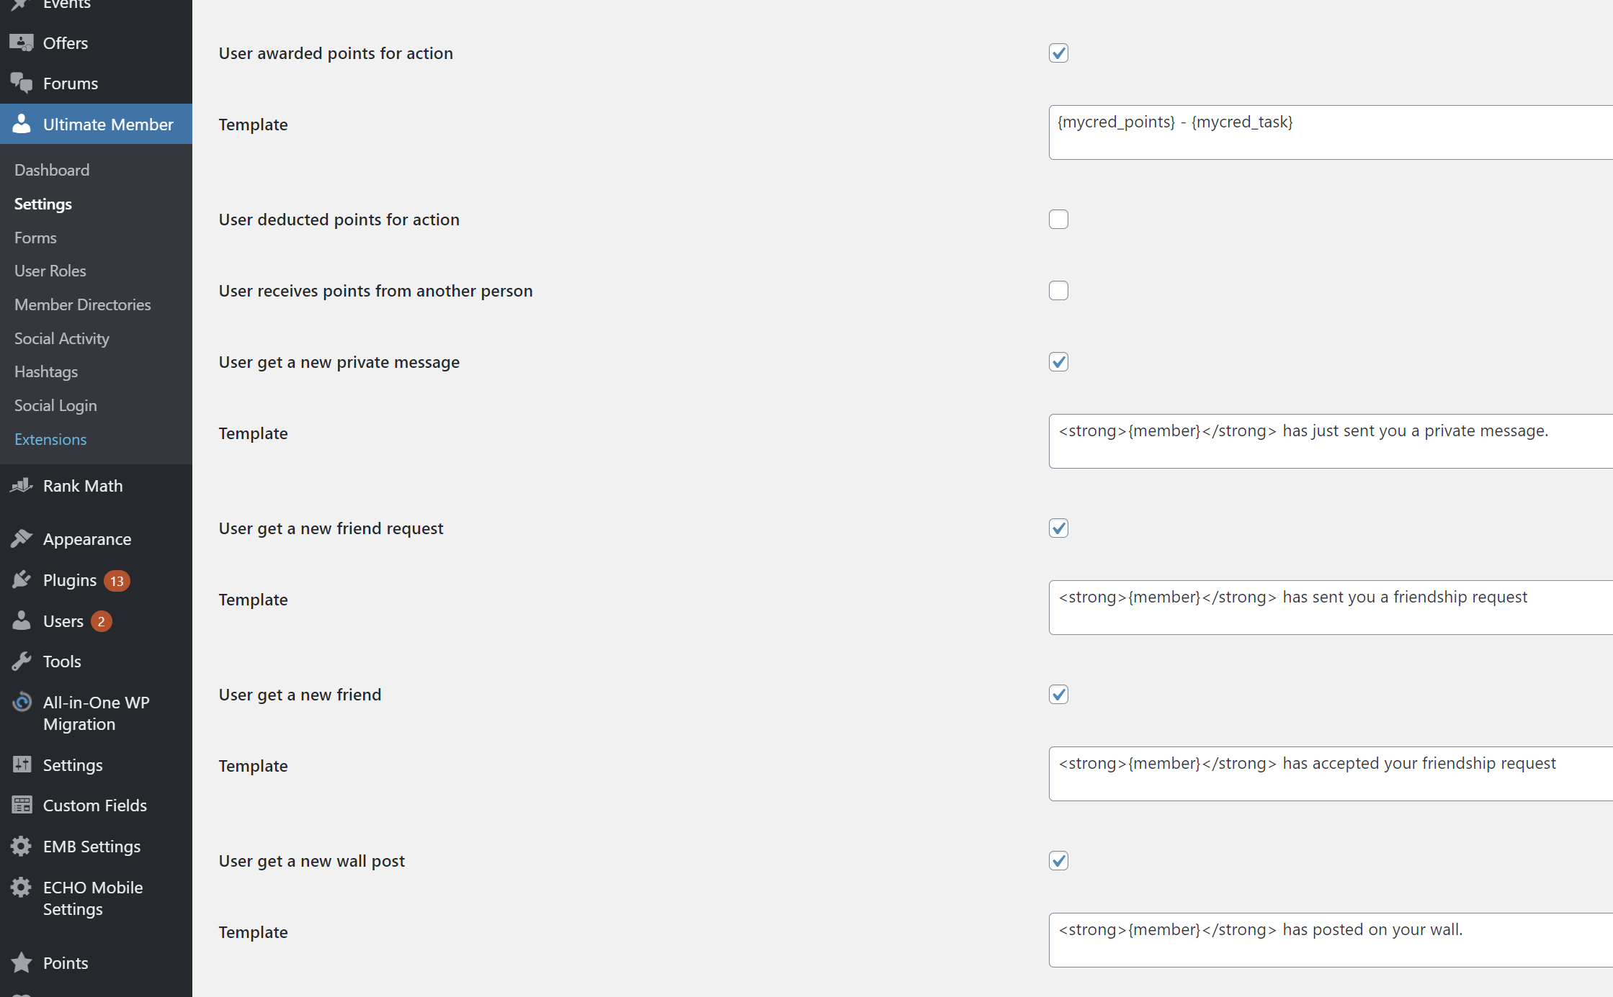

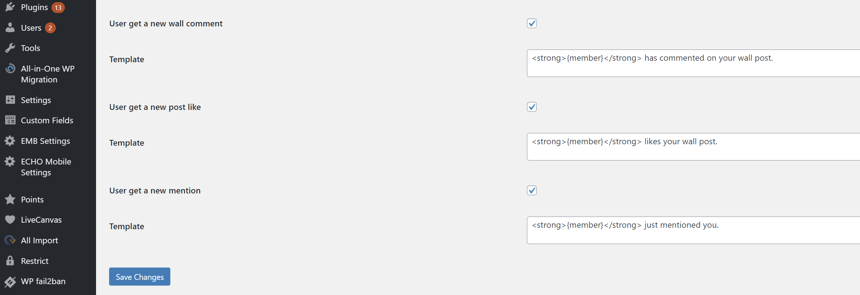

### Extensions -> Private messaging

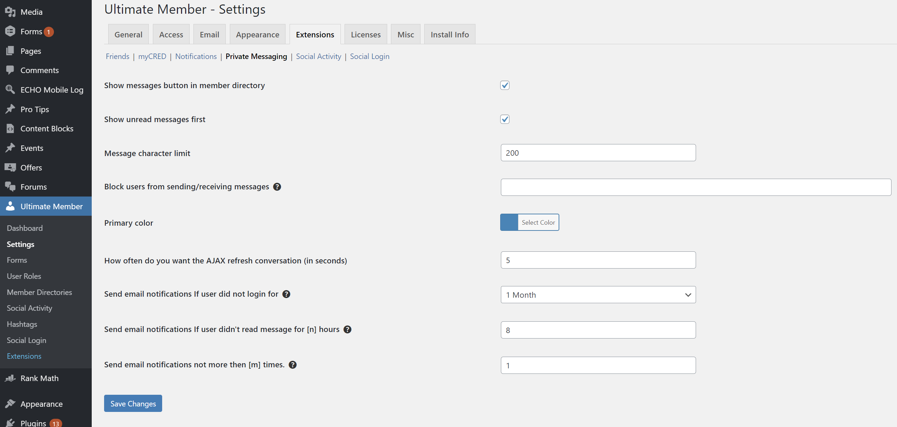

### Extensions -> Social Activity

### Extensions -> Social Login

### Misc

### User Roles (Master)

[Dec 1, 2020, from Dima]

New user role settings to be available to work with Forum

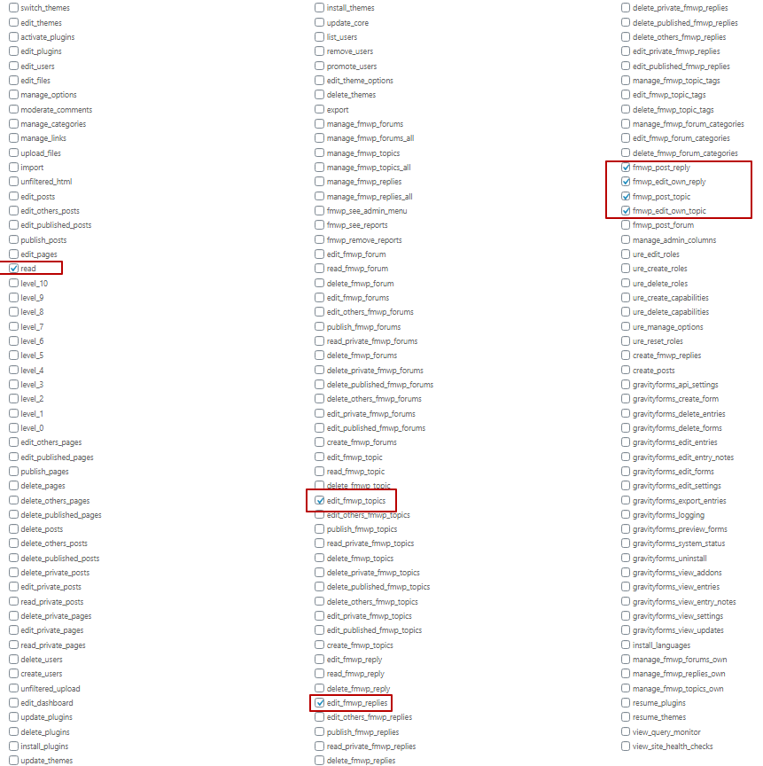

### Forms

#### Default profile

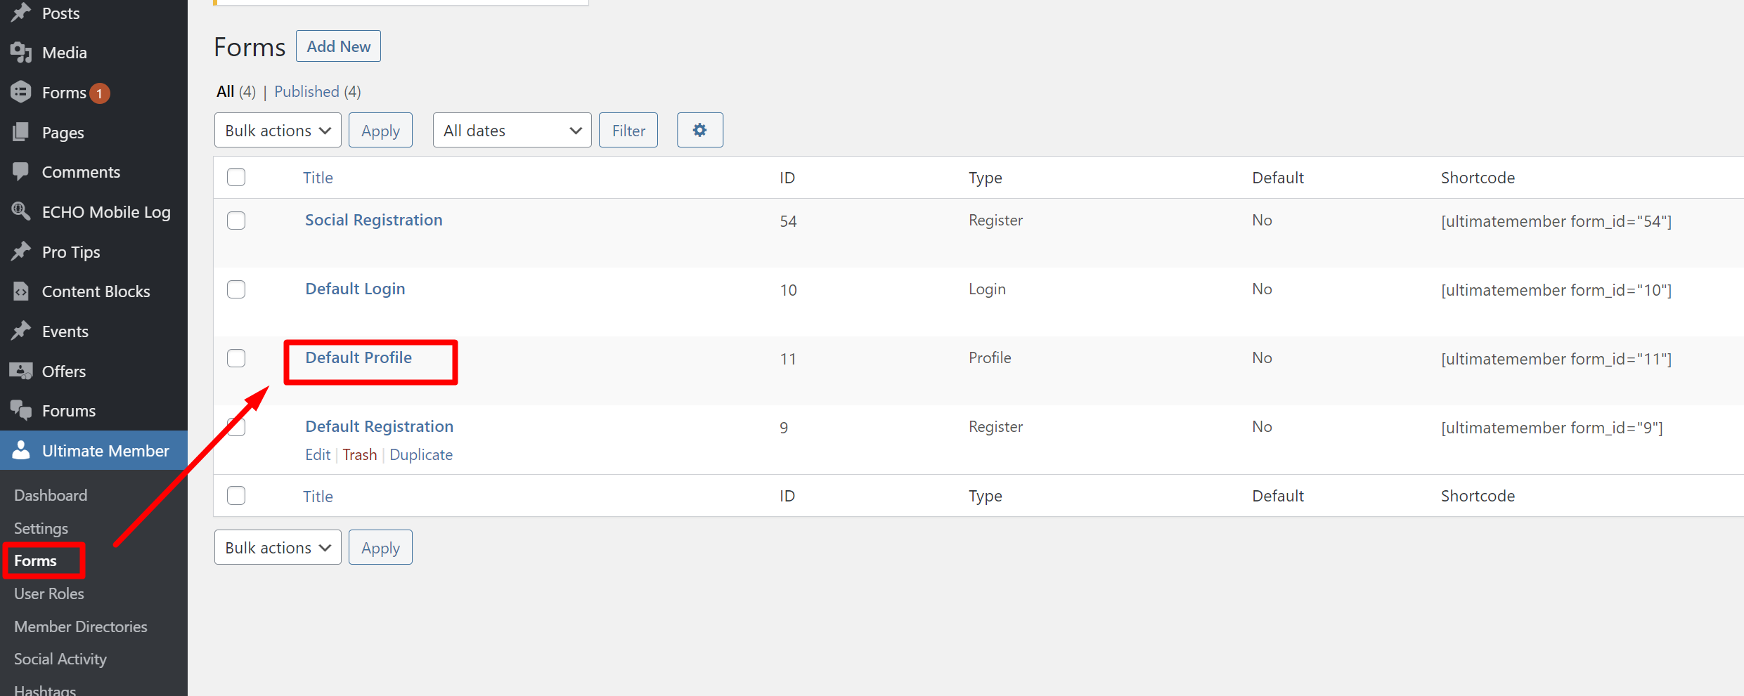

Fields list

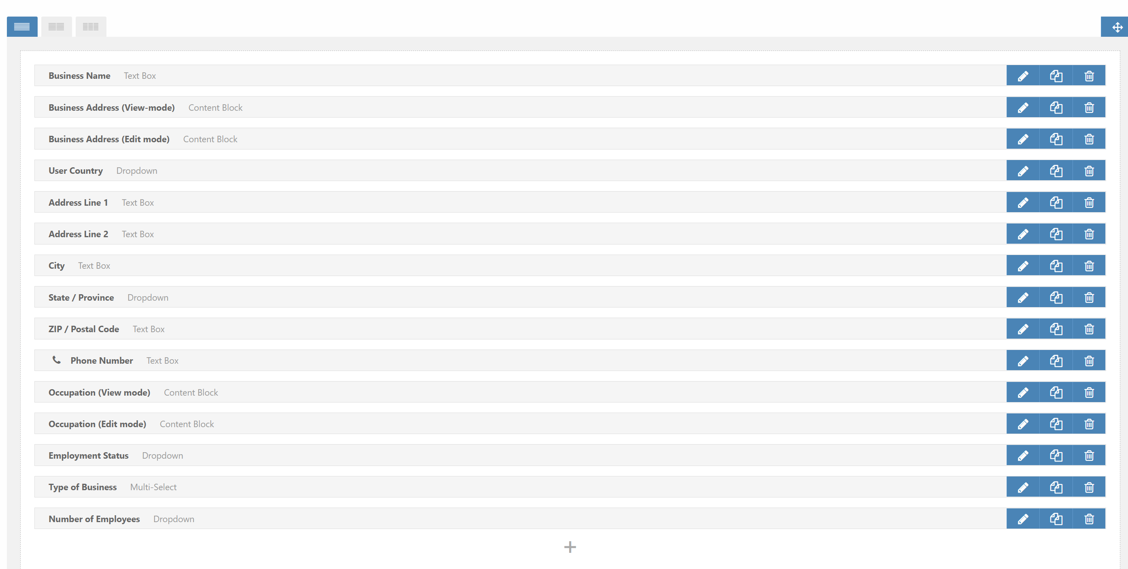

Fields settings one by one:

|  |  |
| --- | --- |
| Business name |  |
| Business Address (View-mode) |  |
| Business Address (Edit mode) |  |
| User Country |  |
| Address Line 1 |  |
| Address Line 2 |  |
| City | UPD: this field is required |
| State / Province | UPD: this field is required |
| Zip / Postal code |  |
| Phone number |  |
| Occupation (View mode) |  |
| Occupation (Edit mode) |  |
| Employment Status |  |
| Type of Business |  |
| Number of Employees |  |

### User roles

General list

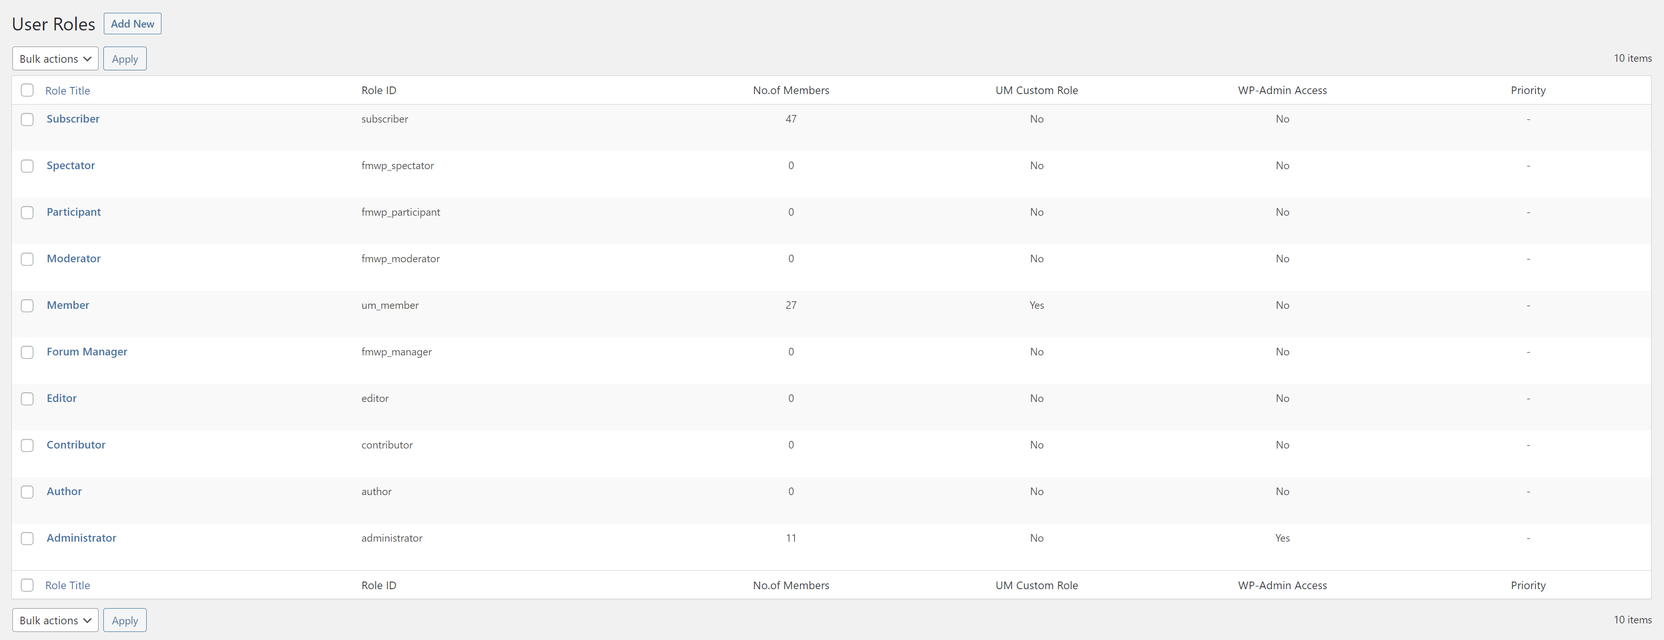

#### Subscriber

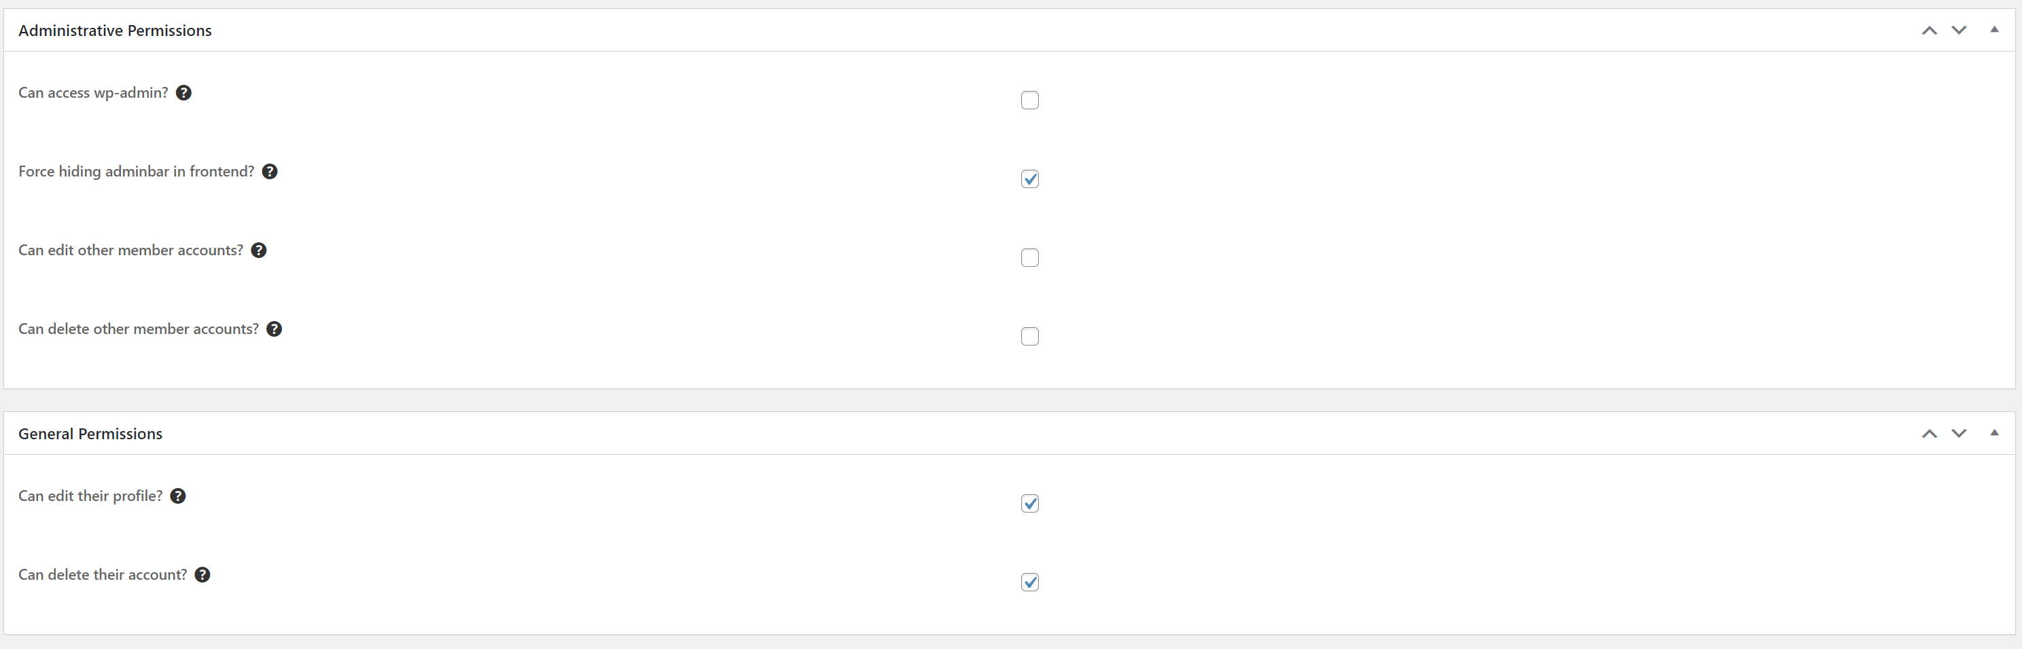

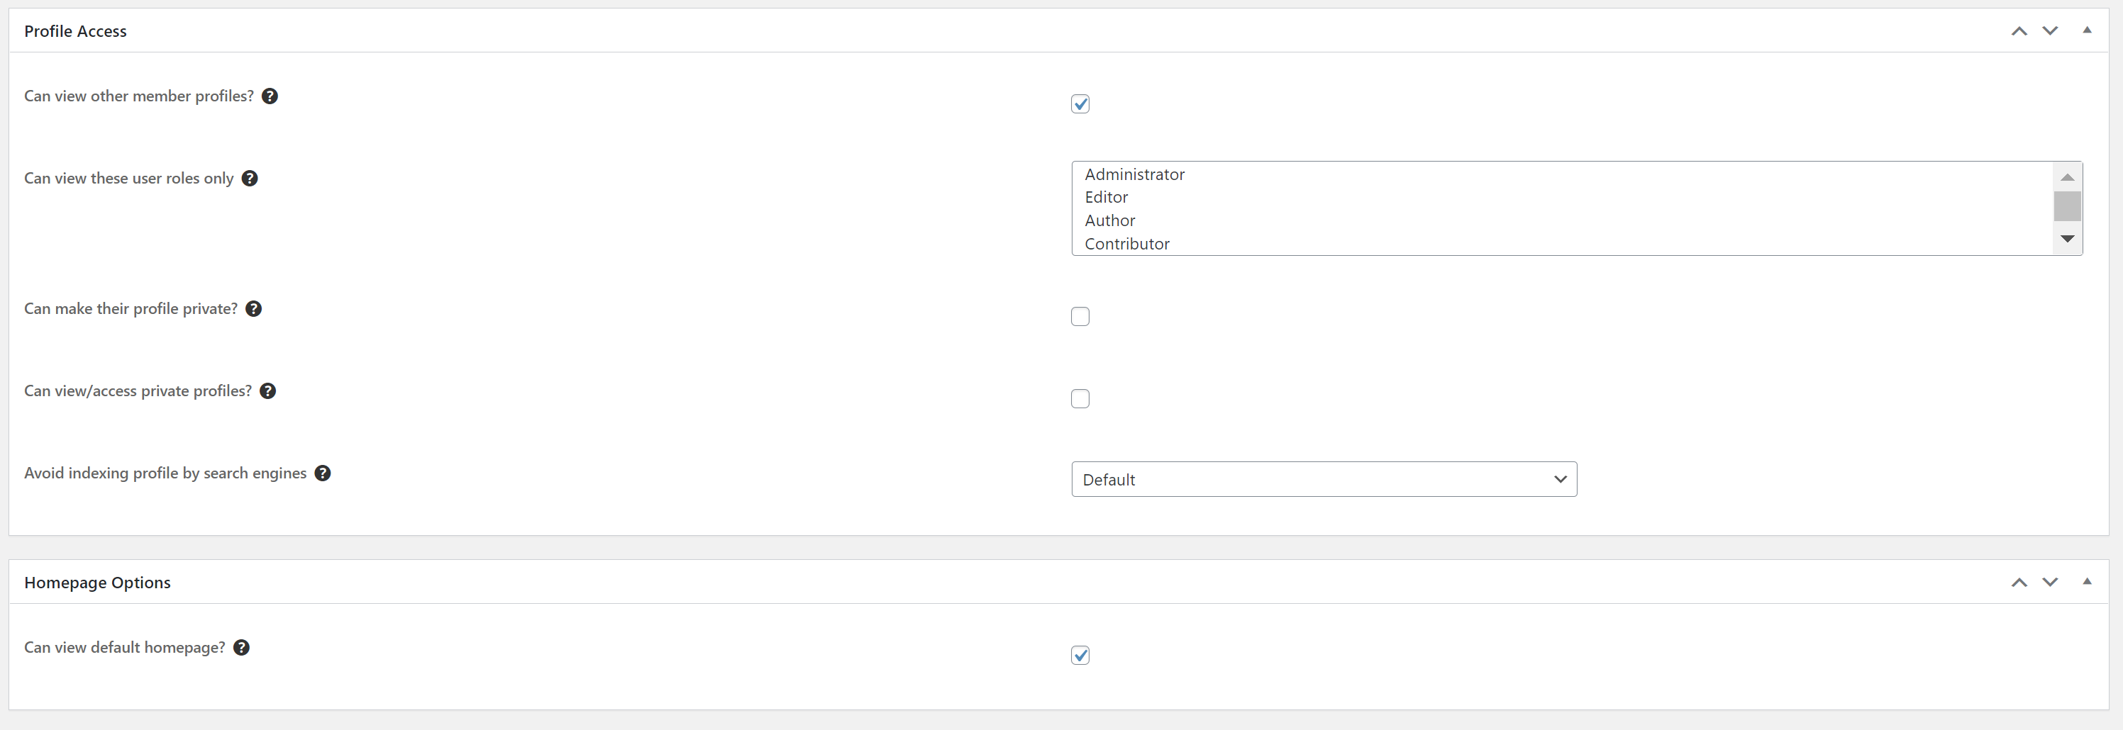

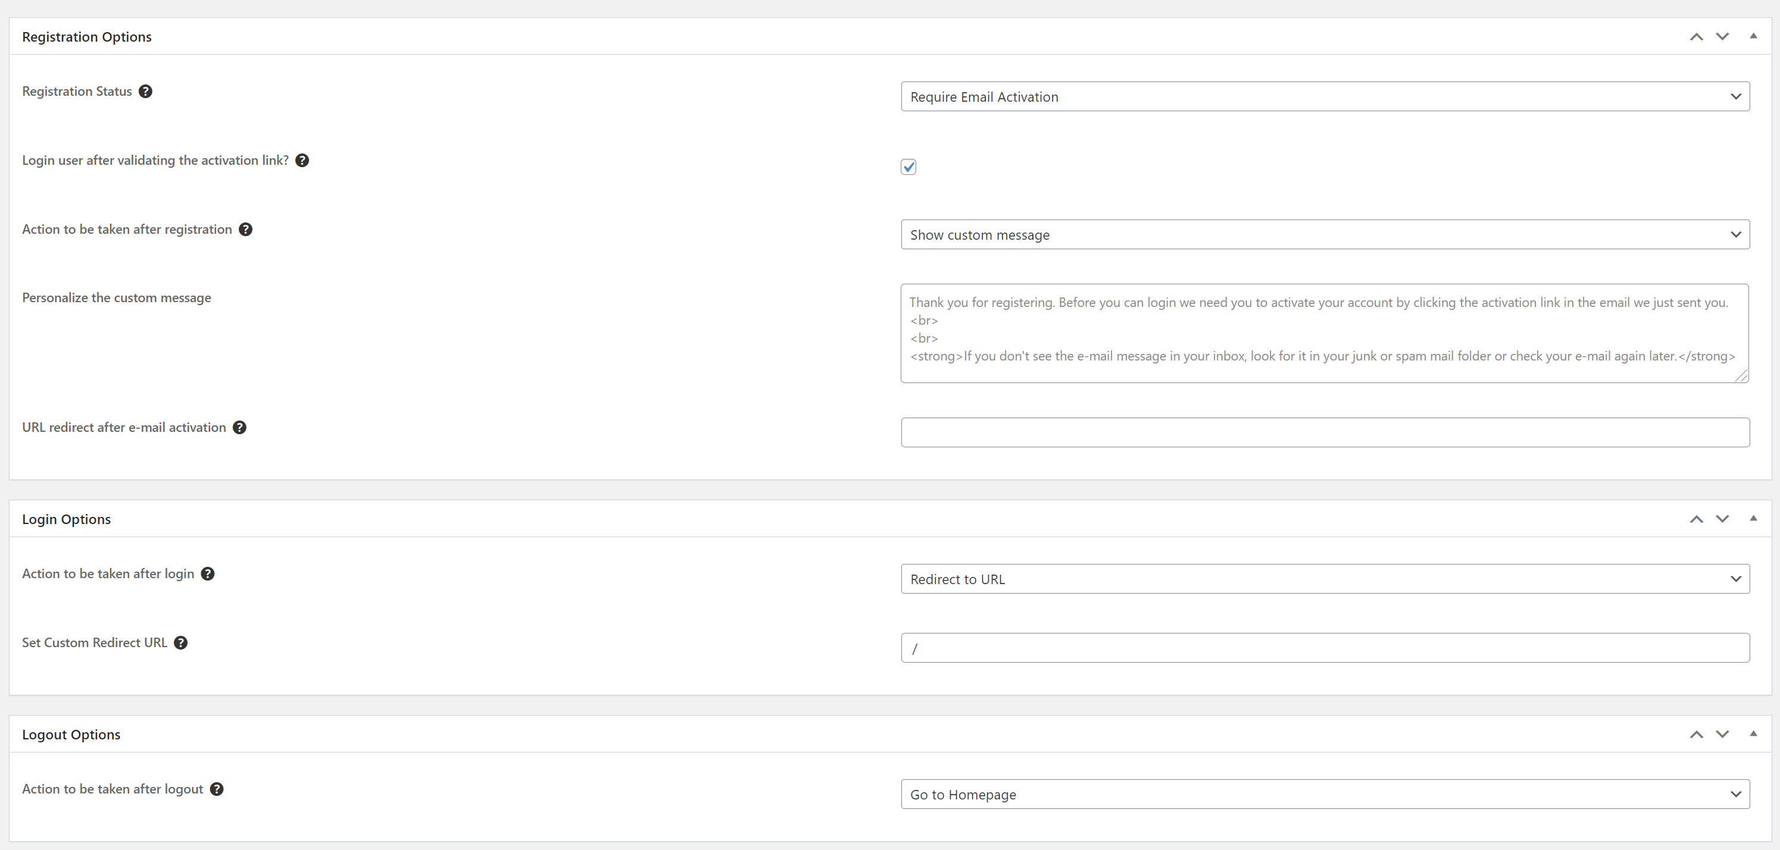

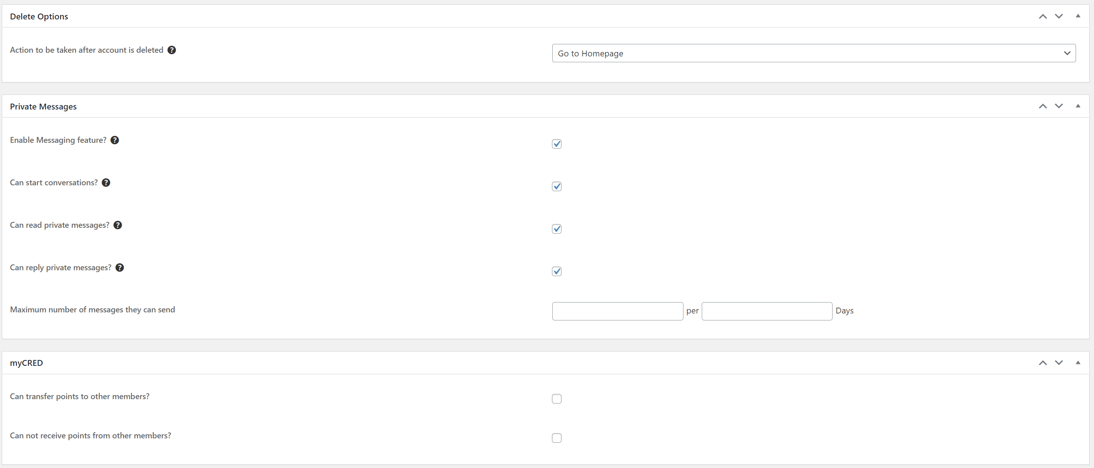

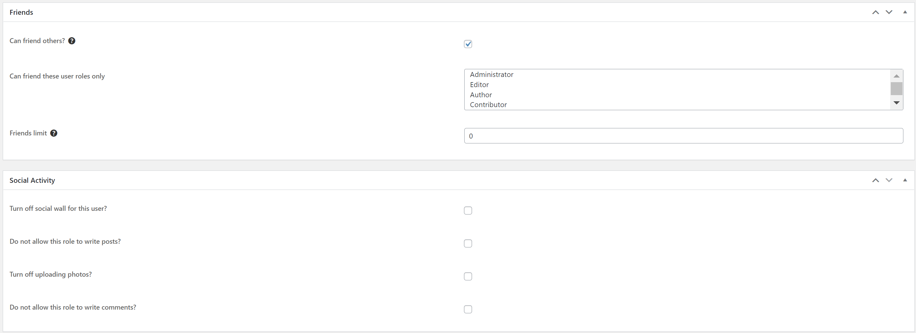

#### Member

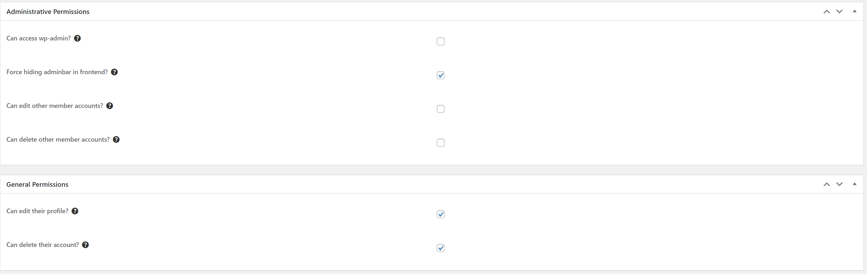

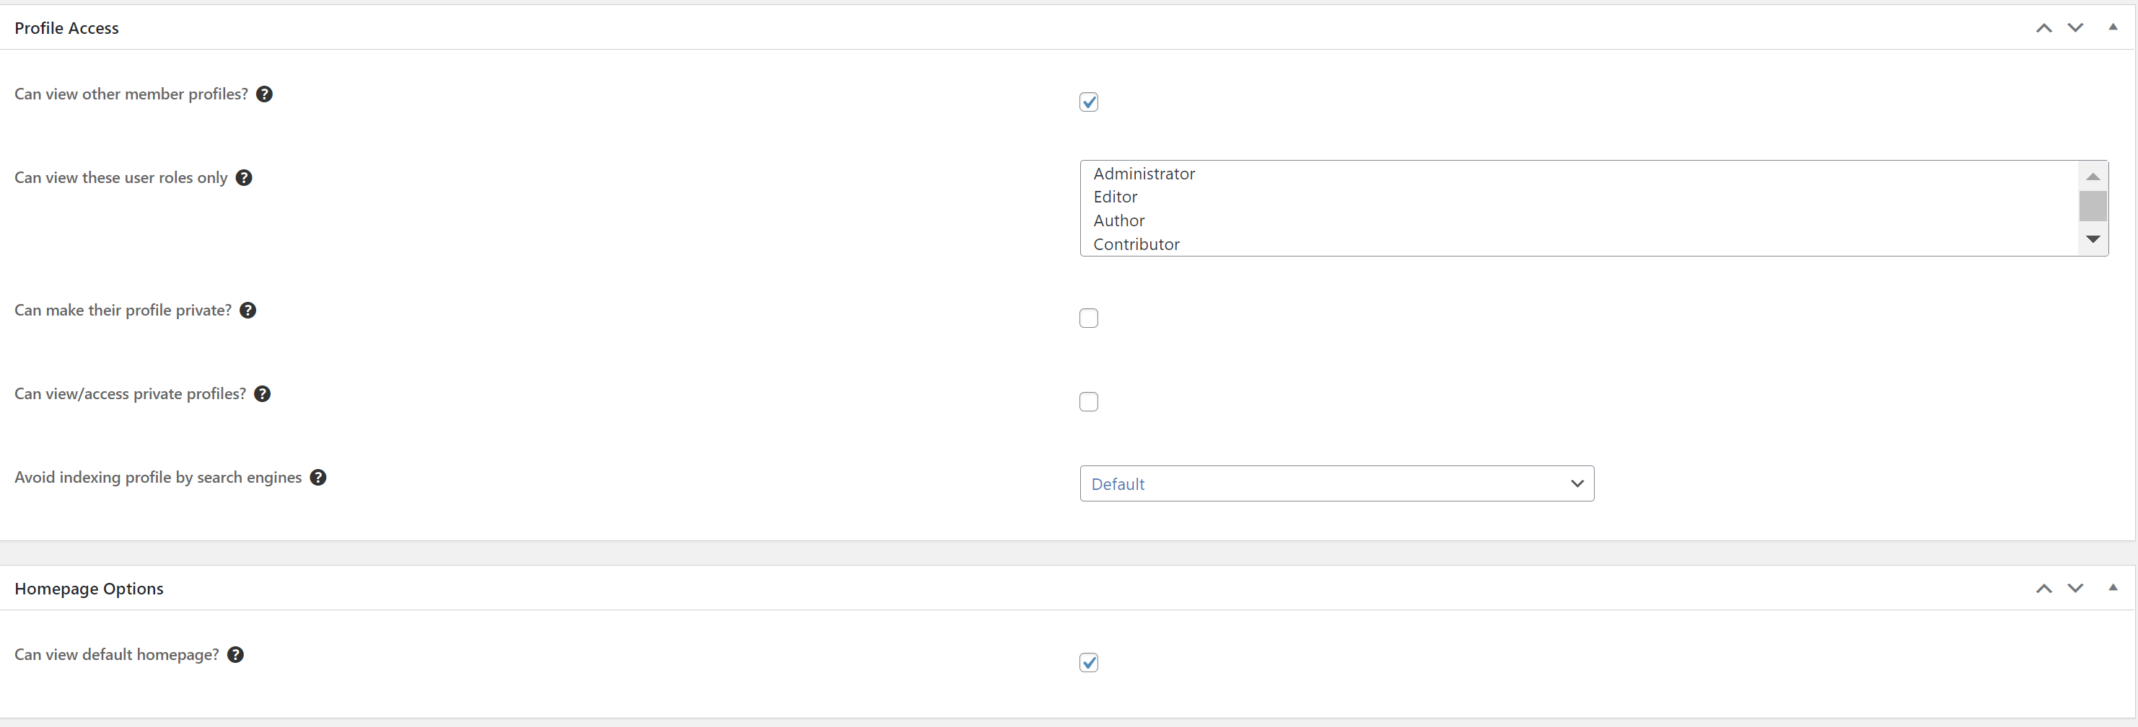

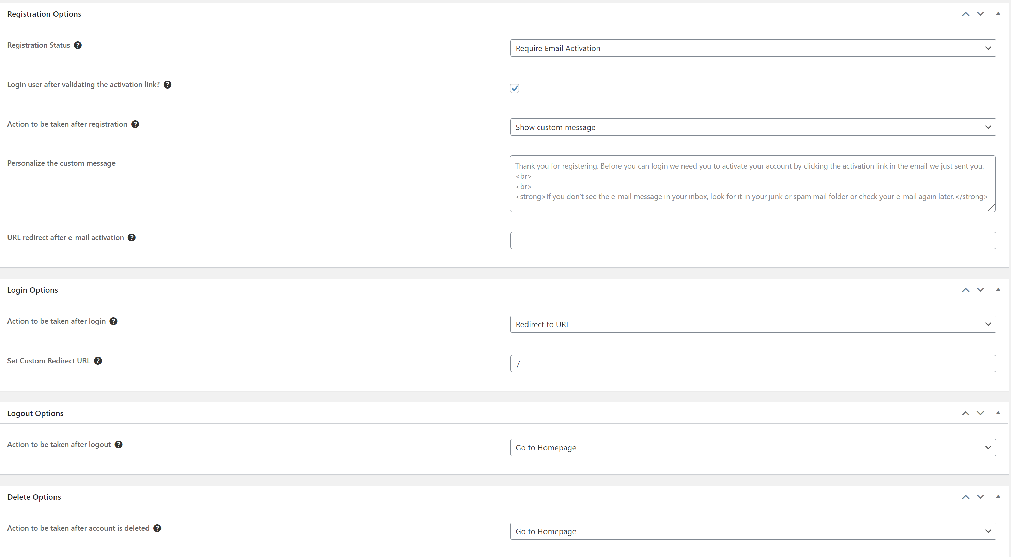

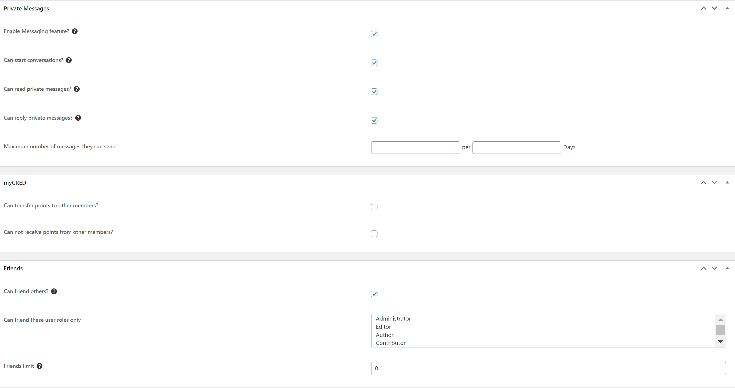

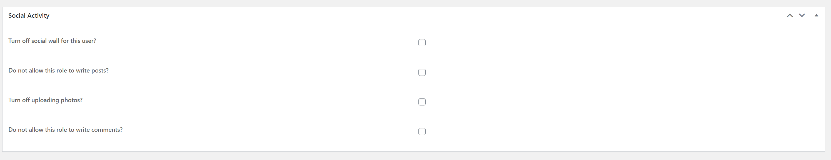

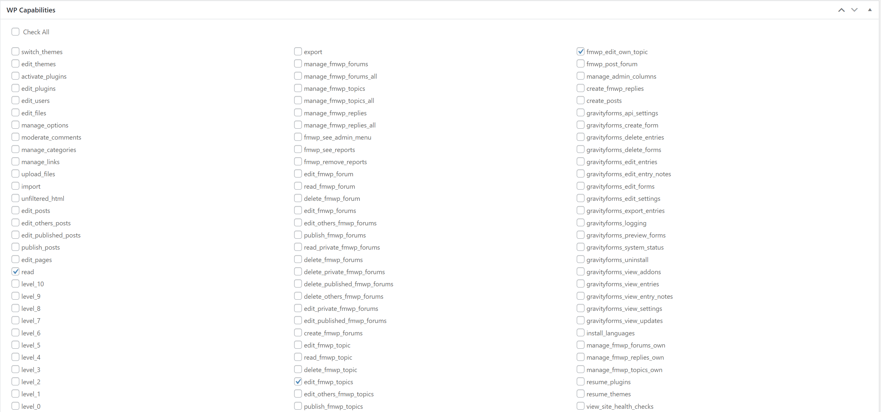

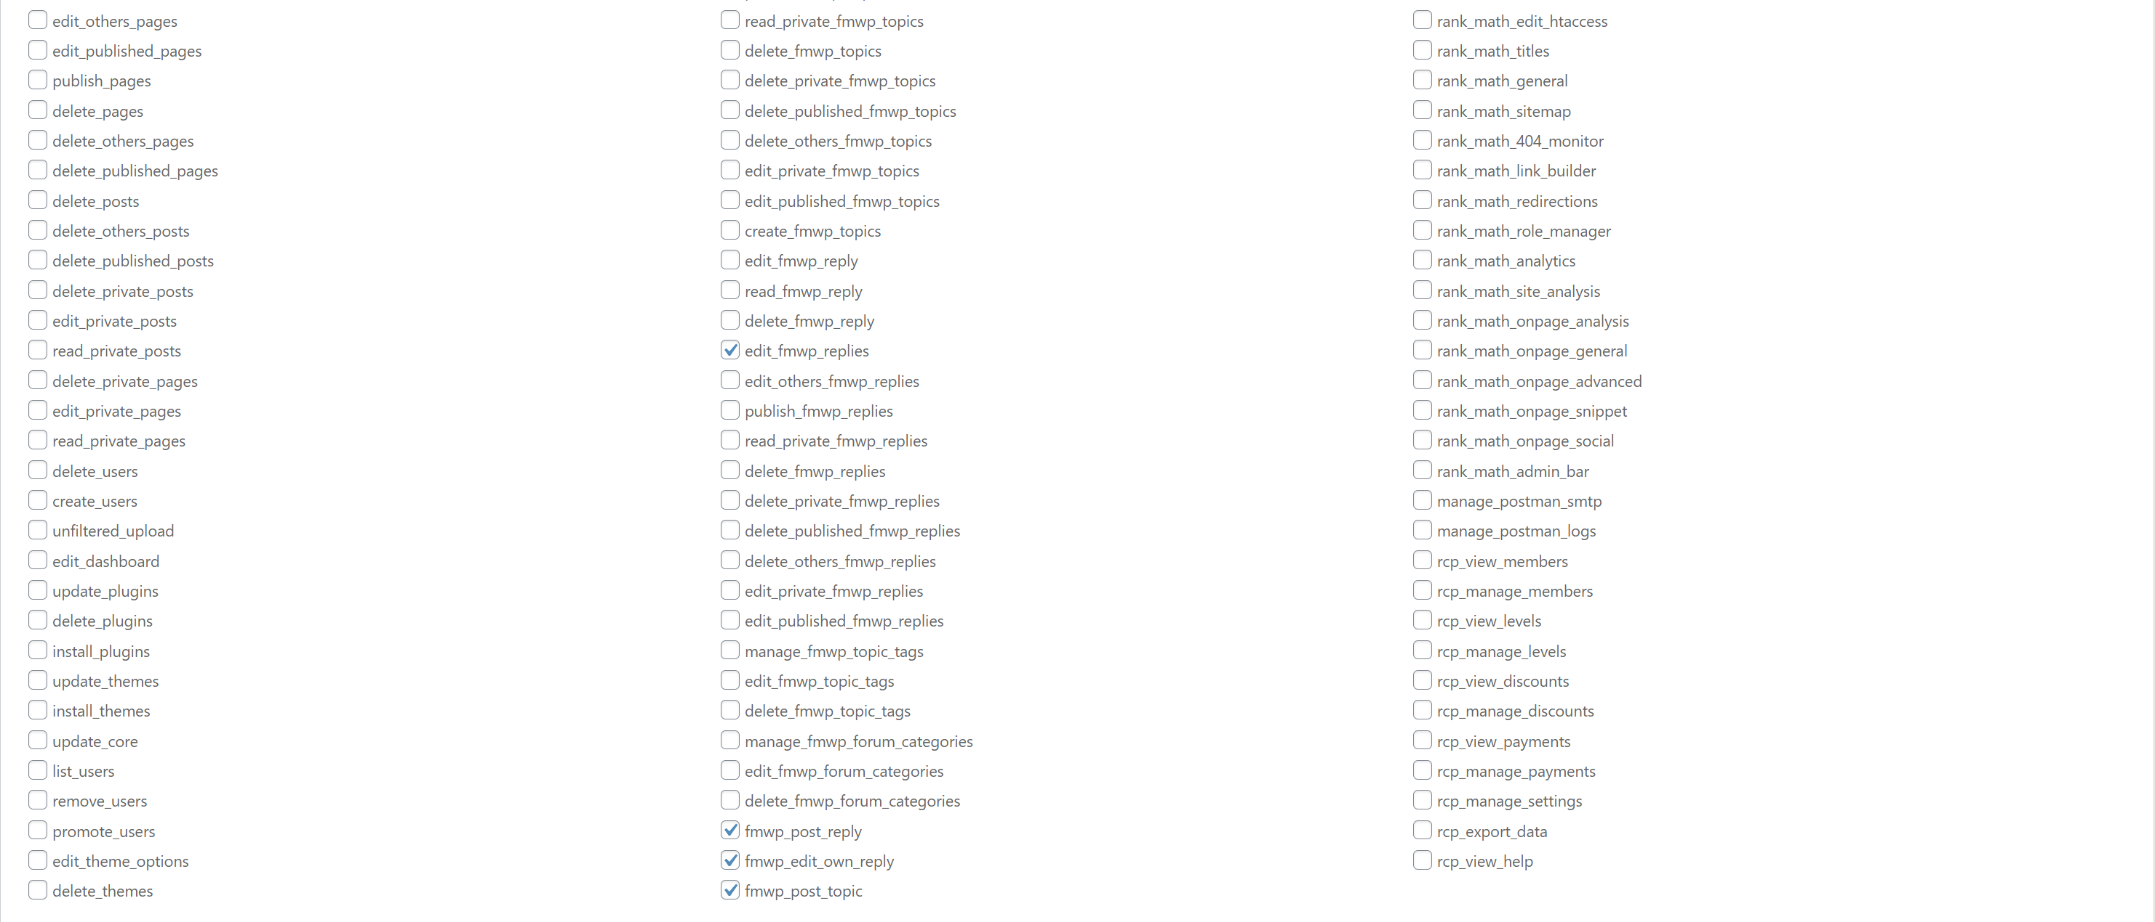

#### Administrator

### Member Directories

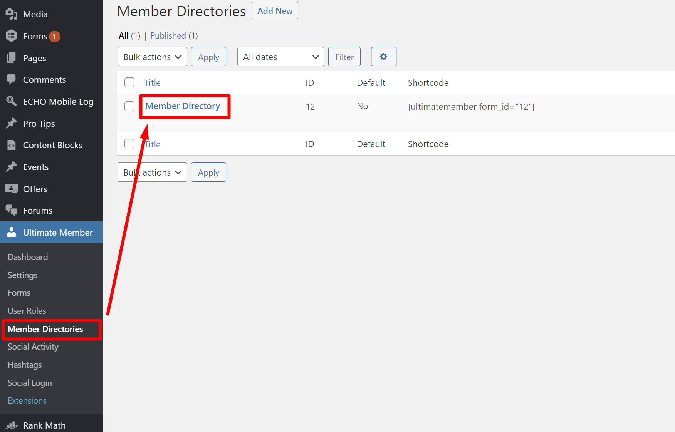

Settings inside:

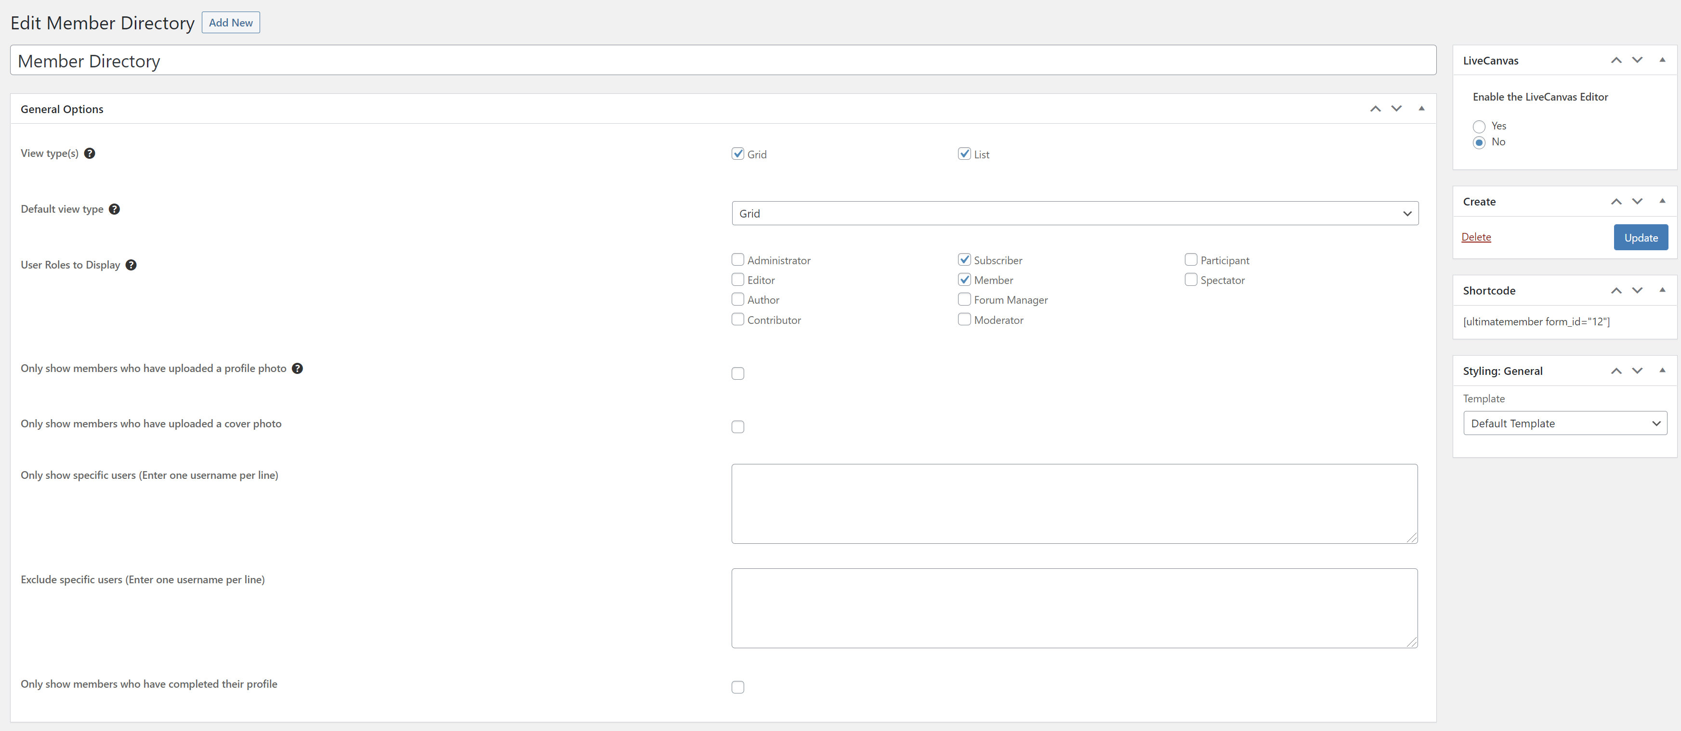

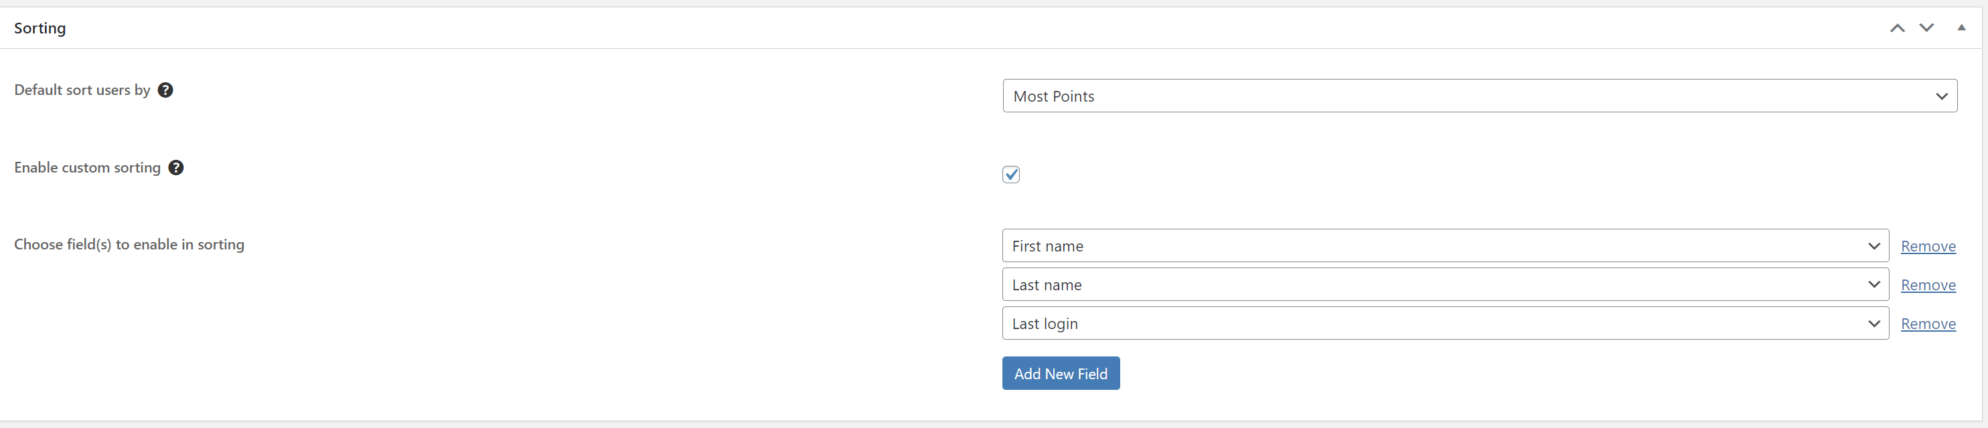

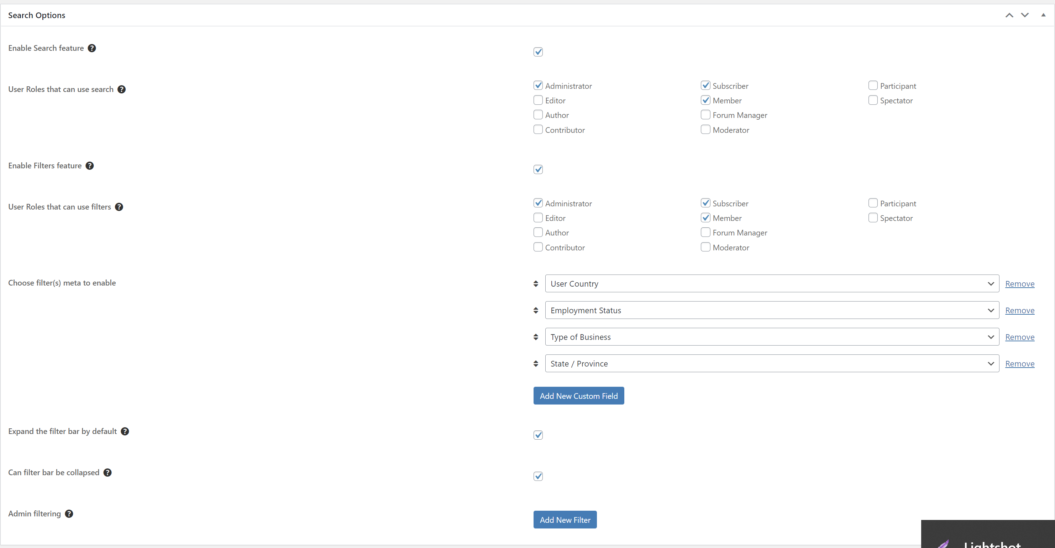

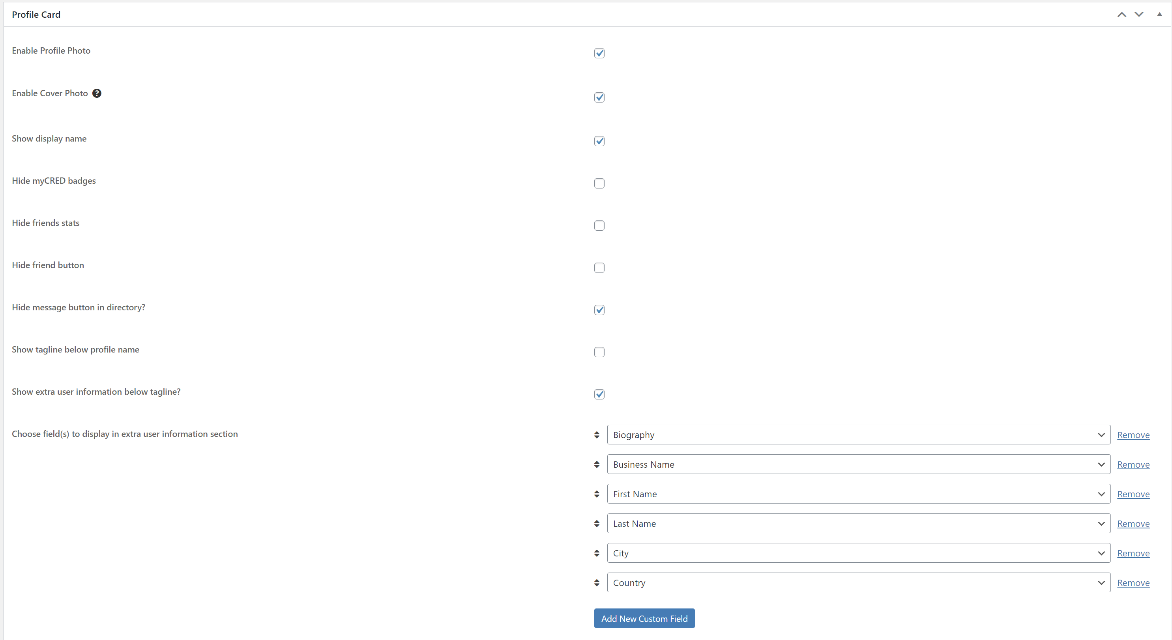

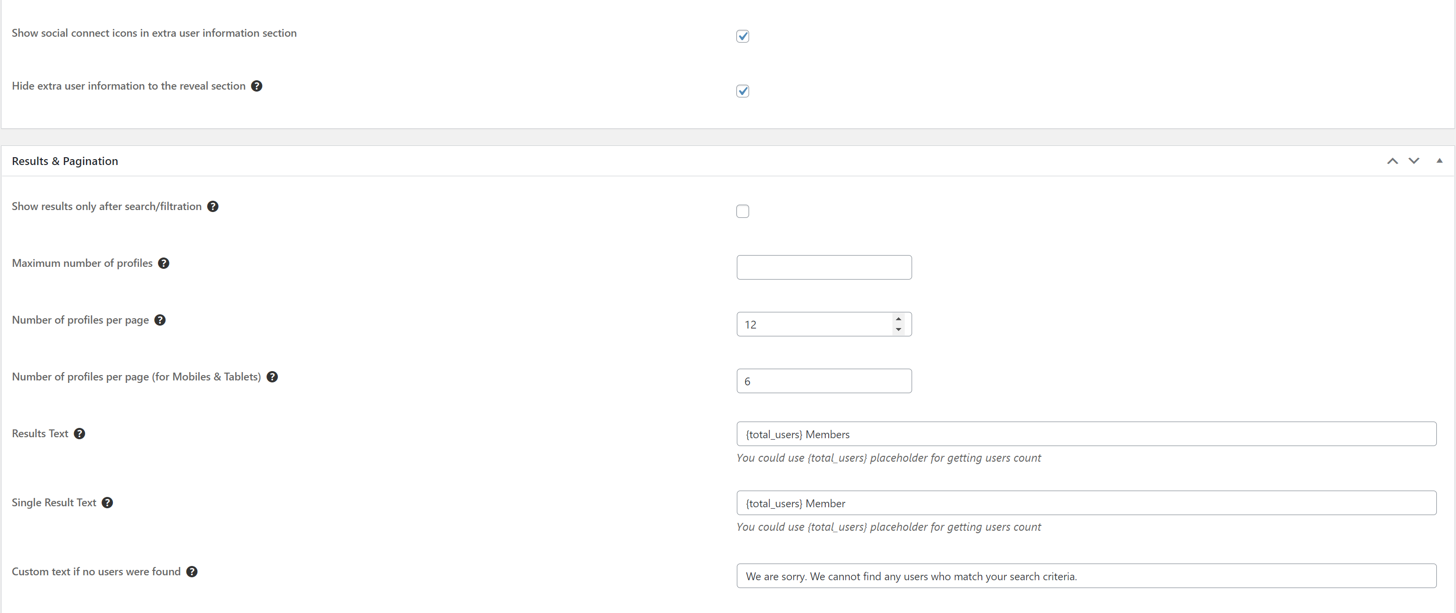

## Mobile Testing Procedures

Need to check both: iPhone and Android apps.

Mobile app was switched to work from JAVA project on WordPress.

JAVA project was moved on this domain: <https://echo-old.dev.our-projects.info/>

WordPress project was moved on this one: <https://echo.dev.our-projects.info/>

Mobile app works the following way for now:

* All registered users were moved from JAVA project into WordPress project;
* When user registered, then registration is go to WordPress Project;
* When user confirms email then user is created in both WordPress and JAVA projects;
* When user logs in then user credentials are taken from JAVA project;
* When user changes profile on mobile app then all changes are saved both in JAVA and WordPress project;
* When user changes profile on WordPress then all changes are applied for JAVA project.
* All information such as feeds, posts, articles, challenges, push notifications, comments, likes and leaderboard are taken from JAVA project.
* DO NOT change user profile in JAVA project, because these changes will not be applied for WordPress user profile.

Checklist for mobile app:

|  |  |
| --- | --- |
| Feature | Steps |
| Registration | [Igor, could you please confirm this]   * Once user completes the form, then a registration confirmation email from WordPress should be sent to user * After user confirms email address, then user account should be created in WordPress and JAVA projects * Welcome email with login and password will be sent to user * Try to log in using new created account into:   + Mobile app   + WordPress website |
| Log In | [Igor, could you please confirm this]   * Try to log in using any existing registered accounts from JAVA project |
| Log In | [Igor, could you please confirm this]   * Register new user via WordPress registration form   + After user confirms email, then it should be created in both JAVA and WordPress projects * Try to log in into mobile app using new registered account |
| Menu->User profile->Personal Information | [Igor, could you please confirm this]  Existing account from JAVA project:   * Check that all fields are displayed properly. To check this you can log in into JAVA project using this user credentials and open his profile on Web   Modify info:   * Try to modify personal info on mobile. All changes should be saved in both JAVA and WordPress projects |
| Menu->User profile->Email Address | [Igor, could you please confirm this]  Existing account from JAVA project:   * Check that all fields are displayed properly. To check this you can log in into JAVA project using this user credentials and open his profile on Web   Modify info:   * Try to modify info on mobile. All changes should be saved in both JAVA and WordPress projects |
| Menu->User profile->Business Address | [Igor, could you please confirm this]  Existing account from JAVA project:   * Check that all fields are displayed properly. To check this you can log in into JAVA project using this user credentials and open his profile on Web   Modify info:   * Try to modify info on mobile. All changes should be saved in both JAVA and WordPress projects |
| Menu->User profile->Password | [Igor, could you please confirm this]  Existing account from JAVA project:   * Check that all fields are displayed properly. To check this you can log in into JAVA project using this user credentials and open his profile on Web   Modify info:   * Try to modify info on mobile. All changes should be saved in both JAVA and WordPress projects |
| Menu->User profile->Profile Picture | [Igor, could you please confirm this]  Existing account from JAVA project:   * To check this need to ask Igor to provide what image was associated with user account, because in JAVA it is not visible   Modify info:   * Try to modify info on mobile. All changes should be saved in both JAVA and WordPress projects |
| Menu->User profile->Notification Settings | [Igor, could you please confirm this]  Existing account from JAVA project:   * To check this need to ask Igor to provide what settings were associated with user account, because in JAVA it is not visible   Modify info:   * Try to modify info on mobile. All changes should be saved in both JAVA only. To check this refresh, the page to see if saved values are displayed properly. |
| Feed | Check that data is displayed properly according mobile spec   * For existing user from JAVA * For new registered user from WordPress |
| Posts->View | Check that posts are displayed properly   * For existing user from JAVA * For new registered user from WordPress |
| Posts->Add Image Post | Check adding and displaying post for   * For existing user from JAVA * For new registered user from WordPress |
| Posts->Add Video Post | Check adding and displaying post for   * For existing user from JAVA * For new registered user from WordPress |
| Post->Comments | Check adding comments and replies for   * For existing user from JAVA * For new registered user from WordPress |
| Post->Post Likes | Check setting / resettings likes for Post   * For existing user from JAVA * For new registered user from WordPress |
| Post->Comments Likes | Check setting / resettings likes for post->Comments   * For existing user from JAVA * For new registered user from WordPress |
| Post->Report | Check REPORT feature for   * For existing user from JAVA * For new registered user from WordPress   It should work without errors, cannot check its action, because there is no admin interface for it. |
| Articles | Check that articles are displayed properly   * For existing user from JAVA * For new registered user from WordPress   NOTE: Articles are taken from JAVA project only |
| Article->Comments | Check adding comments and replies for   * For existing user from JAVA * For new registered user from WordPress |
| Article->Post Likes | Check setting / resettings likes for Article   * For existing user from JAVA * For new registered user from WordPress |
| Article->Comments Likes | Check setting / resettings likes for Article->Comments   * For existing user from JAVA * For new registered user from WordPress |
| Challenges->CURRENT | Check that challenges and Responses are displayed properly   * For existing user from JAVA * For new registered user from WordPress |
| Challenges->PAST | Check that challenges and Responses are displayed properly   * For existing user from JAVA * For new registered user from WordPress |
| Challenges->Add Video Response | Check that Video Responses is added and displayed properly   * For existing user from JAVA * For new registered user from WordPress |
| Challenges->Add Image Response | Check that Image Responses is added and displayed properly   * For existing user from JAVA * For new registered user from WordPress |
| Response->Comments | Check adding comments and replies for   * For existing user from JAVA * For new registered user from WordPress |
| Response->Likes | Check setting / resettings likes for Response   * For existing user from JAVA * For new registered user from WordPress |
| Response->Comments Likes | Check setting / resettings likes for Response->Comments   * For existing user from JAVA * For new registered user from WordPress |
| Scores | NOTE: scores will be taken from JAVA project, so they will not be the same as on WordPress |
| Notifications (bell icon at the top right corner) | Check that user receives notifications according spec   * For existing user from JAVA * For new registered user from WordPress |
| Push Notifications | Check that user receives push notifications according spec for new articles, challenges, comments and likes   * For existing user from JAVA * For new registered user from WordPress |

## Custom Plugins Naming Rules

Custom plugin should follow the rules:

* Plugin Name: EMB <plugin name>
* Plugin URI: <https://senseimarketing.com/>
* Description: <short plugin description. Contact Sergey if need to add details here>
* Version: <version like X.Y.Z>
* Author: Sensei Marketing
* Author URI: <https://senseimarketing.com/>
* Copyright: Sensei Marketing

# Guide

## Discount management

Discount management is located in the Restrict section – Discount code side menu.

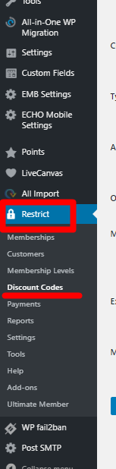

In the discount codes the screen is divided into

* Existing discount section – saved discounts
* Adding new discount section – if you want to add a new discount

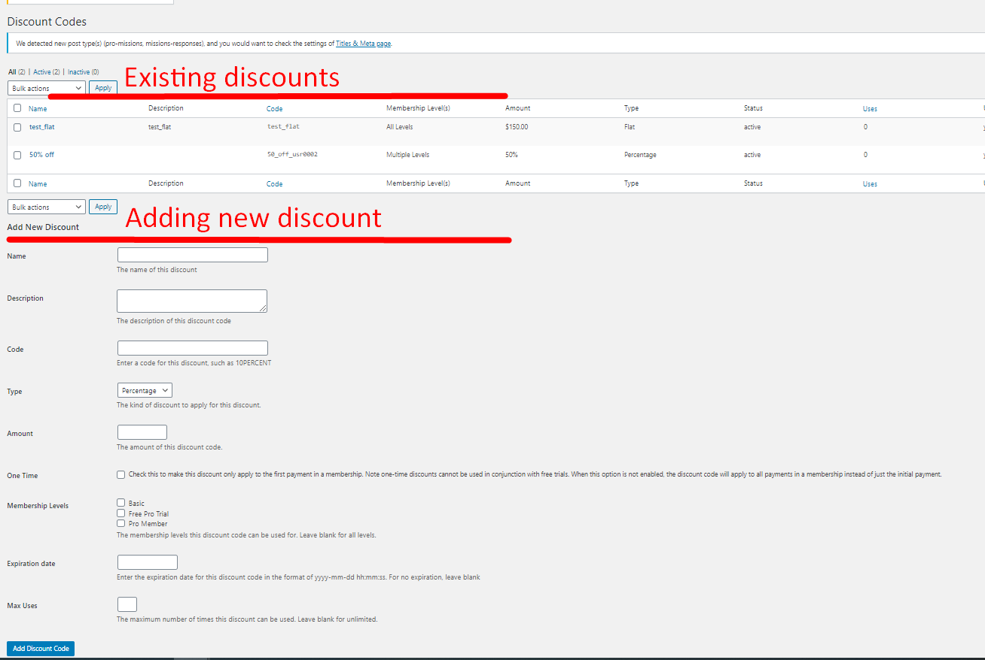

You can add a new discount by filling in the information in the Adding new discount section.

Fields Description:

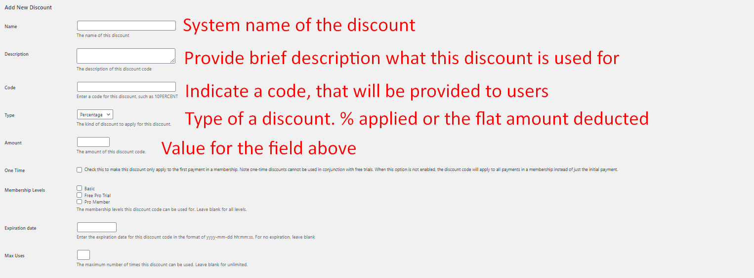

Other fields without a caption are self-explanatory and need to follow the business rules provided.